

**CIS020-1 – Introduction to Software Development**

**Assignment 2 –Individual Project – Case Study**

**(Taxi Booking System)**

**Student Name: Santosh Tamang**

**University ID: 2147440**

Table of Contents

Introduction/Overview 3

Task Description 3

Assumption 4

Project Plan/Schedule 4

Functional Requirements 5

Non-functional Requirements 6

Design: 6

UML Diagram 6

Uses Case Diagrams 7

Activity Diagram 9

Class Diagram 20

Database Design 21

Logical Database Design 21

Physical Database Design 23

User Interface Design 31

Implementation 39

Testing 47

Discussion / Reflection / Critical Analysis 54

Works Cited 54

Appendix 54

CIS020-1 – Introduction to Software Development - 2021-2022

Assignment 2 – Individual Project – Case Study (Taxi Booking System)

# Introduction/Overview

The S&S Taxi Service has been providing taxi services for a long time. They now want to provide the booking facilities through an online medium and a desktop application was requested to be created.

Currently, all the details of their customer, driver and staff are registered in hard copy format along with the trips they have booked. The customer must come to the office, send an e-mail or call the office to book a trip, or to cancel the current trip. Searching for data takes a long time as it was hard to search through all the data. It was hard for the customer to just book or cancel a trip.

For the easiness of the customer to book, cancel and view trips and the staff to search and fill data by converting data into softcopy version. A desktop application is purposed to solve all the existing problem and creating user-friendly environment. The application allows different users (i.e. customer, staff and drive) to perform different activity. The application allows customer to login, book a trip, update the trip, view the trip and cancel the trip. The application allows staff to login, confirm a trip booked by the customer and assign a suitable driver. The application allows driver to login and view their upcoming trips.

To fulfil the requirement of the given assignment, a desktop application was created to book, view, update and cancel trips via online medium, with database to store all data. PostgreSQL database was used to create the required RDBMS with all the required queries and data dictionary.

# Task Description

The task requires the creation of a desktop application with a functioning database for a taxi company that is attempting to offer its services online. There are only three users i.e., customer, driver and staff.

The customer should be able to book a trip, i.e., provide pickup location and time as well as the number of passengers, destination location and payment method. They should be able to view their bookings and booking can be cancelled if needed. To be able to do the above-mentioned activity customer must log in first. If not registered, the customer must register providing their name, address, email and telephone number.

The driver should be able to view all the upcoming trips after logging in. They should be able to start and complete the trip.

The trip booking is confirmed and drivers are assigned by the taxi company administrative after logging in. The staff can see all trips booked.

Include the scenario, and Use Case Diagram from the Brief.

Include any assumptions you make about the system.

# Assumption

* Company have their own vehicle so the driver are assigned a vehicle when they are registered.
* Drivers are registered by the company due to the security of the passenger issues.
* Customers can only book a trip as late as 15 days and as soon as tomorrow.

# Project Plan/Schedule

|  |  |  |
| --- | --- | --- |
| Week No. | Tasks | Priority |
| 1 | Research in the related field | MUST |
| 2 | Requirement Analysis and GUI Prototype Design | MUST |
| 3 | Database Design | MUST |
| 4 | GUI Implementation | MUST |
| 5 | Database Implementation and Testing the Application | MUST |
| 6 | Finalizing Product | MUST |
| 7 | Optimizing Product | SHOULD |
| 8 | Submit Group Report, Project Code and Video Recording | MUST |
| 9 | Project Presentation | MUST |

Overview of Functional, Technical (Non-Functional Requirements) and Usability Requirements

# Functional Requirements

TBS = Taxi Booking System

Customer

1. A customer must register.
2. A customer must log in.
3. A customer should be able to select the pickup locations and the destination.
4. A customer should be able to view their trips.
5. A customer can cancel the booking.
6. A customer should be able to make multiple bookings using the same id.

Staff

1. A staff must login.
2. A staff should be able to view all the customers, drivers, vehicles and drivers.
3. A staff should be able assign a driver to a booking.
4. A staff should be able view driver schedule.
5. A staff should be able to see the status of a trip.

Driver

1. A driver must login.
2. Drivers should be able to view their upcoming trip.
3. They should be able to start a trip and end them.

# Non-functional Requirements

1. The system should respond as fast as possible.
2. The system must be platform independent.
3. The system must be online 24/7.
4. Future amendments must be allowed in the system.

Usability Requirements

1. The system should be user-friendly.
2. There should be validation to enter data and the forms should be short and easy to fill.
3. Enough information about the booking should be provided to meet users’ needs.
4. The navigation in the application should be easy the user should not need a guide to do the basics.

# Design:

## UML Diagram

### Uses Case Diagrams

( TechTarget Contributor, 2023) “A use case diagram is a way to summarize details of a system and the users within that system.”

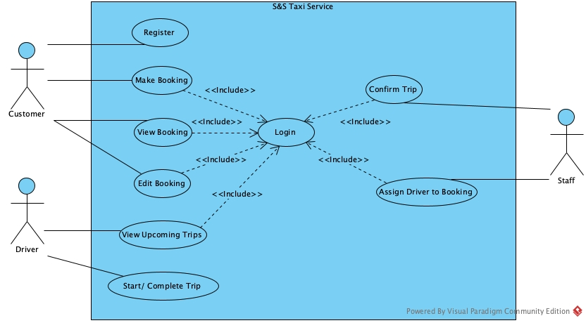

Fig.no.1.Sea Level Use Case

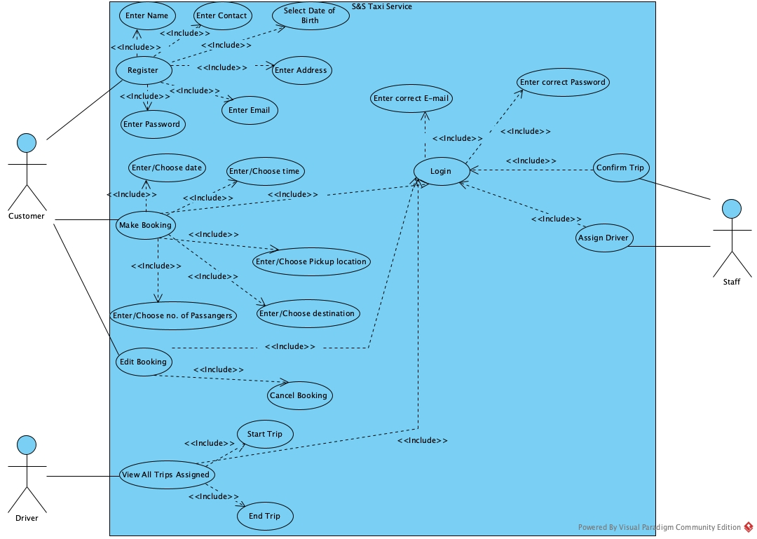

Fig.no.2.Fish Level Use Case

The use case shows how the software works on the surface level.

There are 3 types of users, i.e. customer, driver and staff. They all must login before performing any activities in the software.

To login customer must register with valid information. The registered customer can directly login and view the trips booked or book a trip then. They can even cancel or delete the trip.

A staff confirms a trip by assigning a driver, the driver must be empty, to the trip.

A driver can check for their upcoming trips, start a trip and end it. To start a trip, the date must of the same day or else they cannot.

Use Case Specifications / Description

Allocate Taxi

Only one taxi can be assigned to a single driver.

Make a Booking

After customer made a trip booking, the staff will assign a driver and make the booking confirmed.

Cancel Booking

A customer may cancel a trip any time before a diver is assigned to the trip.

Pickup Date

On the pickup date the driver will wait in the location entered by the Customer. They will wait for 5 extra minutes and call the customer for conformation. If they are not going to make the trip they will be fined

.

Assign Driver

After a driver is requested for a trip, the staff can see the request and assign one of the available driver to the trip.

### Activity Diagram

(Tutorialspoint, 2022) “Activity diagram is basically a flowchart to represent the flow from one activity to another activity.”

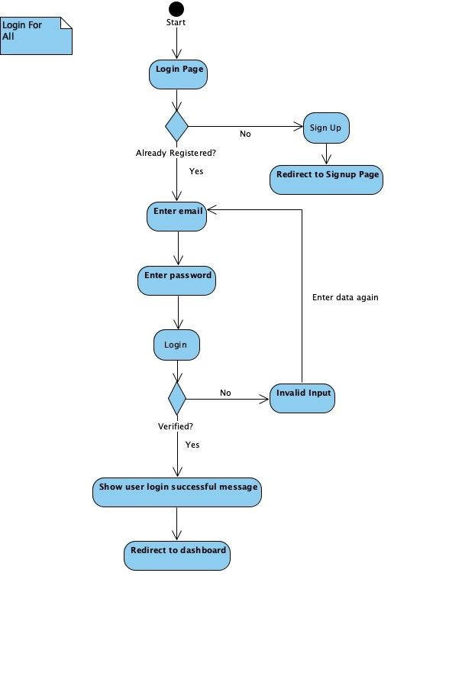

Fig.no.3. Activity Diagram For Logging

The given figure shows the flowchart of the logging process. After opening the software user are provided with two options, to login or register. A user having an account can directly login using this flowchart. For users trying to register pressing the signup button they are redirected to registration page. For the users having account, they are redirected to the dashboard.

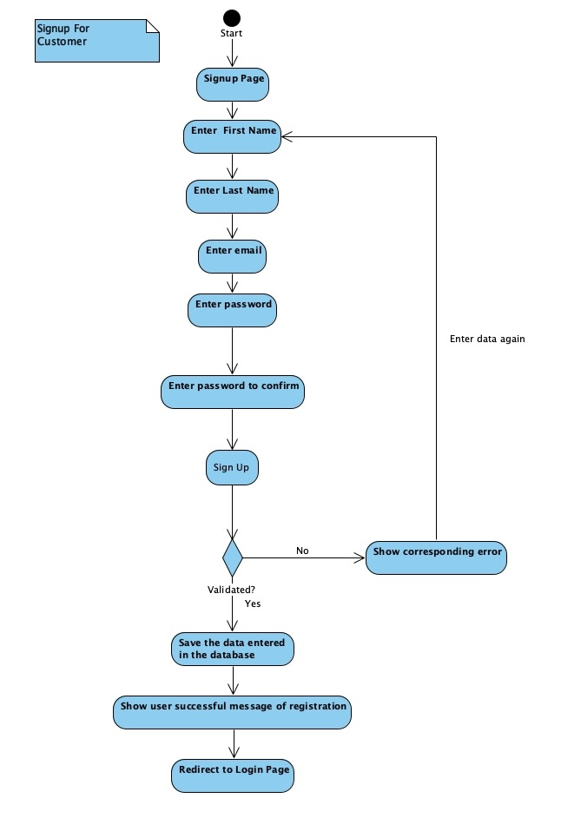

Fig.no.4. Activity Diagram For Registration

After reaching the registration page user can simply fill the form with valid data, if any data is considered incorrect user have to refill the form. After the success in the creation of the account users are redirected to login where they are supposed to login using the data they had just entered.

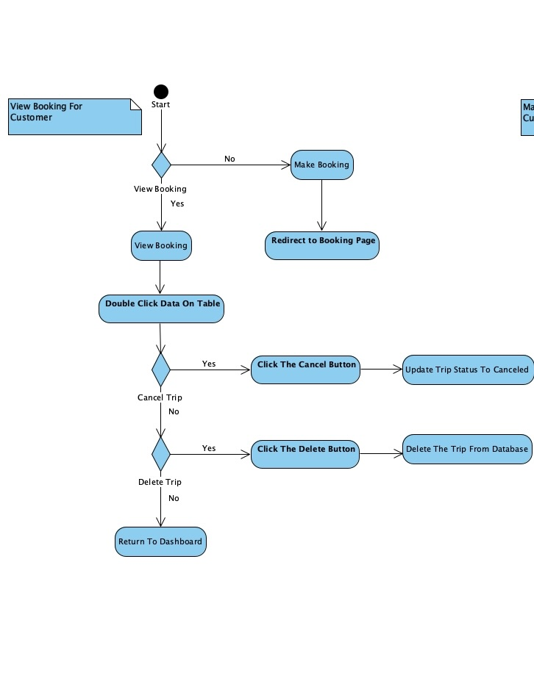

Fig.no.5. Activity Diagram To View Booked Trips

Users that are redirected to the dashboard can see that they are provided with two options: view the trip details and book a trip.

For the users trying to book a trip, they can press the book now button and they are redirected to the booking page.

For the users trying to see the trip details, they can choose one trip and double click on the trip. Then, they are provides two options: cancel the trip, delete the trip. The customer can simply cancel the trip by clicking the cancel button if the cancellation is an option. Similarly, customer can delete the trip by clicking the delete button if the deletion is allowed. Cancellation and deletion is allowed until trip is confirmed.

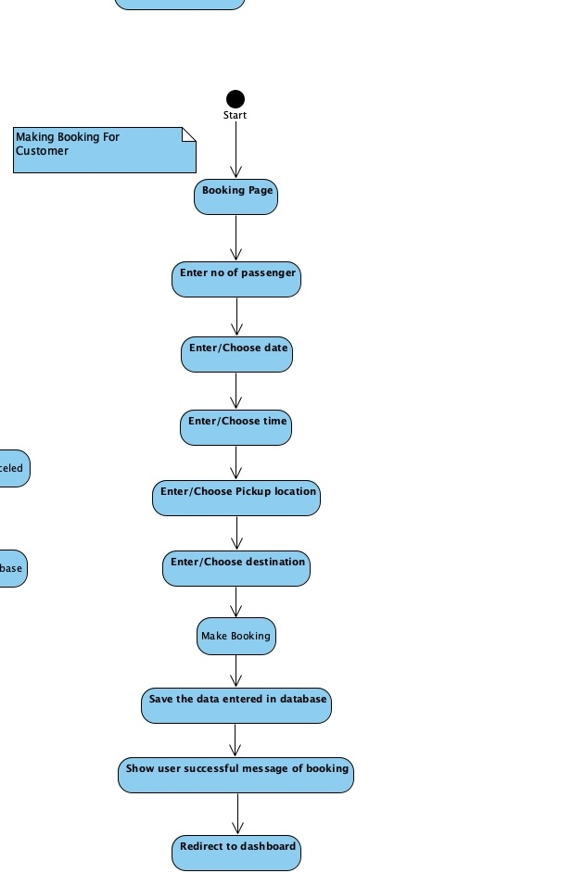

Fig.no.6. Activity Diagram For Booking A Trip

The users redirected to booking page can simply enter or choose the pickup location and destination. The can choose the number of passenger that are travelling. They can choose the pickup time. Having entered the required data, users can simply click the book button and a driver for the trip is requested.

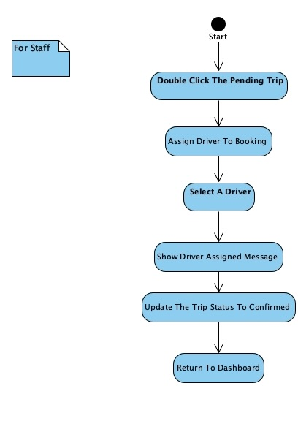

Fig.no.7. Activity Diagram For Staff

This flowchart shows the order of activity of the staff after logging. Staff double clicks the trip that is to be assigned a driver. They select one of the available diver and make the trip confirmed.

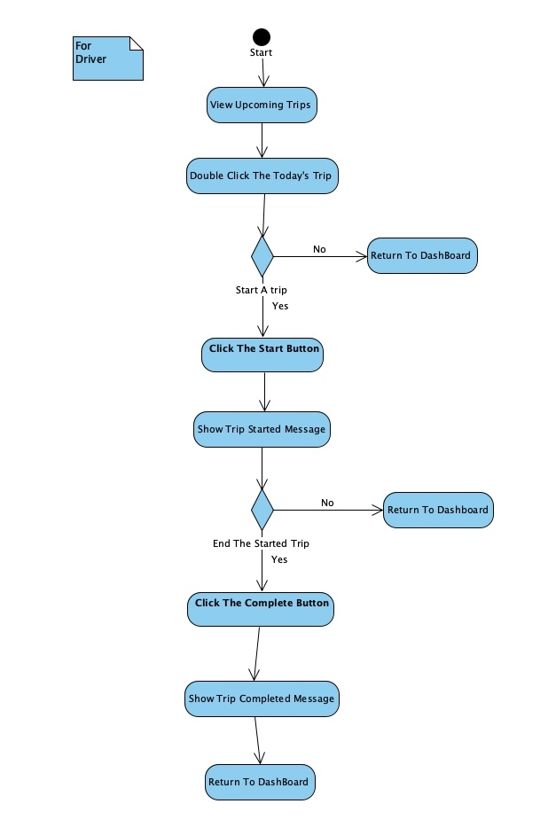

Fig.no.8. Activity Diagram Of Driver

Driver are redirected to driver dashboard after logging. The see their upcoming trips. To start and end the trip they must double click the trip to be started or ended.

### Class Diagram

(Tutorialspoint, 2011) “The class diagram depicts a static view of an application. It represents the types of objects residing in the system and the relationships between them.”

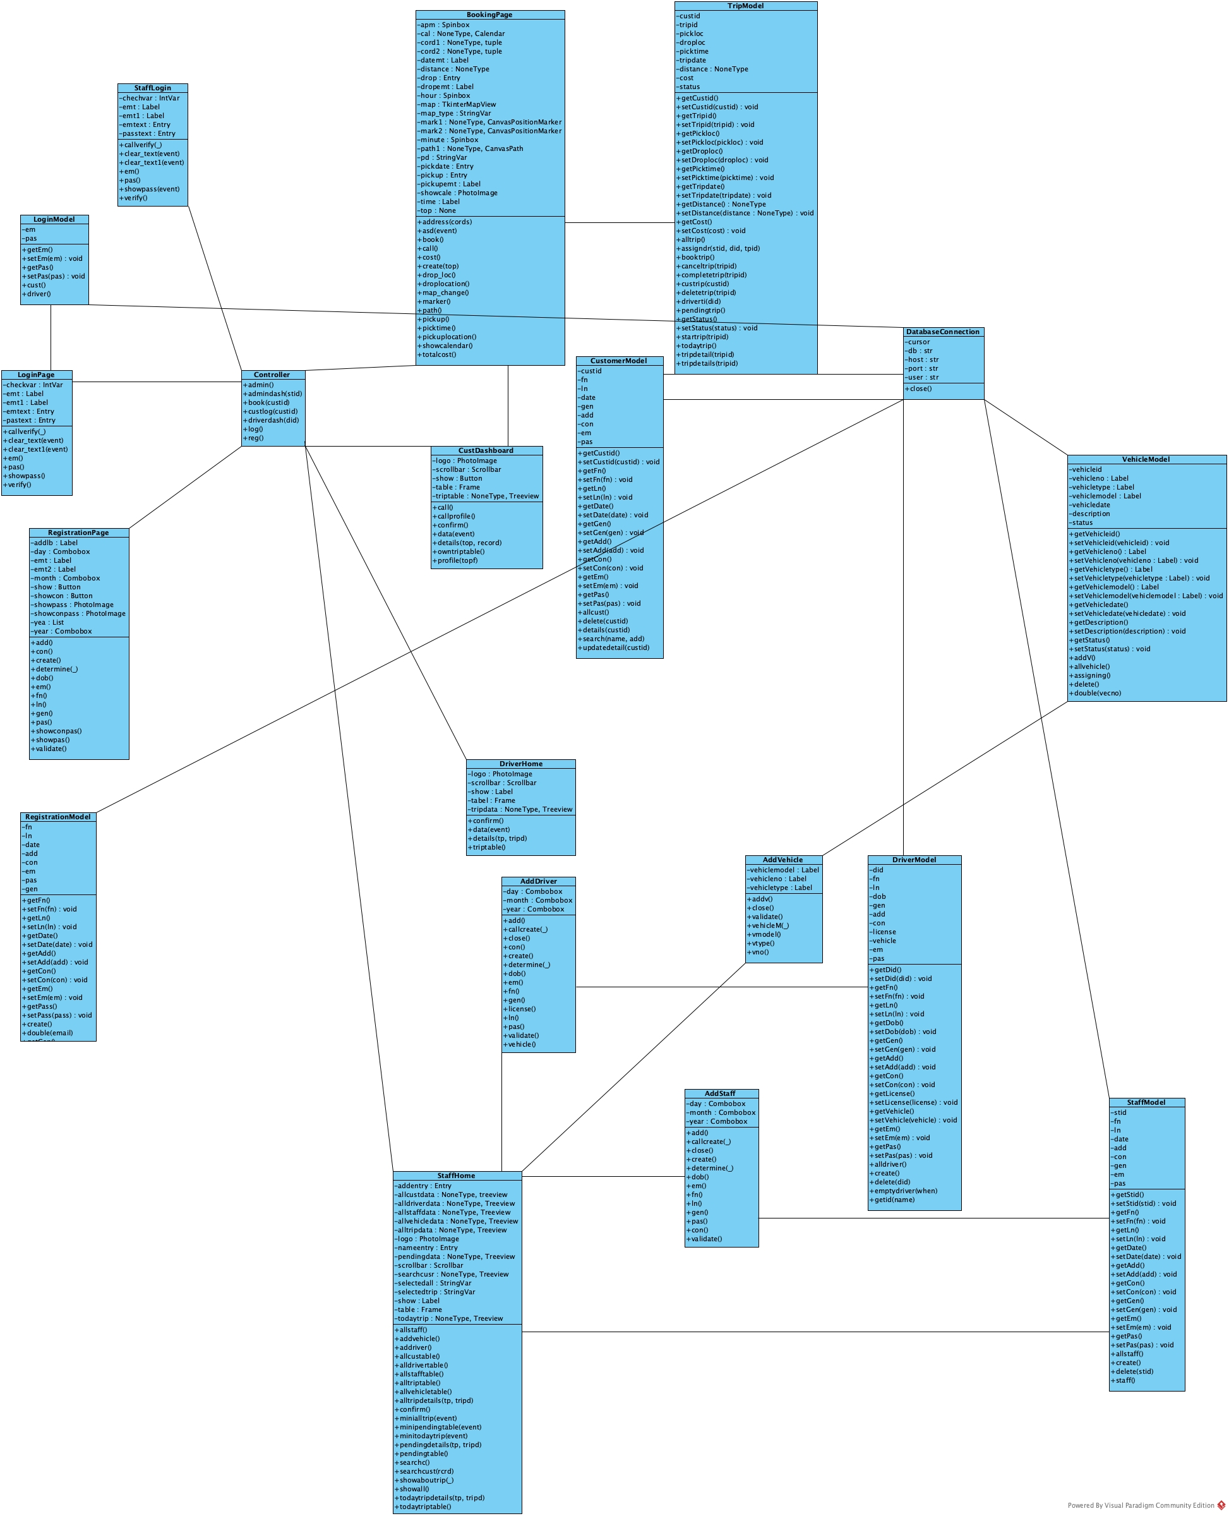

Fig.no.9. Class Diagram

This class diagram describes the system’s classes and its attributes along with the relation with other classes. The class diagram represents almost all the aspect of the software.

## Database Design

### Logical Database Design

* + - Entity Relationship Model(ERM)
      * ERM Diagram

(Visual Paradigm, 2022) “Entity Relationship Diagram, also known as ERD, ER Diagram or ER model, is a type of structural diagram for use in database design.”

In the ERM, the structure of the database is portrayed in the entity relationship. This helps to develop the conceptual design of the database.

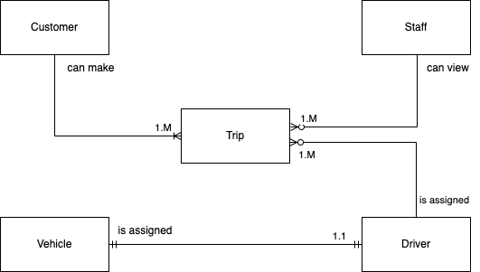

Fig.no.10. Logical Database

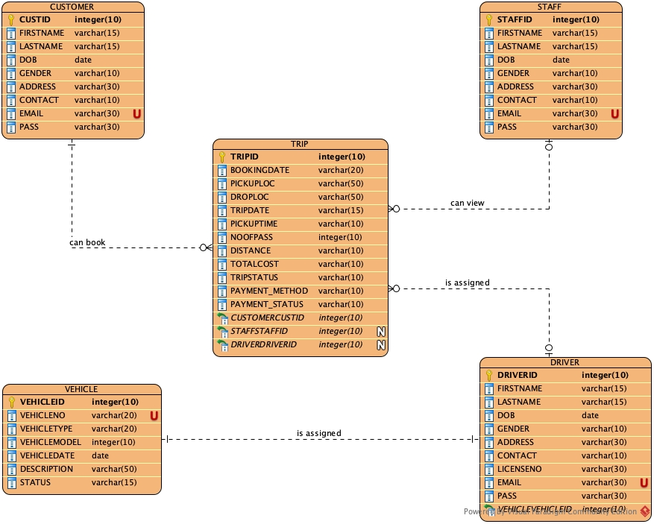

Fig.no.11. Entity Relationship Diagram

The above figure is the ERM diagram of the database creates to satisfy the need of this assignment. For this assignment five entities are identified by the normalization process. The entities are Customer, Staff, Trip, Driver and Vehicle. Each entities contains primary key to maintain data redundancy.

A customer can make many trips at a time.

A staff can view all the trips booked by the customer and assigns available drivers.

Driver can see all trips assigned to them.

A vehicle is assigned to a single driver only.

* + - * List Of Entities

Customer (custid, firstname, lastname, gender, dob, address, contact, email, pass)

Vehicle(vehicleid, vehicleno, vehicletype, vehiclemodel, vehicledate, description, status)

Driver (driverid, firstname, lastname, gender, dob, address, contact, licenseno, vehicleis*, email, pass)

Staff(staffed, firstname, lastname, gender, dob, address, contact, email, pass)

Booking (tripid, bookingdate, pickuploc, droploc, tripdate, pickuptime, noofpass, distance, totalcost, tripstatus, payment_method, payment_status, custid*, driverid*, staffed*)

### Physical Database Design

* + - Skeleton Table

Customer (custid, firstname, lastname, gender, dob, address, contact, email, pass)

Vehicle(vehicleid, vehicleno, vehicletype, vehiclemodel, vehicledate, description, status)

Driver (driverid, firstname, lastname, gender, dob, address, contact, licenseno, vehicleis*, email, pass)

Staff(staffed, firstname, lastname, gender, dob, address, contact, email, pass)

Booking (tripid, bookingdate, pickuploc, droploc, tripdate, pickuptime, noofpass, distance, totalcost, tripstatus, payment_method, payment_status, custid*, driverid*, staffed*)

* + - Data Dictionary

(Varma, 2022) “A data dictionary in Database Management System (DBMS) can be defined as a component that stores the collection of names, definitions, and attributes for data elements that are being used in a database.”

|  |  |  |  |  |  |  |  |
| --- | --- | --- | --- | --- | --- | --- | --- |
| Customer | | | | | | | |
| **Description: Customer details** | | | | | | | |
| **Field Name** | **Datatype** | **Length** | **Index** | **Null** | **Default** | **Validation rule** | **Description** |
| **CustID *(Primary)*** | int (10)  unsigned | 10 | PK | No |  |  | Autoincremented Uniquely identifies every customer |
| Firstname | varchar (15) | 15 |  | No |  | First letter must be capital, no space allowed | First name of customer |
| Lastname | varchar (15) | 15 |  | No |  | First letter must be capital, no space allowed | Last name of customer |
| Dob | date | 10 |  | No |  |  | Birthdate of customer |
| Contact | varchar (10) | 10 |  | No |  |  | Customer contact number |
| Address | varchar (30) | 30 |  | No |  |  | Address of customer |
| Gender | varchar (10) | 10 |  | No |  |  | Gender of customer |
| Email | varchar (30) | 30 |  | No |  | Must be email format containing an @ and a ‘.’  Regex expression used | Email of customer |
| Password | varchar (30) | 30 |  | No |  | Must contain 8 letters, a small, a capital letter, symbol and a number | TBS password |

Indexes

|  |  |  |  |  |
| --- | --- | --- | --- | --- |
| **Key name** | **Type** | **Unique** | **Column** | **Null** |
| PRIMARY | BTREE | Yes | CustID | No |

|  |  |  |  |  |  |  |  |
| --- | --- | --- | --- | --- | --- | --- | --- |
| Staff | | | | | | | |
| **Description: Staff details** | | | | | | | |
| **Field Name** | **Datatype** | **Length** | **Index** | **Null** | **Default** | **Validation rule** | **Description** |
| **StaffID *(Primary)*** | int (10)  unsigned | 10 | PK | No |  |  | Autoincremented Uniquely identifies every staff |
| Firstname | varchar (15) | 15 |  | No |  | First letter must be capital, no space allowed | First name of staff |
| Lastname | varchar (15) | 15 |  | No |  | First letter must be capital, no space allowed | Last name of staff |
| Dob | date | 10 |  | No |  |  | Birthdate of staff |
| Contact | varchar (10) | 10 |  | No |  |  | Staff contact number |
| Address | varchar (30) | 30 |  | No |  |  | Address of staff |
| Gender | varchar (10) | 10 |  | No |  |  | Gender of staff |
| Email | varchar (30) | 30 |  | No |  | Must be email format containing an @ and a ‘.’  Regex expression used | Email of staff |
| Password | varchar (30) | 30 |  | No |  | Must contain 8 letters, a small, a capital letter, symbol and a number | TBS password |

Indexes

|  |  |  |  |  |
| --- | --- | --- | --- | --- |
| **Key name** | **Type** | **Unique** | **Column** | **Null** |
| PRIMARY | BTREE | Yes | StaffID | No |

|  |  |  |  |  |  |  |  |
| --- | --- | --- | --- | --- | --- | --- | --- |
| Vehicle | | | | | | | |
| **Description: Vehicle details** | | | | | | | |
| **Field Name** | **Datatype** | **Length** | **Index** | **Null** | **Default** | **Validation rule** | **Description** |
| **VehicleID *(Primary)*** | int (10)  unsigned | 10 | PK | No |  |  | Autoincremented Uniquely identifies every vehicle |
| VehicleNo | varchar (15) | 15 |  | No |  | Must in format (Ba 23 Ja 1324) | Registered vehicle number |
| VehicleType | varchar (15) | 15 |  | No |  |  | Vehicle company name |
| VehicleModel | date | 10 |  | No |  |  | Vehicle model |
| VehicleDate | varchar (10) | 10 |  | No |  |  | Date vehicle registered to company |
| Description | varchar (30) | 30 |  | No |  |  | Description of the vehicle |
| Status | varchar (10) | 10 |  | No |  |  | Status of the vehicle |

Indexes

|  |  |  |  |  |
| --- | --- | --- | --- | --- |
| **Key name** | **Type** | **Unique** | **Column** | **Null** |
| PRIMARY | BTREE | Yes | VehicleID | No |

|  |  |  |  |  |  |  |  |
| --- | --- | --- | --- | --- | --- | --- | --- |
| Driver | | | | | | | |
| **Description: Driver details** | | | | | | | |
| **Field Name** | **Datatype** | **Length** | **Index** | **Null** | **Default** | **Validation rule** | **Description** |
| **DriverId *(Primary)*** | int (10)  unsigned | 10 | PK | No |  |  | Autoincremented Uniquely identifies every driver |
| Firstname | varchar (15) | 15 |  | No |  | First letter must be capital, no space allowed | First name of driver |
| Lastname | varchar (15) | 15 |  | No |  | First letter must be capital, no space allowed | Last name of driver |
| Dob | date | 10 |  | No |  |  | Birthdate of driver |
| Contact | varchar (10) | 10 |  | No |  |  | Driver contact number |
| Address | varchar (30) | 30 |  | No |  |  | Address of driver |
| Gender | varchar (10) | 10 |  | No |  |  | Gender of driver |
| LicenseNo | varchar (30) | 30 |  | No |  |  | Registered license number of driver |
| Email | varchar (30) | 30 |  | No |  | Must be email format containing an @ and a ‘.’  Regex expression used | Email of driver |
| Password | varchar (30) | 30 |  | No |  | Must contain 8 letters, a small, a capital letter, symbol and a number | TBS password |
| VehicleID | Int (10) unsigned | 10 | FK | No |  |  | Vehicle assigned to the driver |

Indexes

|  |  |  |  |  |
| --- | --- | --- | --- | --- |
| **Key name** | **Type** | **Unique** | **Column** | **Null** |
| PRIMARY | BTREE | Yes | DriverID | No |
| FOREIGN | BTREE | Yes | VehicleID | No |

|  |  |  |  |  |  |  |  |
| --- | --- | --- | --- | --- | --- | --- | --- |
| BOOKING | | | | | | | |
| Description: Booking details | | | | | | | |
| Field Name | **Datatype** | **Length** | **Index** | **Null** | **Default** | **Validation rule** | **Description** |
| TripID | Int (10) | 10 | PK | No |  |  | Autoincremented Uniquely identifies every trip booked |
| BookingDate | varchar (20) | 20 |  | No |  |  | Date the trip is booked |
| Pickuploc | varchar (50) | 50 |  | No |  |  | Pickup address |
| Droploc | varchar (50) | 50 |  | No |  |  | Destination |
| TripDate | varchar (15) | 15 |  | No |  |  | The trip date |
| PickupTime | varchar (10) | 10 |  | No |  |  | Pickup time |
| NoofPass | int (10) | 10 |  | No |  | Cannot be more than 4 | Number of passenger travelling |
| Distance | varchar (10) | 10 |  | No |  |  | Distance to cover for the trip |
| TotalCost | varchar (10) | 10 |  | No |  |  | Cost for the trip |
| TripStatus | varchar (10) | 10 |  | No |  |  | Status of the trip booked |
| Payment_Method | varchar (10) | 10 |  | No | Cash |  | Payment method for the trip |
| Payment_Status | varchar (10) | 10 |  | No |  |  | Payment status for the trip |
| CustID | int (10) | 10 | FK | No |  |  | Uniquely identifies every customers |
| StaffID | int (10) | 10 | FK | Yes |  |  | Uniquely identifies admin |
| DriverID | int (10) | 10 | FK | Yes |  |  | Uniquely identifies every driver |

Indexes

|  |  |  |  |  |
| --- | --- | --- | --- | --- |
| **Key name** | **Type** | **Unique** | **Column** | **Null** |
| PRIMARY | BTREE | Yes | TripID | No |
| FOREIGN | BTREE | Yes | CustID | No |
| FOREIGN | BTREE | Yes | StaffID | Yes |
| FOREIGN | BTREE | Yes | DriverID | Yes |

## User Interface Design

(Tutorialspoint, 2022) “User interface is the front-end application view to which user interacts in order to use the software. User can manipulate and control the software as well as hardware by means of user interface.”

(Interaction Design Foundation, 2022) “User interface (UI) design is the process designers use to build interfaces in software or computerized devices, focusing on looks or style. Designers aim to create interfaces which users find easy to use and pleasurable.”

For the fulfilment of the requirement a prototype was created using Balsamiq Wireframes. Designing a prototype was smooth using the Balsamiq Wireframes. The created prototype was converted to actual user interface, with the addition of some features. The screenshots of prototype created are given below.

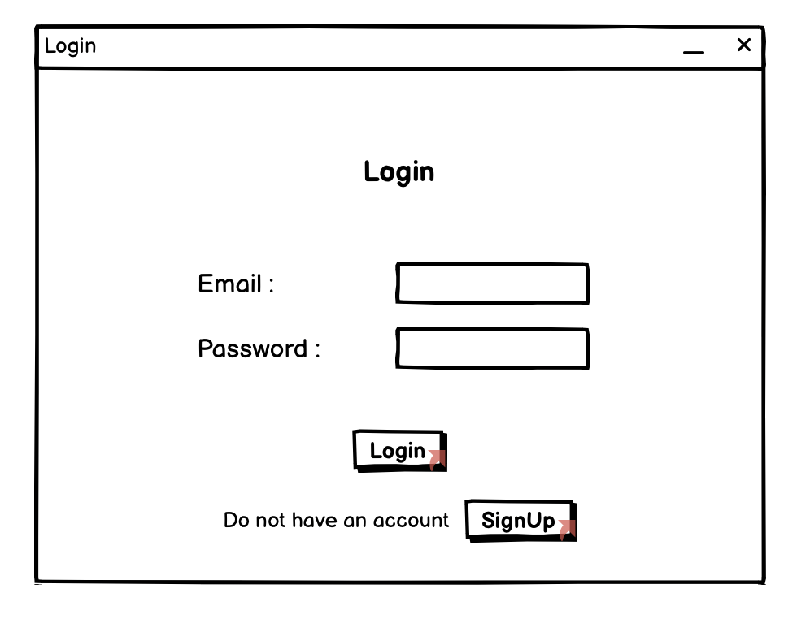

Fig.no.12 Login of Prototype

This is the login page created in the prototype phase.

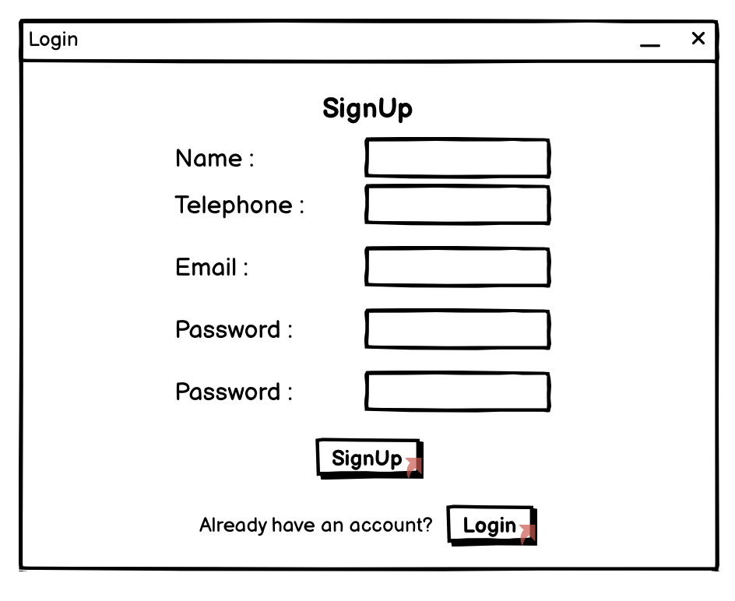

Fig.no.13 Registration of Prototype

This is the registration page where customers can register to login.

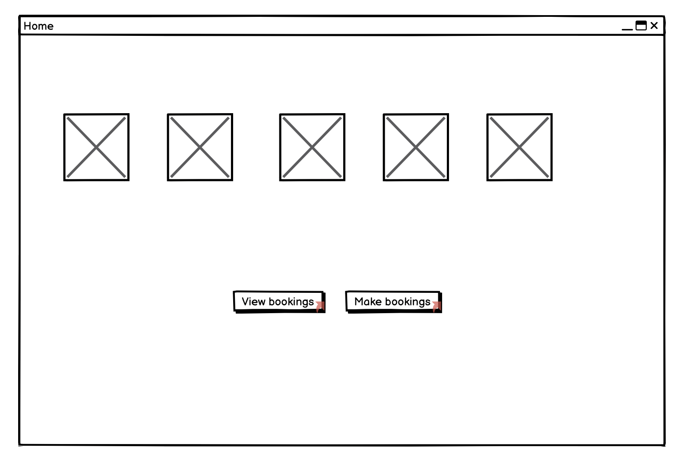

Fig.no.14 Customer Dashboard of Prototype

This is the home page of the customer after logging in.

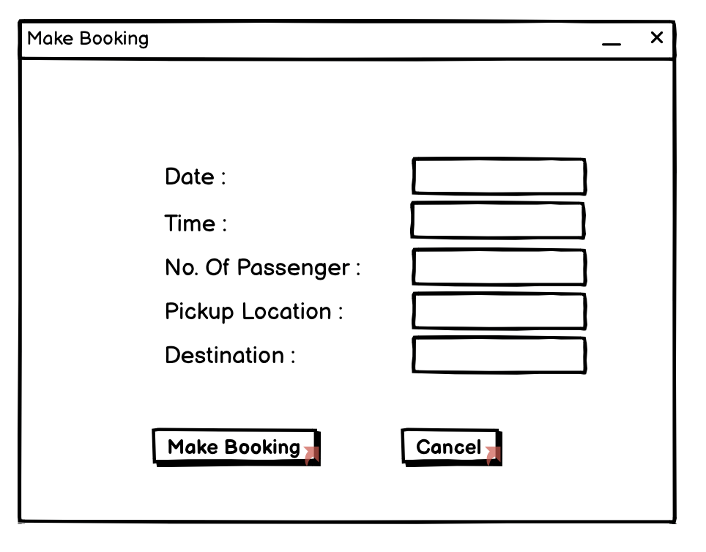

Fig.no.15 Booking Page

This is the booking page where customer can book trips.

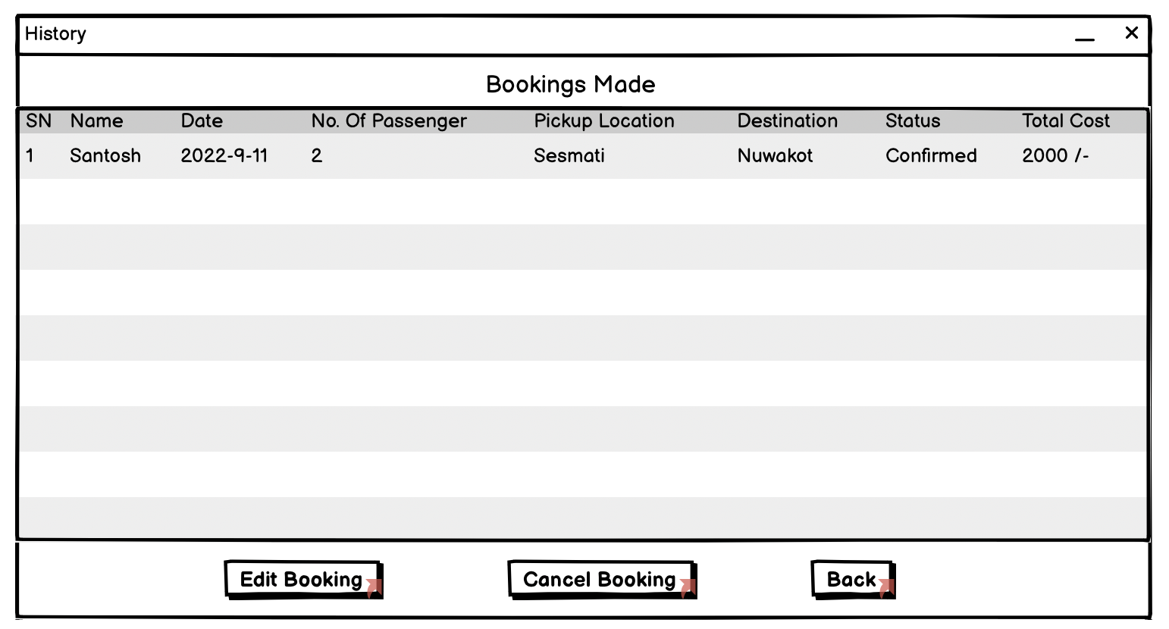

Fig.no.16. History Page of Prototype

This is the history page of customer where they can view all their trip. They can edit the trip if they wanted.

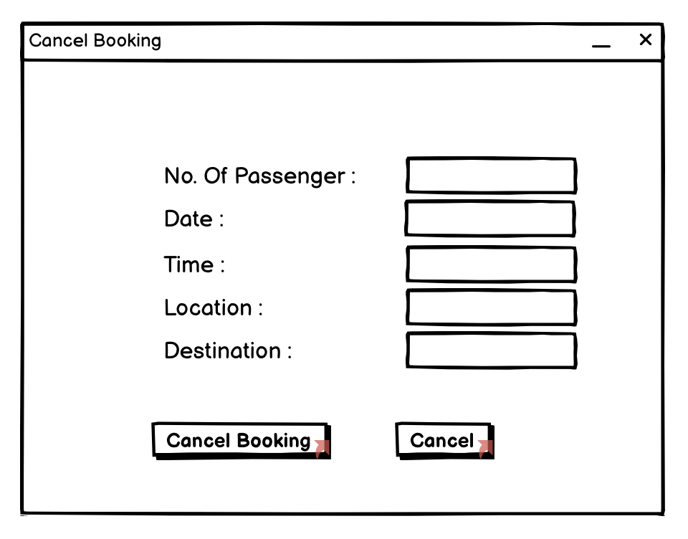

Fig.no.17 Cancel Trip of Prototype

This the trip cancellation page, where customer can cancel their trips.

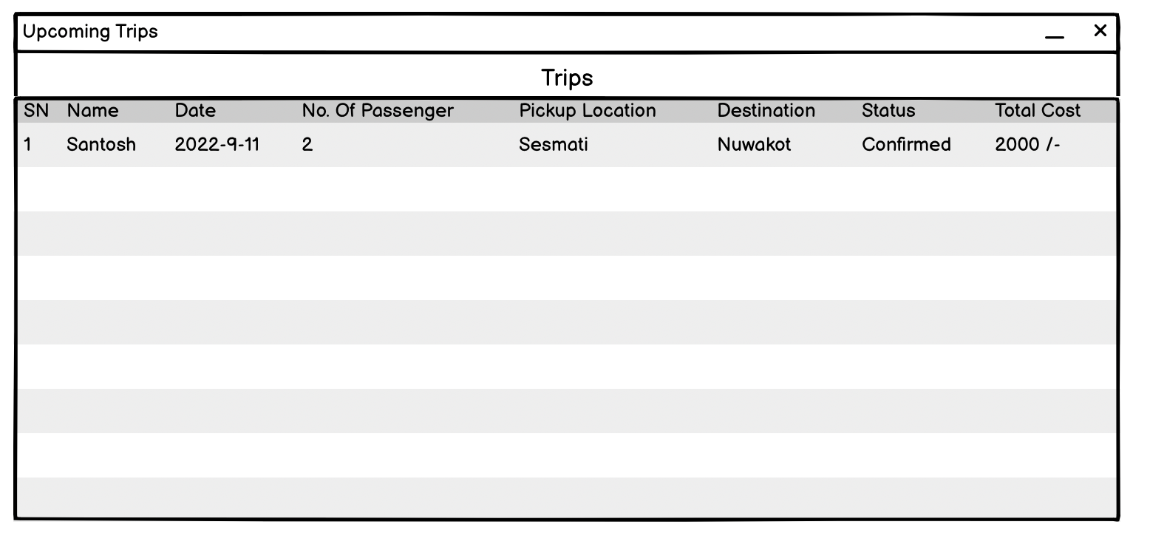

Fig.no.18 Driver Dashboard

This is the driver dashboard where they can see all their upcoming trips.

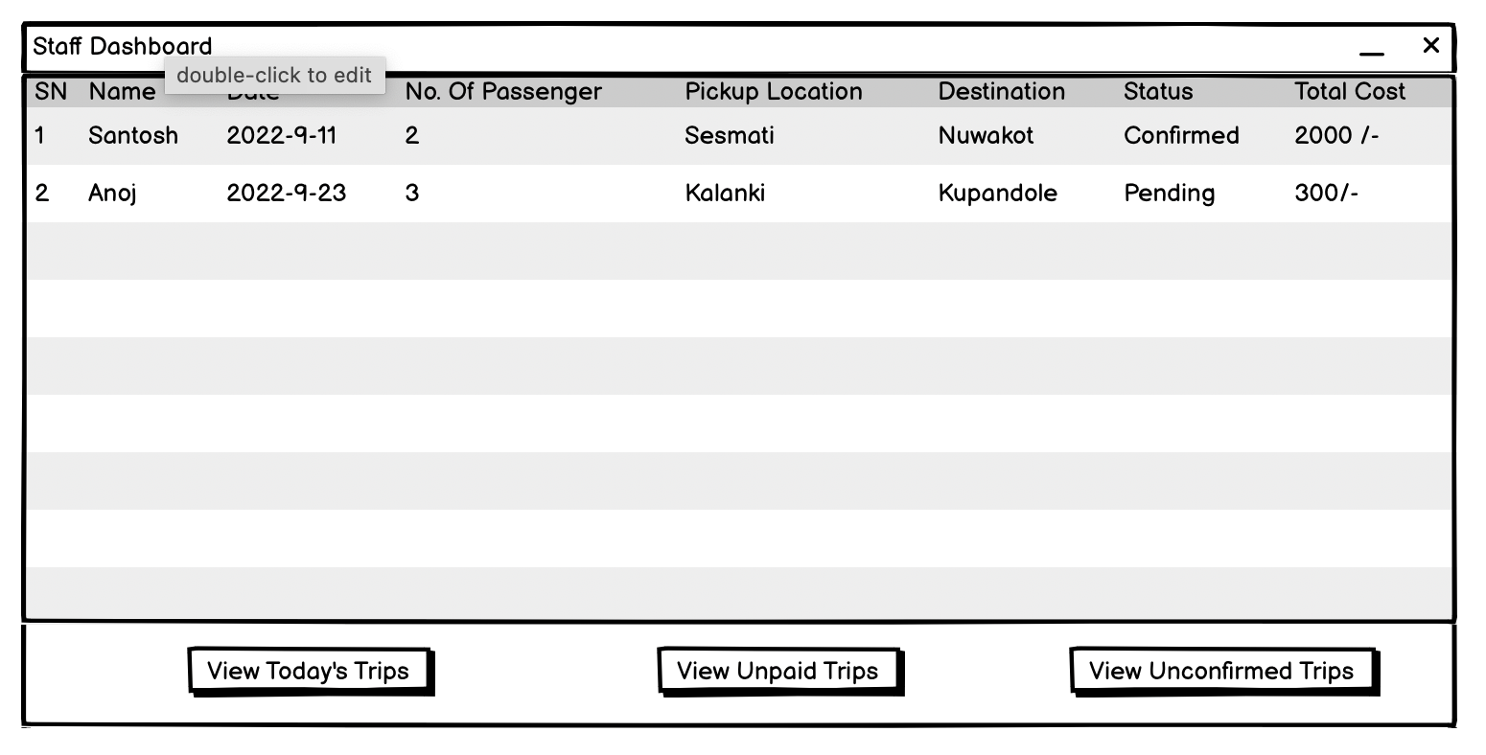

Fig.no.19. Staff Dashboard of Prototype

This is the staff dashboard where they can view all the trips and assign driver to the trips.

# Implementation

Client-Server architecture was created for the development of the application. This architecture was considered the best option for the solution, as all users cannot access all the data stored in the database.

For the programming of the user interface and back-end part Python language was used. The language was implemented using PyCharm Integrated Development Environment (IDE). Development of the solution was simple due to its user-friendly interface and the range of its modules. Balsamiq was used to develop the prototype of the solution.

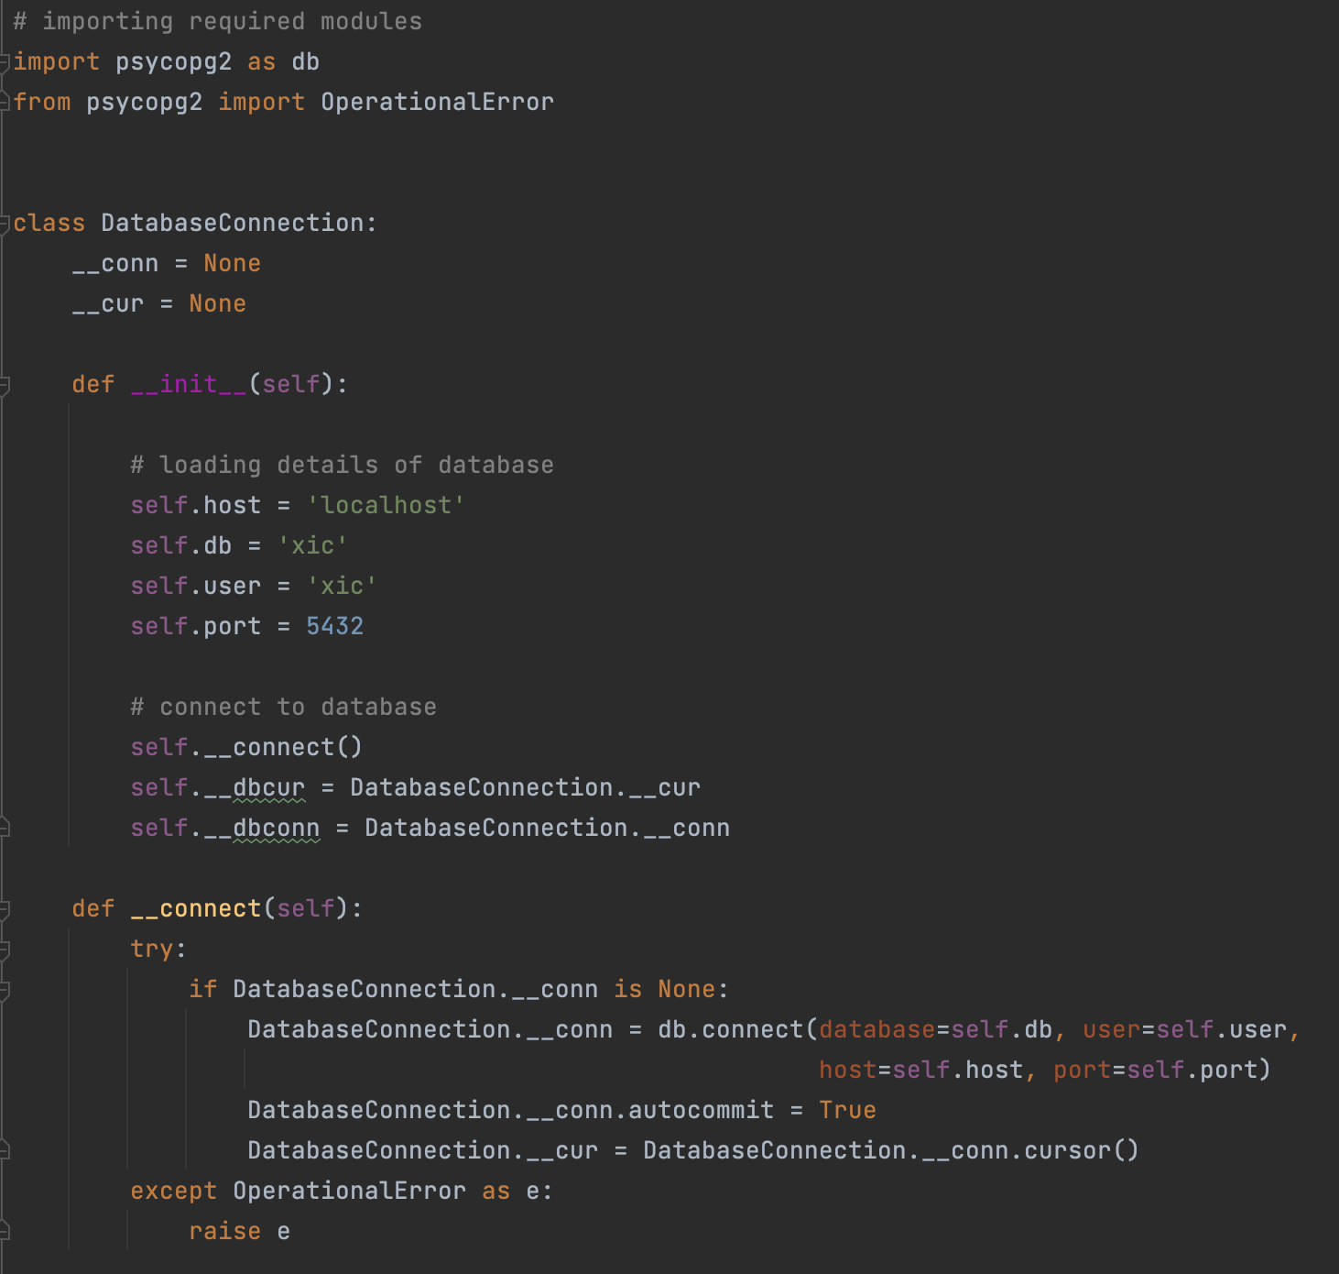

Fig.no.20 Database Connector

The psycopg2 module was used to connect the application to the PostgreSQL database.

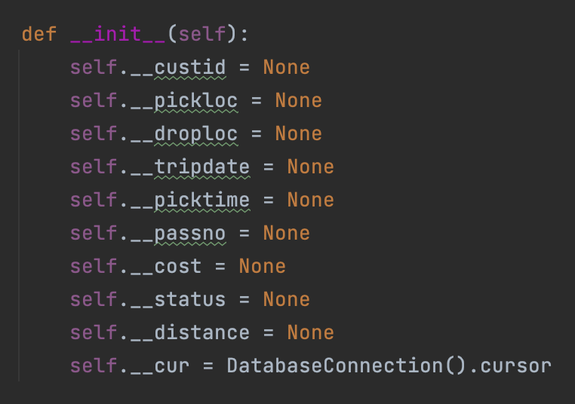

Fig.no.21.1 Encapsulation1

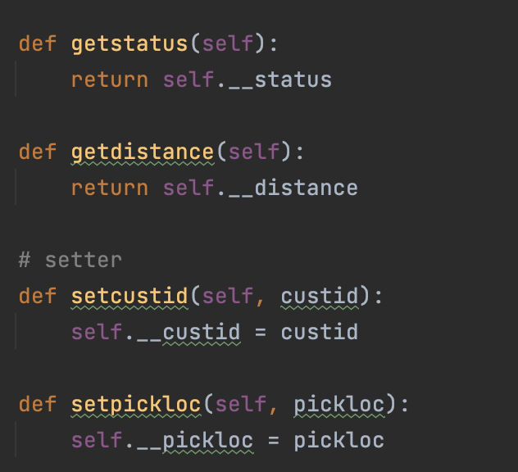

Fig.no.21.2 Encapulation2

The above two figures show the encapsulation of data. Similarly, encapsulation was used in various other places this is just an example.

At the start, Balsamiq Wireframe was used to design a desired prototype for the solution. Then the Tkinter module was used to create the desired GUI for the development of the desired solution for the assignment. For the final product various modules were used which made the GUI more attractive.

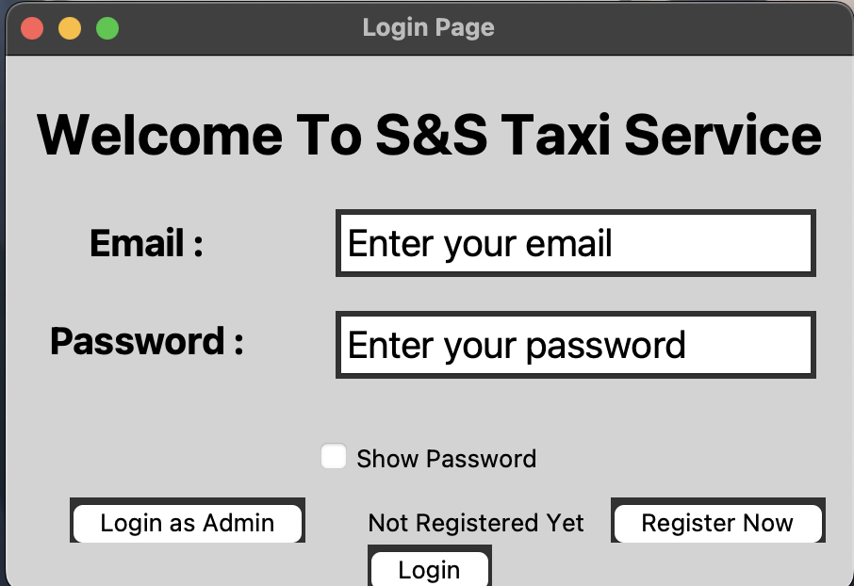

Fig.no.22 Login Page

The first page after opening the software.

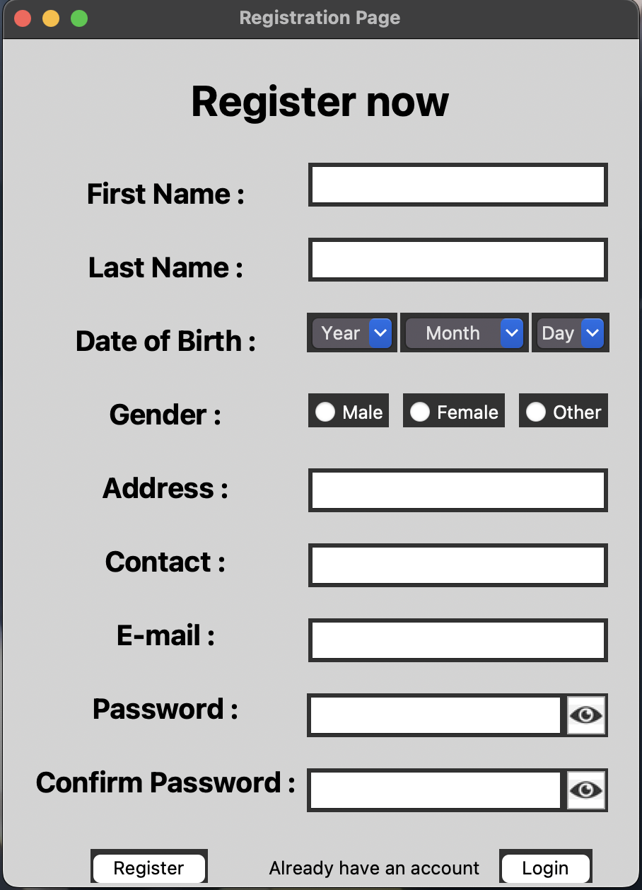

Fig.no.23 Registration Page for Customer

This is the registration page for the customer, as driver and staff are added by staff.

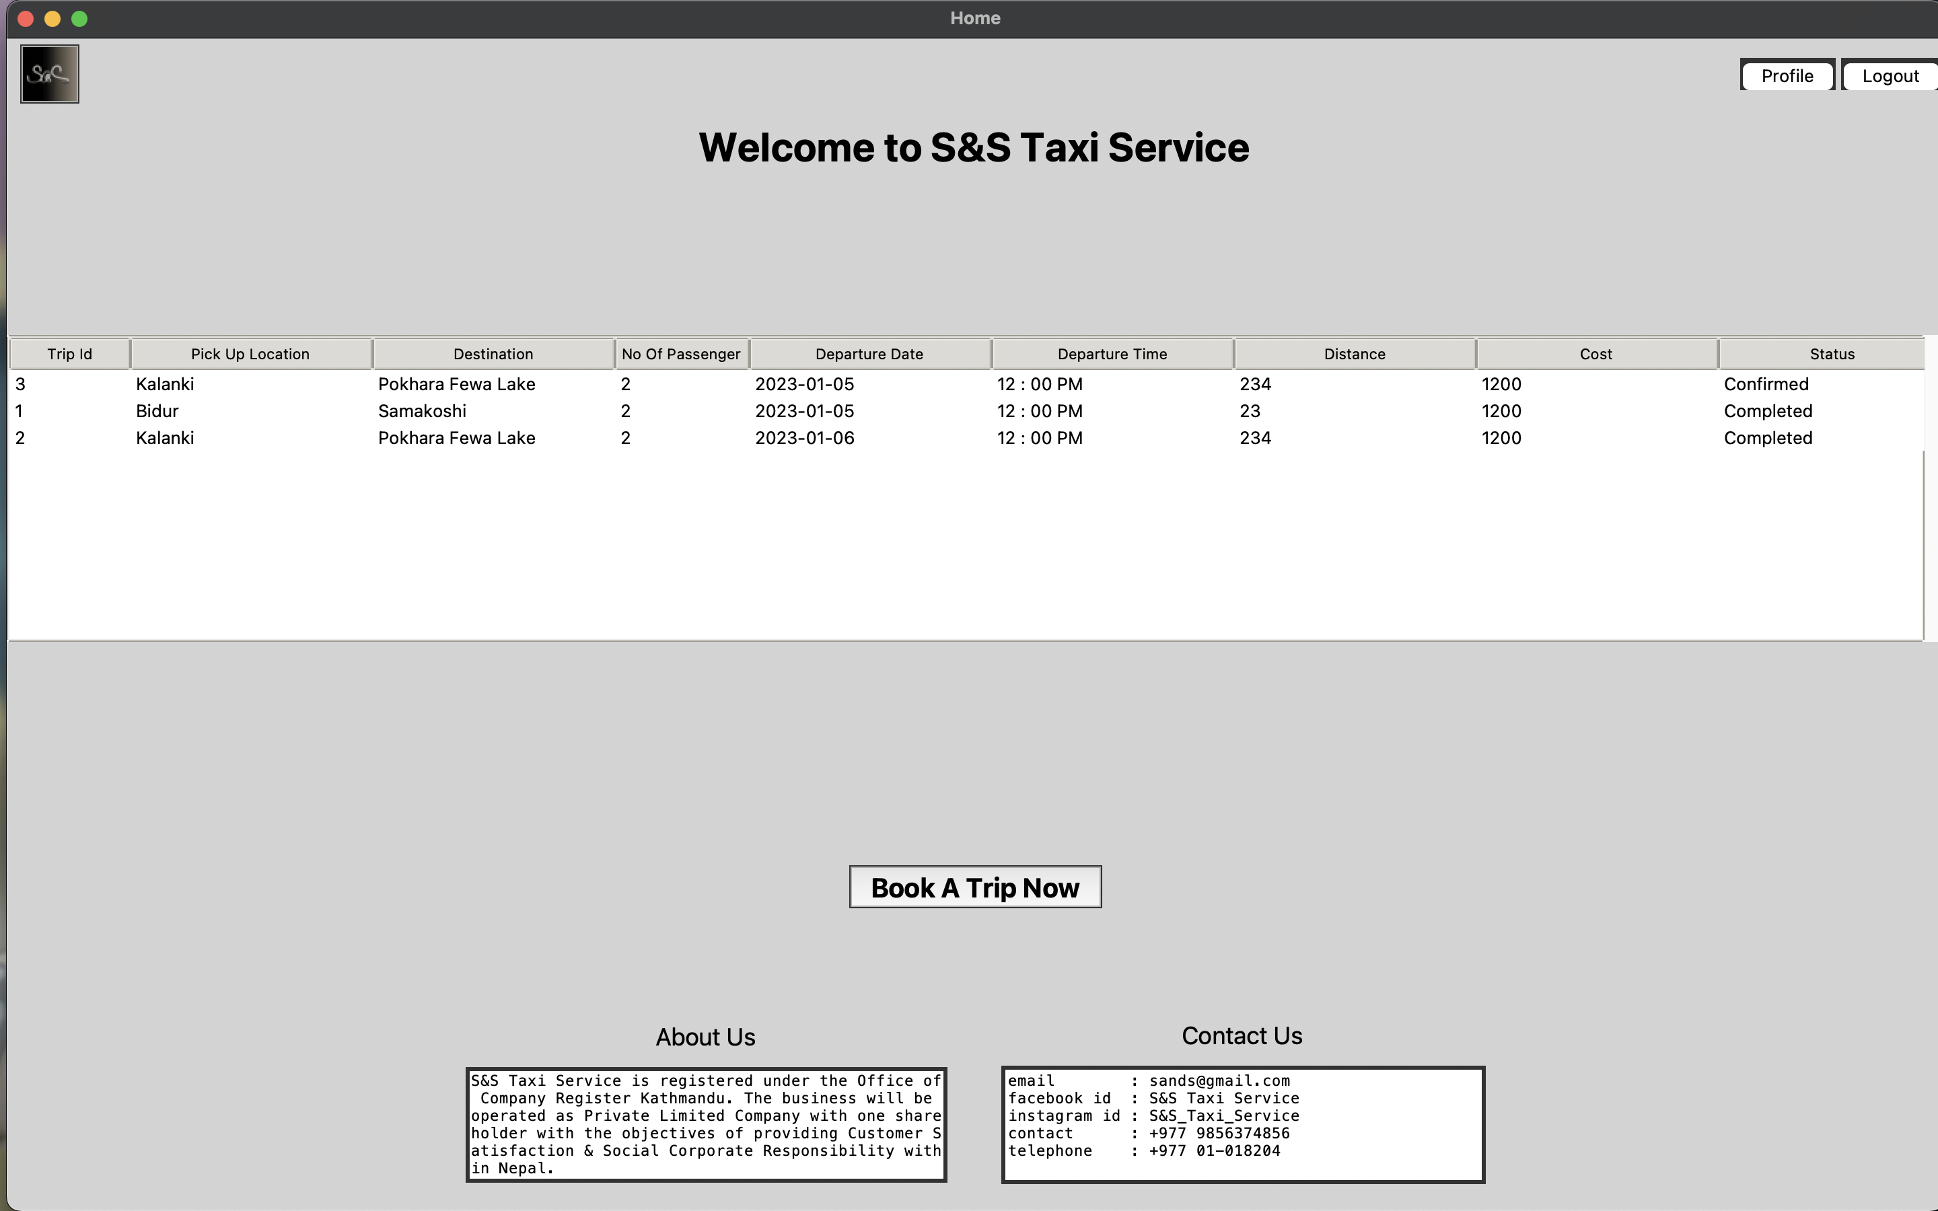

Fig.no.24 Dashboard of Customer

The page after logging in the application.

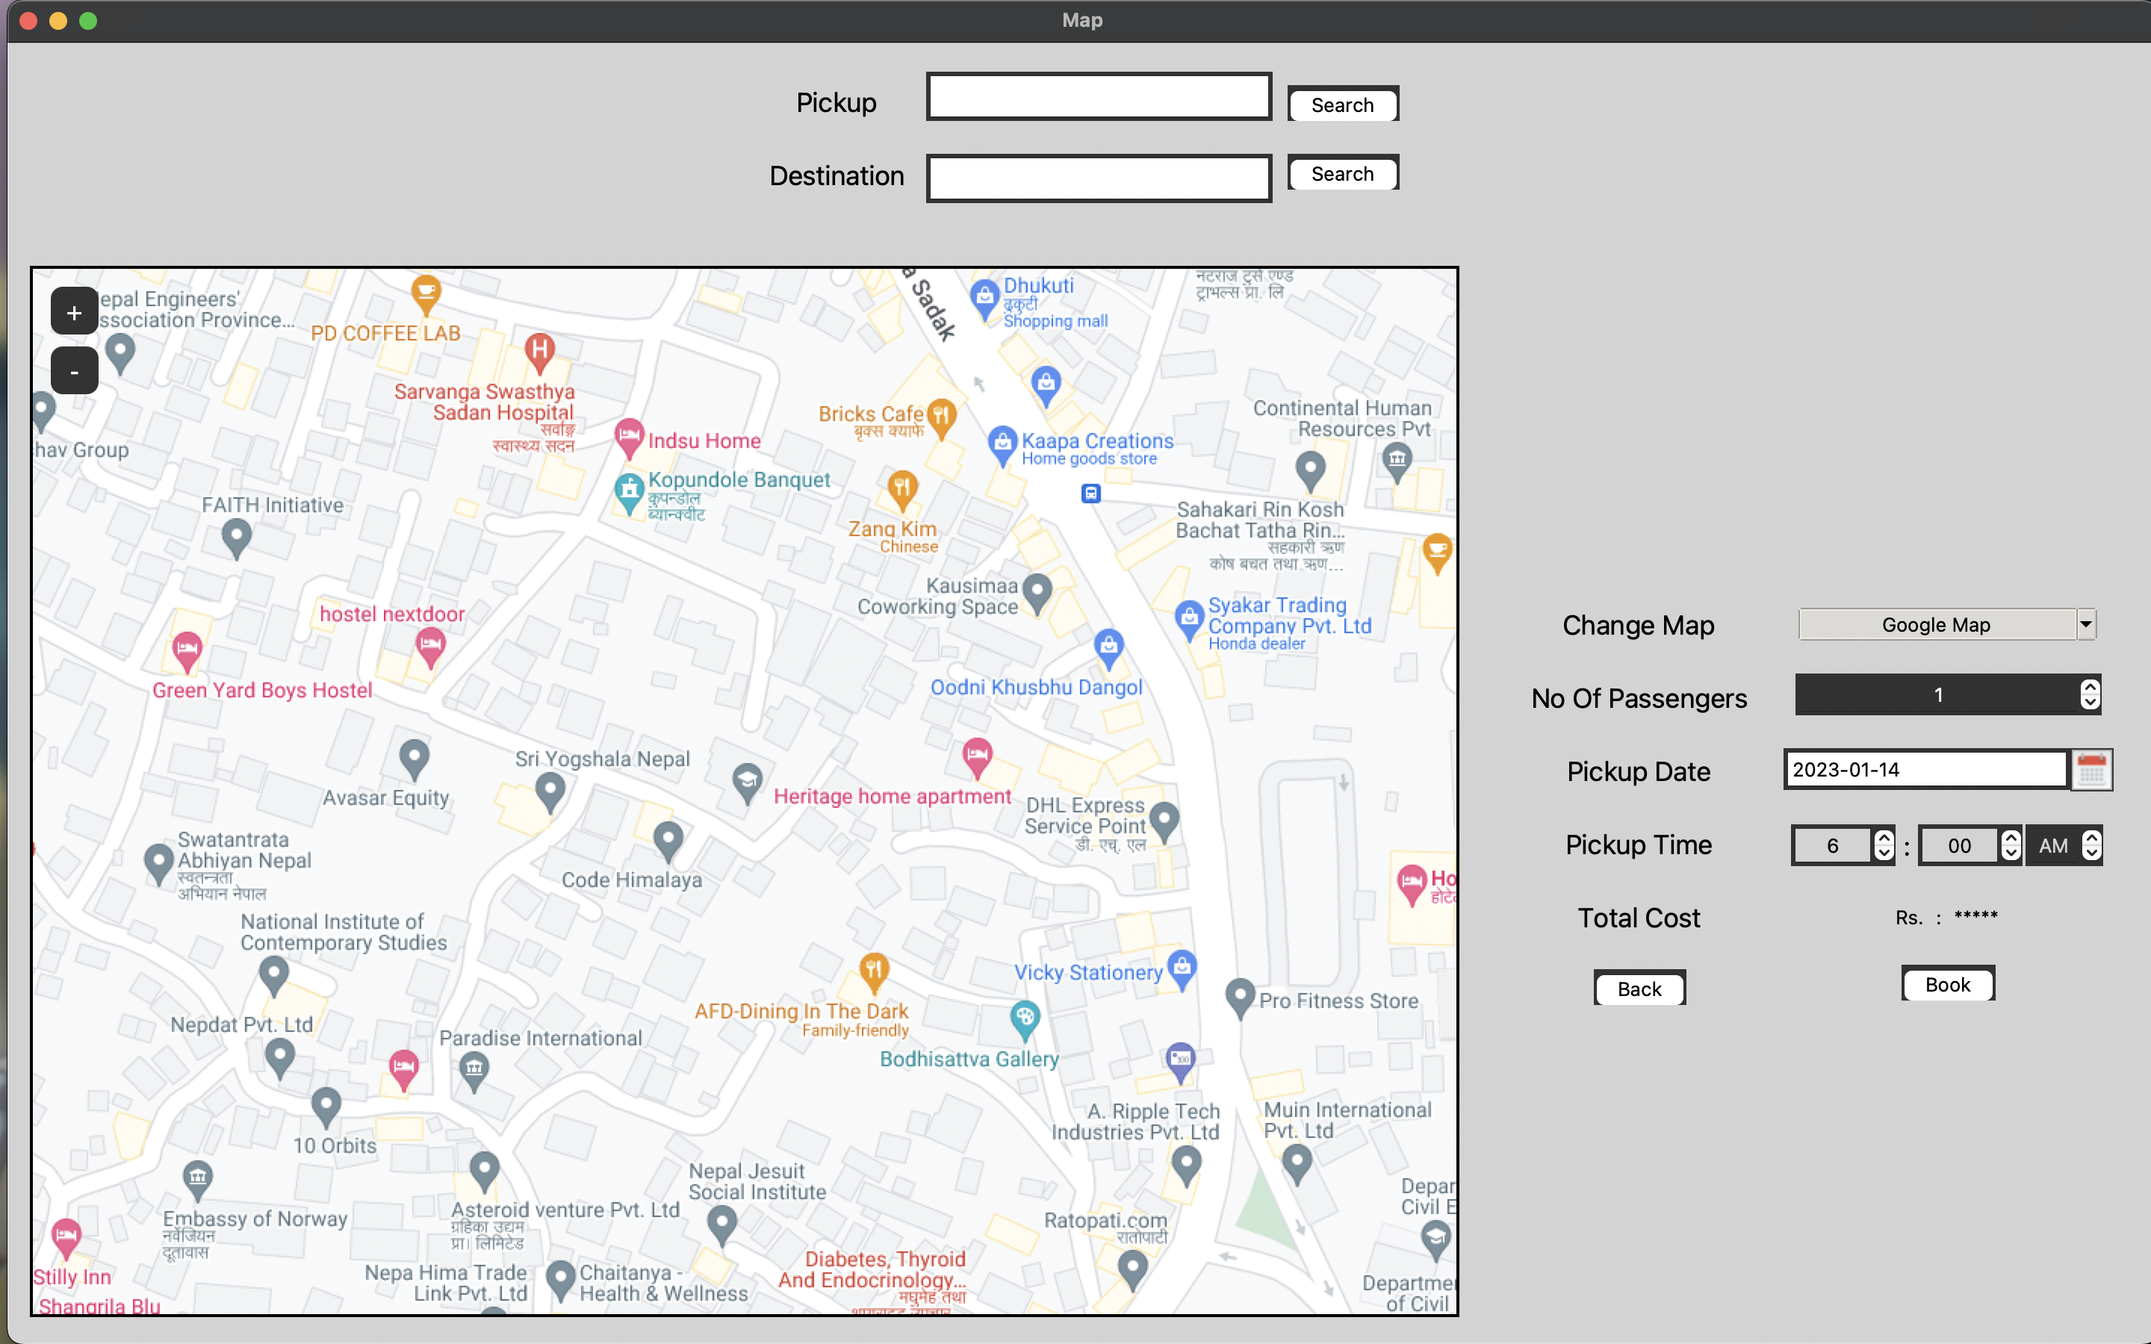

Fig.no.25 Booking Page

The page where customers can book as many trips as they like.

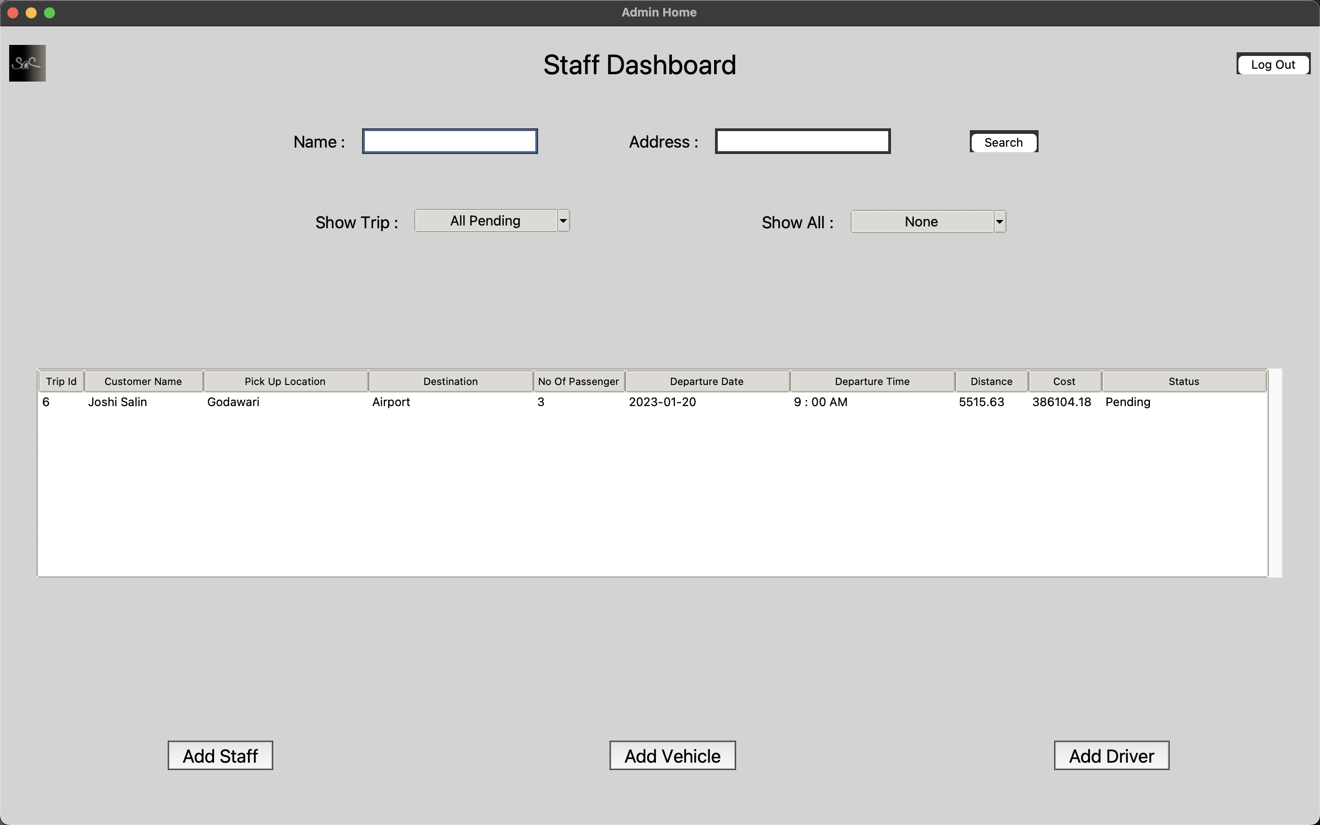

Fig.no.26 Staff Dashboard

This is the staff dashboard where staff adds driver, vehicle and staff and assigns driver to the booking.

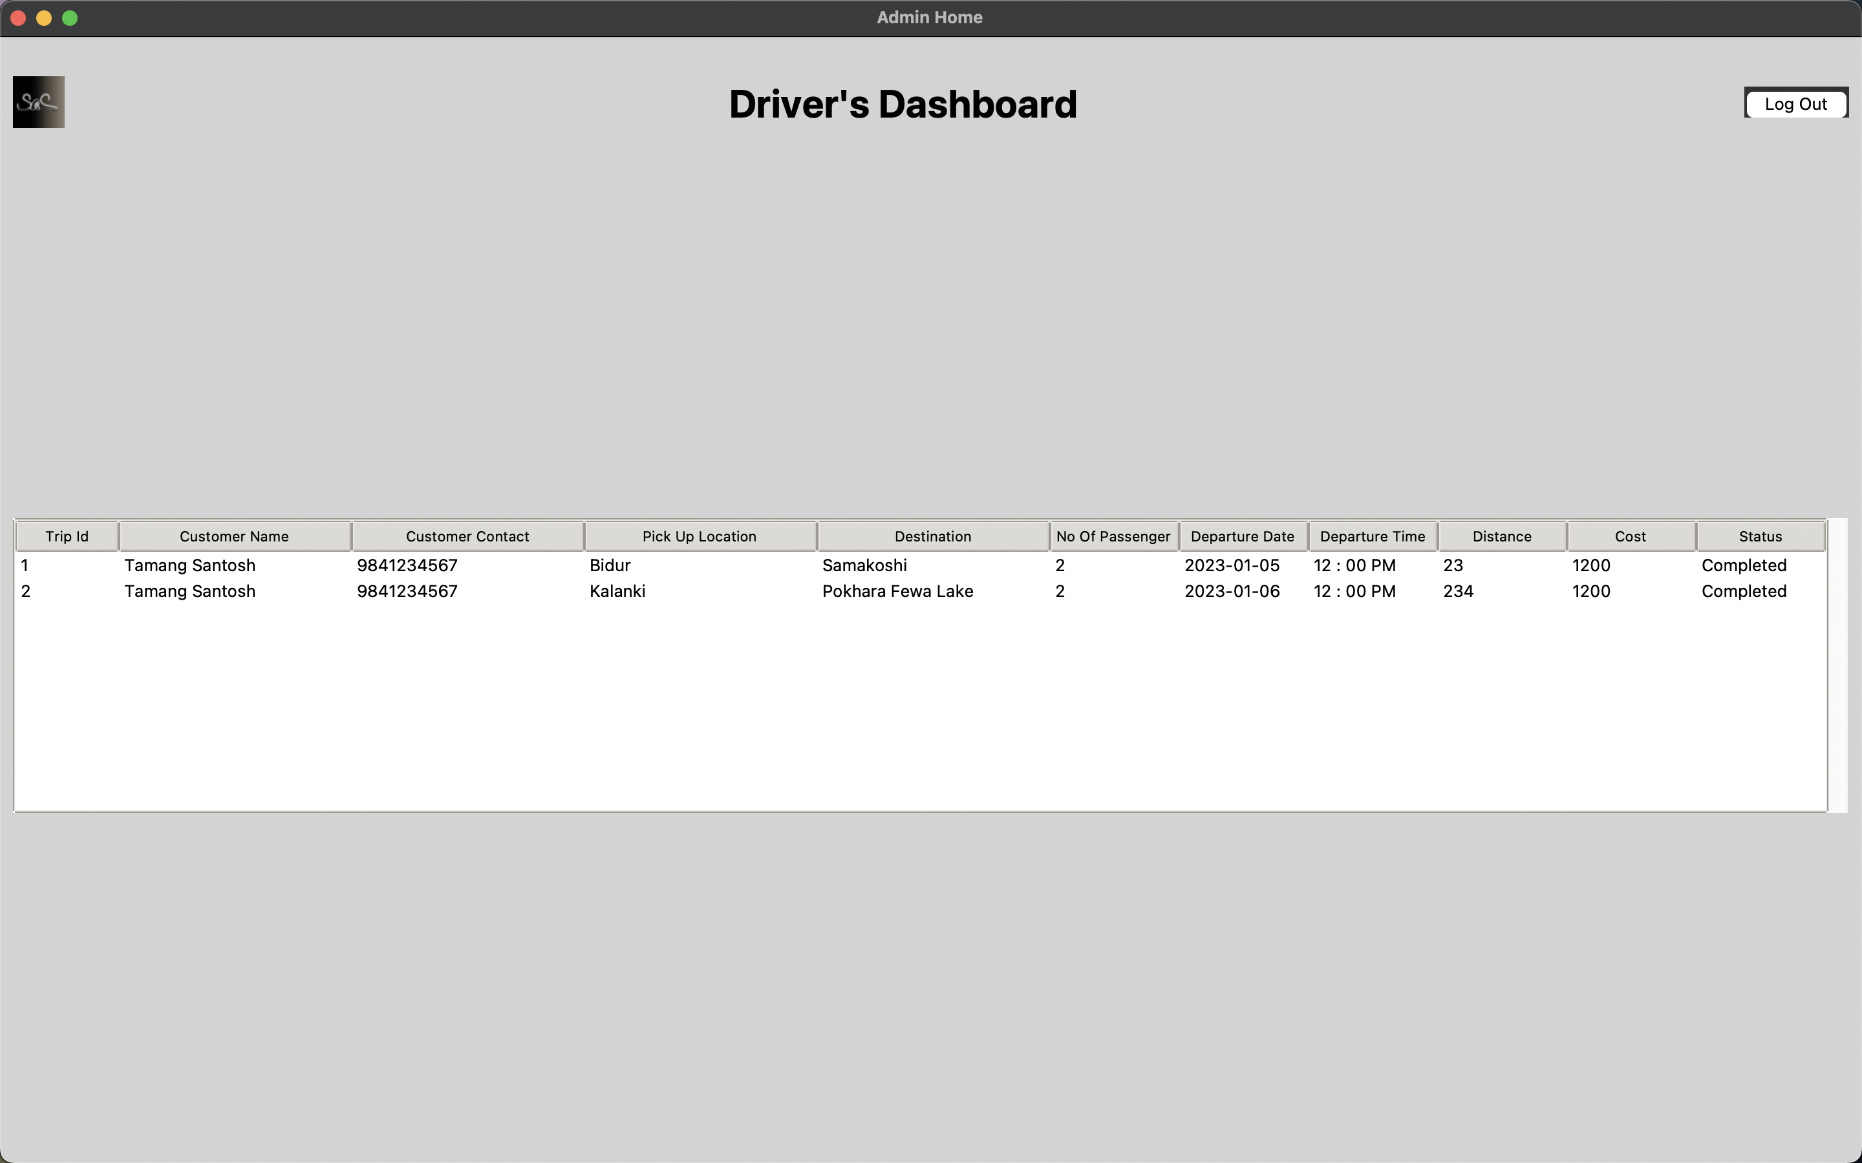

Fig.no.27 Driver Dashboard

This is page where the drivers can see their upcoming trips and start and end them.

# Testing

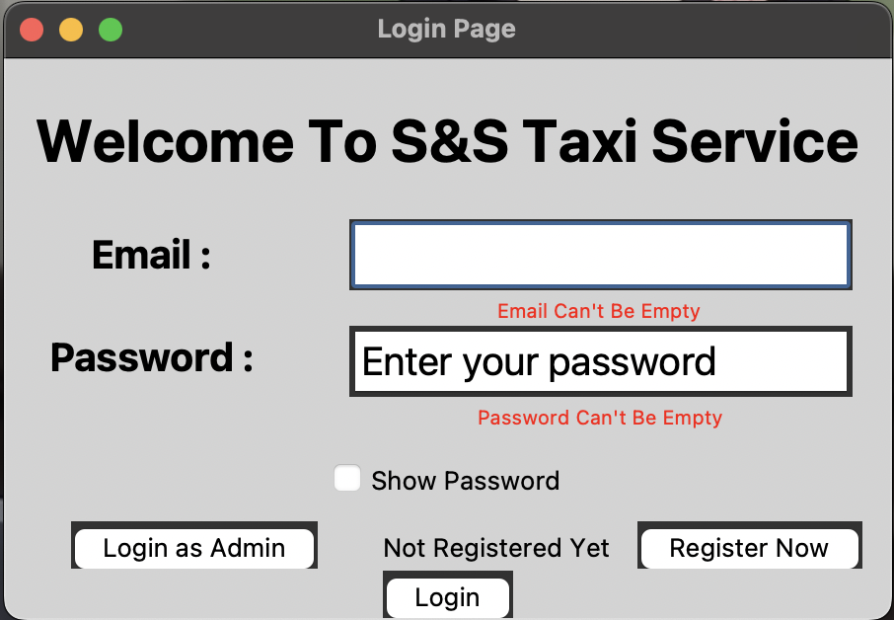

Fig.no.28 Logging with Empty Fields

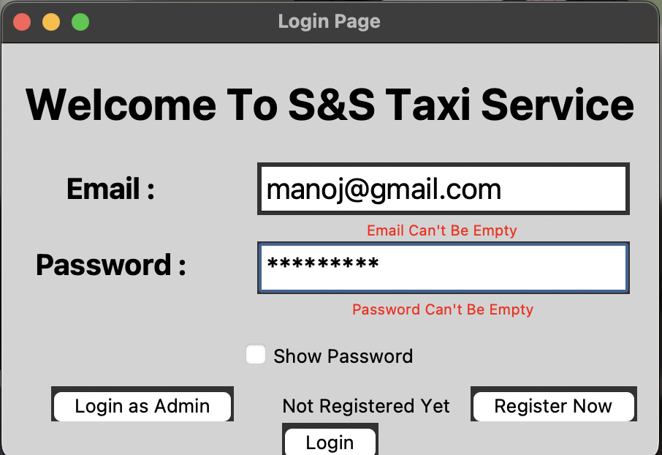

Fig.no.29 Logging with Incorrect Data

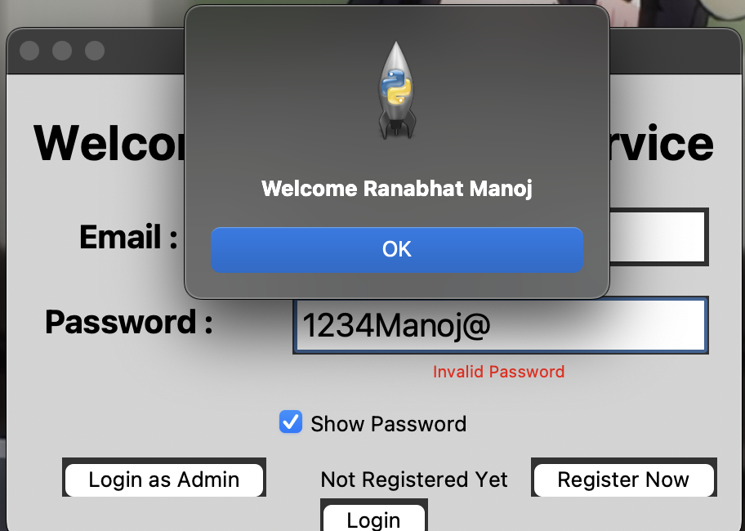

Fig.no.30 Logging with Correct Data

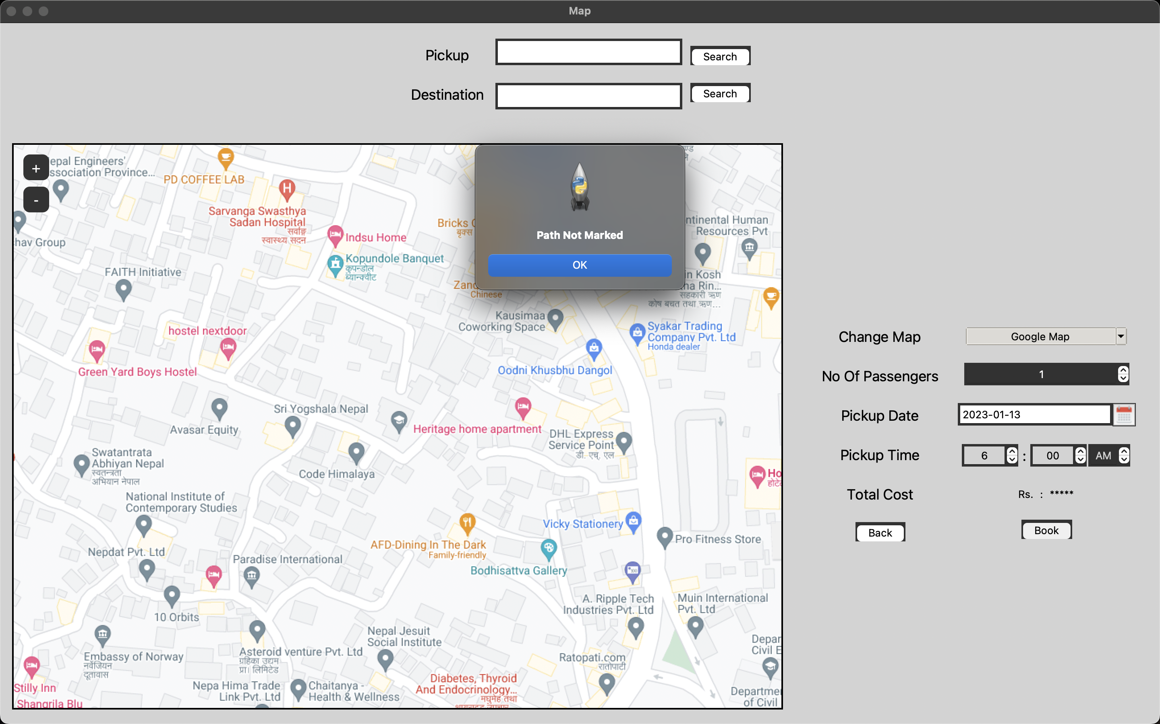

Fig.no.31 Booking Trip with Empty Field

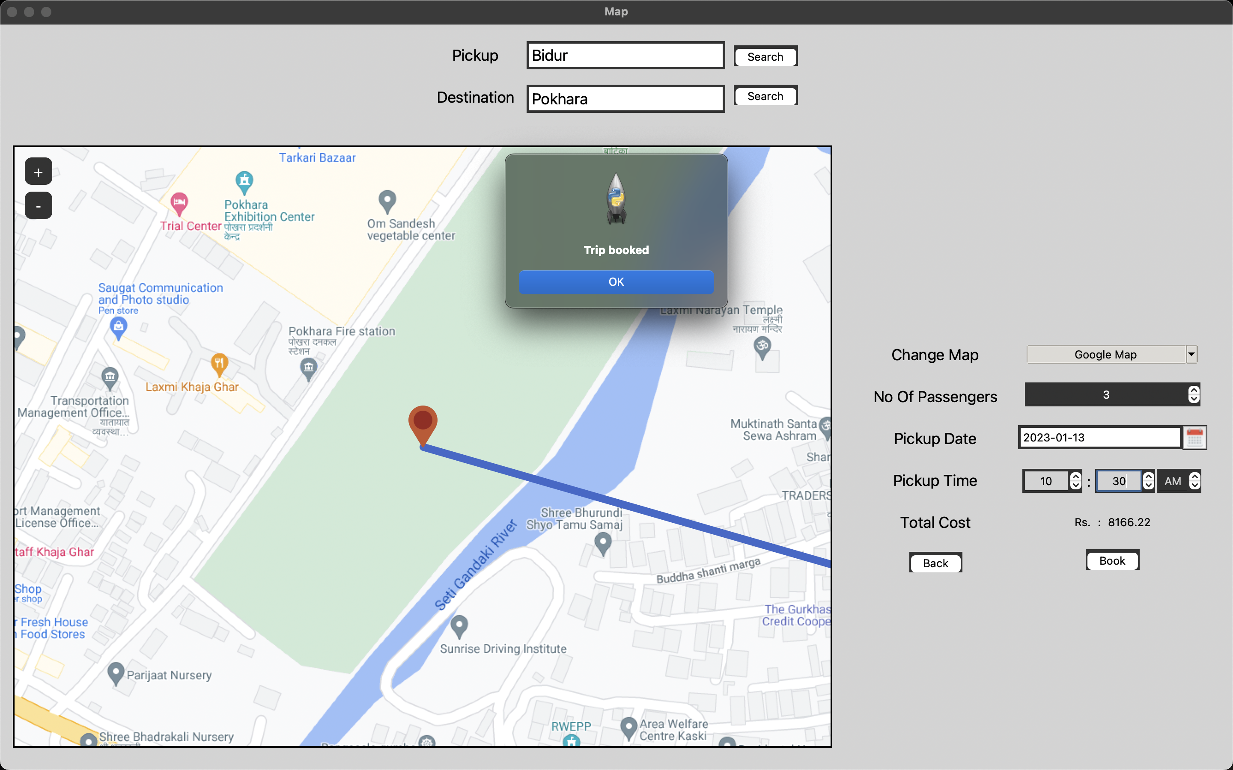

Fig.no.32 Booking with Correct Information

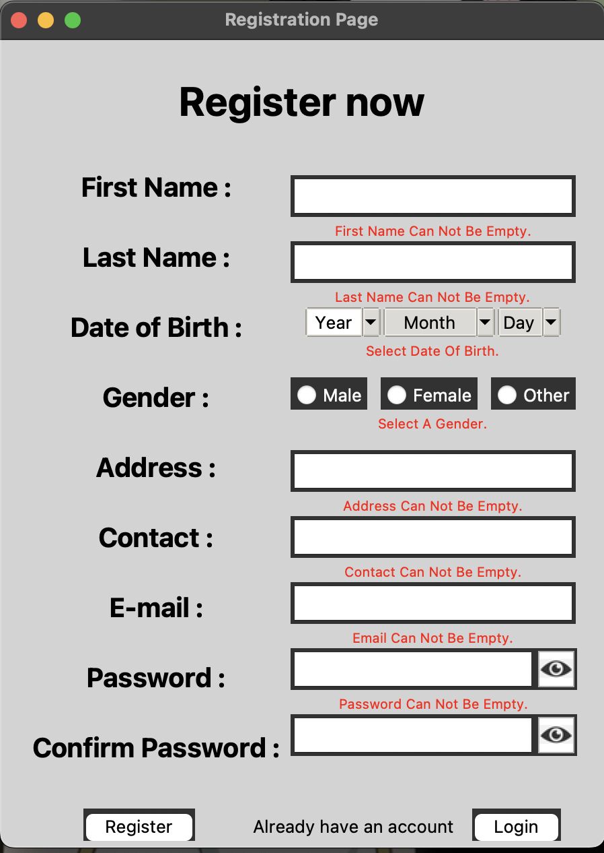

Fig.no.33 Registering with Empty Field

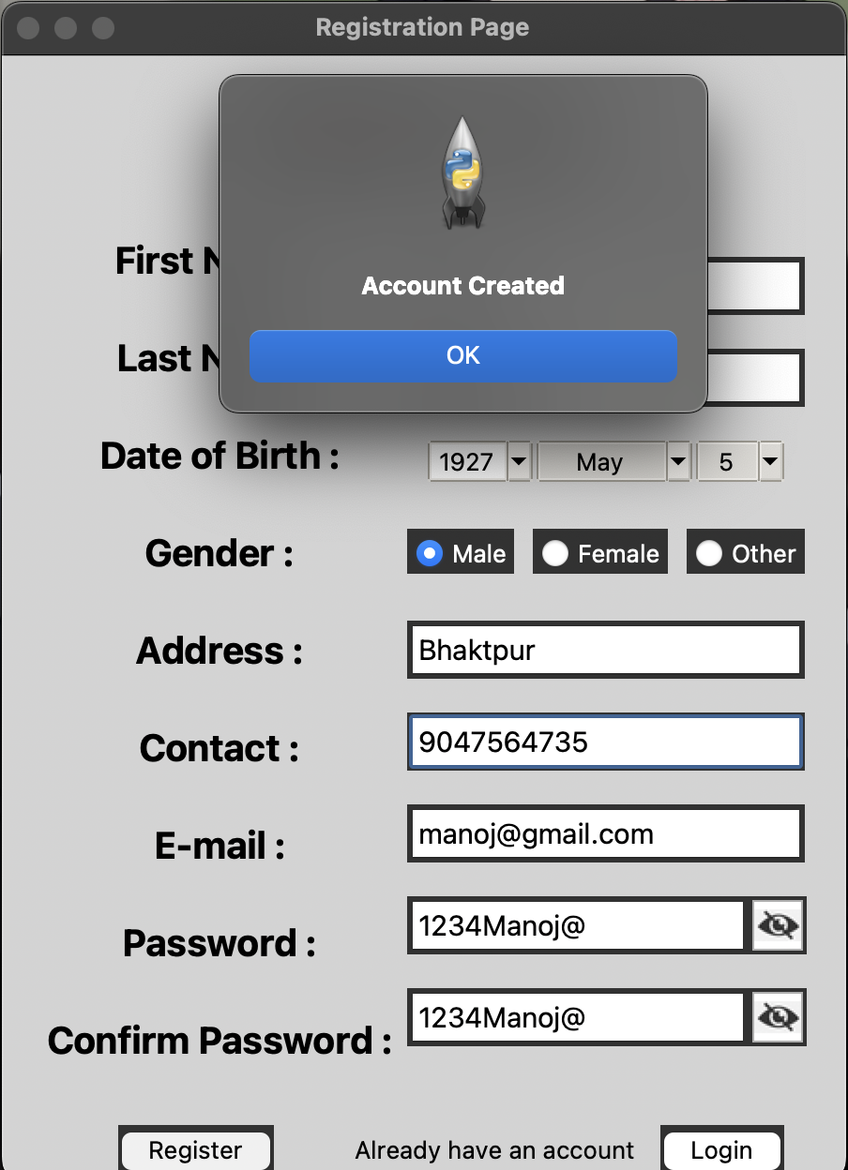

Fig.no.34 Registering with Correct Information

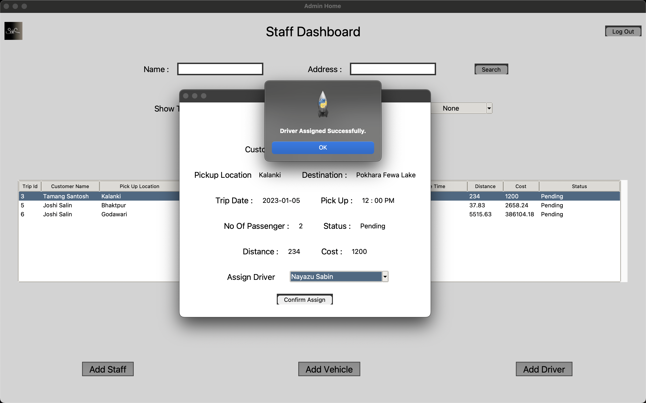

Fig.no.35 Assigning Driver

|  |  |  |  |  |
| --- | --- | --- | --- | --- |
| Test No. | Description | Expected Result | Obtained Result | Figure No. |
| 1 | Logging in with empty fields | Show error under entry field | Error shown under entry field | 28 |
| 2 | Logging in with incorrect data | Show error message | Error message shown | 29 |
| 3 | Logging in with correct data | Login successful | Login successful | 30 |
| 4 | Booking with empty location | Show error message | Error message shown | 31 |
| 5 | Booking with correct information | Booking successful | Booking successful | 32 |
| 6 | Registering with empty fields | Show error under entry field | Error shown under entry field | 33 |
| 7 | Registering with correct information | Register successful | Register successful | 34 |
| 8 | Assigning driver | Show message Driver assigned | Message shown driver assigned | 35 |

# Discussion / Reflection / Critical Analysis

For the assignment, the work was started at most 1 month prior to the submission date to provide more time till the due date to create a solution desired for the assignment. As the work started, I became confused about which architecture to follow. So, I consulted our lecturer, and he provided us with the demo model to follow and we were free to modify the model any way we want.

After getting the model, coding was not the hard part, debugging was. Importing various modules and using them to create a suitable GUI was easy, but many modules mean many debugging. To debug some code, I asked for help from friends, lecturers and even some websites.

Having completed the assignment on time feels so good. The assignment was completed prior to the due date, but the video was not recorded till the second last day.

# Works Cited

TechTarget Contributor, 2023. *Tech Target.* [Online]   
Available at: https://www.techtarget.com/whatis/definition/use-case-diagram  
[Accessed 20 December 2022].

Tutorialspoint, 2022. *Tutorialspoint.* [Online]   
Available at: https://www.tutorialspoint.com/uml/uml_activity_diagram.htm  
[Accessed 20 December 2022].

Tutorialspoint, 2011. *Tutorialspoint.* [Online]   
Available at: https://www.javatpoint.com/uml-class-diagram  
[Accessed 20 December 2022].

Visual Paradigm, 2022. *Visual Paradigm.* [Online]   
Available at: https://www.visual-paradigm.com/guide/data-modeling/what-is-entity-relationship-diagram/  
[Accessed 20 December 2022].

Varma, S., 2022. *Scaler Topics.* [Online]   
Available at: https://www.scaler.com/topics/data-dictionary-in-dbms/  
[Accessed 20 December 2022].

Tutorialspoint, 2022. *Tutorialspoint.* [Online]   
Available at: https://www.tutorialspoint.com/software_engineering/software_user_interface_design.htm  
[Accessed 20 December 2022].

Interaction Design Foundation, 2022. *Interaction Design Foundation.* [Online]   
Available at: https://www.interaction-design.org/literature/topics/ui-design  
[Accessed 20 December 2022].

# Appendix

"""

This is the main file that starts the program.

Everything starts from here.

"""

# importing required modules

from View.Basewindow import Basewindow

from Controller.Controller import Controller

# running the code from here

# START POINT

if __name__ == '__main__':

root = Basewindow()

log = Controller(root)

root.mainloop()

"""

Module View

This Is The Base Window Where All Frame Is Added

"""

# importing required modules

from tkinter import Tk

# creating basewindow class which creates a tk object

class Basewindow(Tk):

# inheriting the tk and creating tk

def __int__(self):

super.__init__()

"""

Module View

This Is A Frontend Which User Sees And Input Data

"""

# importing required modules

import re

from tkinter import *

from tkinter import ttk

from tkinter.ttk import Combobox

from geopy.distance import geodesic

from datetime import date, timedelta

from Model.TripModel import TripModel

from tkcalendar.dateentry import Calendar

from Model.CustomerModel import CustomerModel

from tkinter.messagebox import askyesno, showinfo, showerror

from tkintermapview import TkinterMapView, convert_coordinates_to_address, convert_address_to_coordinates

# creating custdashboard

class CustDashboard(ttk.Frame):

def __init__(self, window, controller, custid):

self.__tripmod = TripModel()

self.__custmod = CustomerModel()

self.__custid = custid

self.__window = window

self.__window.deiconify()

self.__controller = controller

super().__init__(self.__window)

self.__window.geometry('1920x1080')

self.__window.title("Home")

self.triptable = None

self.__nmregex = ("[A-Z][a-z]{2,15}") # firstname, lastname regex

self.__conregx = ("[9]{1}[\d]{9}") # contact regex

mainf = Frame(self.__window, bg="Light Grey")

mainf.pack(fill="both", expand=True)

top = Frame(mainf, bg="Light Grey")

top.pack(fill="x", pady=5)

title = Frame(mainf, bg="Light Grey")

title.pack(side="top", pady=5)

titlelb = Label(title, text="Welcome to S&S Taxi Service", bg="Light Grey", fg="Black", font=("", 30, "bold"))

titlelb.pack(anchor="center")

self.logo = PhotoImage(file='Resource/logo.png')

self.show = Button(top, image=self.logo, bd=0, command=self.call)

self.show.pack(side='left', padx=10)

logout = Button(top, text="Logout", bg="light Grey", fg="Black", bd=0, command=self.confirm)

logout.pack(side="right", padx=2)

profile = Button(top, text="Profile", bg="light Grey", fg="Black", bd=0, command=self.callprofile)

profile.pack(side="right", padx=2)

self.table = Frame(mainf, bg='Light Grey')

self.table.pack(expand=True, pady=40)

style = ttk.Style(self.table)

# set ttk theme to "clam" which support the field background option

style.theme_use("clam")

style.configure("Treeview", background="White", foreground="Black")

self.scrollbar = Scrollbar(self.table)

self.scrollbar.pack(side='right', fill='y')

self.owntriptable()

main = Frame(mainf, bg="Light Grey")

main.pack(pady=50)

makeb = Frame(main, bg="Light Grey")

makeb.pack(anchor='center')

make = Button(makeb, text="Book A Trip Now", bg="light Grey", fg="Black", bd=0, font=("", 20, "bold"),

command=self.call)

make.pack()

bottomf = Frame(mainf, bg='Light Grey')

bottomf.pack(side='bottom', pady=20)

aboutus = Frame(bottomf, bg='Light Grey')

aboutus.pack(side='left', padx=20)

aboutlb = Label(aboutus, text='About Us', bg='Light Grey', fg='Black', font=('', 18))

aboutlb.pack(anchor='center', pady=10)

aboucon = Text(aboutus, width=50, height=6, bg='White', fg='Black', bd=0)

aboucon.pack(anchor='center')

aboucon.insert(1.0, "S&S Taxi Service is registered under the Office of Company Register Kathmandu. The "

"business will be operated as Private Limited Company with one shareholder with the "

"objectives of providing Customer Satisfaction & Social Corporate Responsibility "

"within Nepal.")

aboucon.config(state='disabled')

contactus = Frame(bottomf, bg='Light Grey')

contactus.pack(side='right', padx=20)

contactlb = Label(contactus, text='Contact Us', bg='Light Grey', fg='Black', font=('', 18))

contactlb.pack(anchor='center', pady=10)

concon = Text(contactus, width=50, height=6, bg='White', fg='Black', bd=1)

concon.pack(anchor='center')

concon.insert(1.0, "email : sands@gmail.com "

"facebook id : S&S Taxi Service "

"instagram id : S&S_Taxi_Service "

"contact : +977 9856374856 "

"telephone : +977 01-018204")

concon.config(state='disabled')

# calling profile top level

def callprofile(self):

top = Toplevel()

top.geometry('550x500+450+250')

top.title("Profile")

# always top

top.transient(self.__window)

top.grab_set()

self.profile(top)

# calling booking page

def call(self):

self.__controller.book(self.__custid)

# creating table and adding

def owntriptable(self):

self.triptable = ttk.Treeview(self.table, yscrollcommand=self.scrollbar.set, selectmode="extended")

self.triptable.pack()

self.scrollbar.config(command=self.triptable.yview)

# defining columns

self.triptable["columns"] = ("Trip ID", "Pick Up Location", "Destination", "No Of Passenger", "Departure Date",

"Departure Time", "Distance", "Cost", "Status")

# formatting columns

self.triptable.column("#0", width=0, stretch=NO)

self.triptable.column("Trip ID", width=80, minwidth=90, anchor=W)

self.triptable.column("Pick Up Location", width=180, minwidth=90, anchor=W)

self.triptable.column("Destination", width=180, minwidth=90, anchor=W)

self.triptable.column("No Of Passenger", width=100, minwidth=90, anchor=W)

self.triptable.column("Departure Date", width=180, minwidth=90, anchor=W)

self.triptable.column("Departure Time", width=180, minwidth=90, anchor=W)

self.triptable.column("Distance", width=180, minwidth=90, anchor=W)

self.triptable.column("Cost", width=180, minwidth=90, anchor=W)

self.triptable.column("Status", width=180, minwidth=90, anchor=W)

# creating heading

self.triptable.heading("#0", text='Label')

self.triptable.heading("Trip ID", text="Trip Id")

self.triptable.heading("Pick Up Location", text="Pick Up Location")

self.triptable.heading("Destination", text="Destination")

self.triptable.heading("No Of Passenger", text="No Of Passenger")

self.triptable.heading("Departure Date", text="Departure Date")

self.triptable.heading("Departure Time", text="Departure Time")

self.triptable.heading("Distance", text="Distance")

self.triptable.heading("Cost", text="Cost")

self.triptable.heading("Status", text="Status")

# reading data from table

record = self.__tripmod.custrip(self.__custid)

if record:

# inserting data into table

for data in record:

self.triptable.insert("", index="end",

values=(data[0], data[2], data[3], data[6], data[4], data[5], data[7], data[8]

, data[9]))

self.triptable.bind('<Double-1>', self.data)

# confirm logging out

def confirm(self):

ans = askyesno("Conformation", "Are You Sure You Want To Log Out?")

if ans:

self.__controller.log()

# creating top level for specific trip

def data(self, event):

tripd = None

try:

record = None

if self.triptable.selection()[0]:

for data in self.triptable.selection():

value = self.triptable.item(data)

tripd = value['values']

tp = Toplevel()

# always top

tp.transient(self.__window)

tp.grab_set()

if tripd[8] == 'Pending' or tripd[8] == 'Cancelled':

record = self.__tripmod.tripdetail(tripd[0])

else:

record = self.__tripmod.tripdetails(tripd[0])

self.details(tp, record)

except Exception as e:

showinfo("Message", "Select A Data")

print(e)

def details(self, top, record):

for data in record:

top = top

top.geometry('500x380+450+235')

top.title('Trip Details')

mainf = Frame(top, bg='White')

mainf.pack(fill='both', expand=True)

titlef = Frame(mainf, bg='White')

titlef.pack(pady=10)

title = Label(titlef, text='Trip Detail', bg='White', fg='Black', font=('EB Garamond', 25, 'bold'))

title.pack(anchor='center')

locationf = Frame(mainf, bg='White')

locationf.pack(pady=10)

picklocation = Frame(locationf, bg='White')

picklocation.pack(side='left', padx=10)

pickloc = Label(picklocation, text='Pickup : ', bg='White', fg='Black', font=('Crimson Text', 18))

pickloc.pack(side='left', padx=10)

picklocdata = Label(picklocation, text=data[2], bg='White', fg='Black', font=('Crimson Text', 16))

picklocdata.pack(side='left')

droplocation = Frame(locationf, bg='White')

droplocation.pack(side='right', padx=10)

droploc = Label(droplocation, text='Destination : ', bg='White', fg='Black', font=('Crimson Text', 18))

droploc.pack(side='left')

droplocdata = Label(droplocation, text=data[3], bg='White', fg='Black', font=('Crimson Text', 16))

droplocdata.pack(side='left', padx=10)

datime = Frame(mainf, bg='White')

datime.pack(pady=10)

datef = Frame(datime, bg='White')

datef.pack(side='left', padx=10)

datelb = Label(datef, text='Date : ', bg='White', fg='Black', font=('Crimson Text', 18))

datelb.pack(side='left', padx=10)

datedata = Label(datef, text=data[4], bg='White', fg='Black', font=('Crimson Text', 16))

datedata.pack(side='left')

timef = Frame(datime, bg='White', padx=10)

timef.pack(side='right')

timelb = Label(timef, text='Time : ', bg='White', fg='Black', font=('Crimson Text', 18))

timelb.pack(side='left')

timedata = Label(timef, text=data[5], bg='White', fg='Black', font=('Crimson Text', 16))

timedata.pack(side='left', padx=10)

statupass = Frame(mainf, bg='White')

statupass.pack(pady=10)

passengerf = Frame(statupass, bg='White')

passengerf.pack(side='left', padx=10)

passengerlb = Label(passengerf, text='Passenger : ', bg='White', fg='Black', font=('Crimson Text', 18))

passengerlb.pack(side='left', padx=10)

passegerdata = Label(passengerf, text=data[6], bg='White', fg='Black', font=('Crimson Text', 16))

passegerdata.pack(side='left')

statusf = Frame(statupass, bg='White')

statusf.pack(side='right', padx=10)

statuslb = Label(statusf, text='Status : ', bg='White', fg='Black', font=('Crimson Text', 18))

statuslb.pack(side='left')

statusdata = Label(statusf, text=data[9], bg='White', fg='Black', font=('Crimson Text', 16))

statusdata.pack(side='left', padx=10)

distcost = Frame(mainf, bg='White')

distcost.pack(pady=10)

distf = Frame(distcost, bg='White')

distf.pack(side='left', padx=10)

distlb = Label(distf, text="Distance : ", bg='White', fg='Black', font=('Crimson Text', 18))

distlb.pack(side='left', padx=10)

distdata = Label(distf, text=data[7], bg='White', fg='Black', font=('Crimson Text', 16))

distdata.pack(side='left')

costf = Frame(distcost, bg='White')

costf.pack(side='right', padx=10)

costlb = Label(costf, text="Cost : ", bg='White', fg='Black', font=('Crimson Text', 18))

costlb.pack(side='left')

costdata = Label(costf, text=data[8], bg='White', fg='Black', font=('Crimson Text', 16))

costdata.pack(side='left', padx=10)

driverf = Frame(mainf, bg='White')

driverf.pack(pady=10)

drivernamef = Frame(driverf, bg='White')

drivernamef.pack(side='left', padx=10)

drivernamelb = Label(drivernamef, text='Driver Name : ', bg='White', fg='Black', font=('Crimson Text', 18))

drivernamelb.pack(side='left', padx=10)

drivernamedata = Label(drivernamef, text='Pending', bg='White', fg='Black', font=('Crimson Text', 16))

drivernamedata.pack(side='left')

driverconf = Frame(driverf, bg='White')

driverconf.pack(side='right', padx=10)

driverconlb = Label(driverconf, text="Driver Contact : ", bg='White', fg='Black', font=('Crimson Text', 18))

driverconlb.pack(side='left')

drivercondata = Label(driverconf, text='Pending', bg='White', fg='Black', font=('Crimson Text', 16))

drivercondata.pack(side='left', padx=10)

vehiclef = Frame(mainf, bg='White')

vehiclef.pack(pady=10)

vehiclenamef = Frame(vehiclef, bg='White')

vehiclenamef.pack(side='left', padx=10)

vehiclenamelb = Label(vehiclenamef, text='Vehicle Type : ', bg='White', fg='Black', font=('Crimson Text', 18))

vehiclenamelb.pack(side='left', padx=20)

vehiclenamedata = Label(vehiclenamef, text='Pending', bg='White', fg='Black', font=('Crimson Text', 16))

vehiclenamedata.pack(side='left')

vehiclenof = Frame(vehiclef, bg='White')

vehiclenof.pack(side='right')

vehiclenolb = Label(vehiclenof, text='Vehicle No : ', bg='White', fg='Black', font=('Crimson Text', 18))

vehiclenolb.pack(side='left')

vehiclenodata = Label(vehiclenof, text='Pending', bg='White', fg='Black', font=('Crimson Text', 16))

vehiclenodata.pack(side='left', padx=10)

if not data[9] == 'Pending' and not data[9] == 'Cancelled':

dname = data[17] + " " + data[16]

vname = data[28] + " " + data[29]

drivernamedata.config(text=dname)

drivercondata.config(text=data[21])

vehiclenamedata.config(text=vname)

vehiclenodata.config(text=data[27])

else:

drivernamedata.config(text='Pending')

drivercondata.config(text='Pending')

vehiclenamedata.config(text='Pending')

vehiclenodata.config(text='Pending')

btn = Frame(mainf, bg='White')

btn.pack(expand=True, pady=10)

cancelf = Frame(btn, bg='White')

cancelf.pack(side='left', padx=10)

cancel = Button(cancelf, text='Cancel Trip', bg='Light Grey', fg='Black', bd=0

, command=lambda: canceltrip(top))

cancel.pack(anchor='center')

deletef = Frame(btn, bg='White')

deletef.pack(side='right', padx=10)

delete = Button(deletef, text='Delete Trip', bg='Light Grey', fg='Black', bd=0

, command=lambda: deletetrip(top))

delete.pack(anchor='center')

# cancelling trip

def canceltrip(top):

if data[9] == "Cancelled":

showinfo("Message", 'Trip Already Cancelled')

elif data[9] == "Pending":

if self.__tripmod.canceltrip(data[0]):

ans = askyesno("Conformation", "Are You Sure You Want To Cancel The Trip?")

if ans:

showinfo("Messsage", "Trip Cancelled Succefully")

top.destroy()

self.triptable.destroy()

self.owntriptable()

else:

showinfo("Message", "Trip Can Not Be Cancelled Now")

top.destroy()

def deletetrip(top):

if data[9] == "Cancelled" or data[9] == "Pending":

if self.__tripmod.deletetrip(data[0]):

ans = askyesno("Conformation", "Are You Sure You Want To Delete The Trip?")

if ans:

showinfo("Message", "Trip Deleted Successfully")

top.destroy()

self.triptable.destroy()

self.owntriptable()

else:

showinfo("Message", "Trip Can Not Be Deleted Now")

top.destroy()

# creating profile top level

def profile(self, topf):

top = topf

mainf = Frame(top, bg="Light Grey")

mainf.pack(fill="both", expand=True)

title = Frame(mainf, bg="Light Grey")

title.pack(side="top", pady=5)

titlelb = Label(title, text="Profile", bg="Light Grey", fg="Black", font=("", 30, "bold"))

titlelb.pack(anchor="center")

lbdata = Frame(mainf, bg='Light Grey')

lbdata.pack(pady=10)

lb = Frame(lbdata, bg='Light Grey')

lb.pack(side='left', padx=20, pady=10)

fnamelb = Label(lb, text='First Name : ', bg='Light Grey', fg='Black', font=('', 18))

fnamelb.pack(anchor='center')

Label(lb, bg='Light Grey').pack()

lnamelb = Label(lb, text='Last Name : ', bg='Light Grey', fg='Black', font=('', 18))

lnamelb.pack(anchor='center')

Label(lb, bg='Light Grey').pack()

doblb = Label(lb, text='Date Of Birth : ', bg='Light Grey', fg='Black', font=('', 18))

doblb.pack(anchor='center')

Label(lb, bg='Light Grey').pack()

genderlb = Label(lb, text='Gender : ', bg='Light Grey', fg='Black', font=('', 18))

genderlb.pack(anchor='center')

Label(lb, bg='Light Grey').pack()

addresslb = Label(lb, text='Address : ', bg='Light Grey', fg='Black', font=('', 18))

addresslb.pack(anchor='center')

Label(lb, bg='Light Grey').pack()

contactlb = Label(lb, text='Contact : ', bg='Light Grey', fg='Black', font=('', 18))

contactlb.pack(anchor='center')

Label(lb, bg='Light Grey').pack()

emailb = Label(lb, text='Email : ', bg='Light Grey', fg='Black', font=('', 18))

emailb.pack(anchor='center')

data = Frame(lbdata, bg='Light Grey')

data.pack(side='right', padx=20, pady=10)

fn = StringVar()

fname = Entry(data, state='readonly', fg='Light Grey', readonlybackground='Black', textvariable=fn)

fname.pack(anchor='center')

Label(data, bg='Light Grey').pack()

ln = StringVar()

lname = Entry(data, state='readonly', fg='Light Grey', readonlybackground='Black', textvariable=ln)

lname.pack(anchor='center')

Label(data, bg='Light Grey').pack()

db = StringVar()

dob = Entry(data, state='readonly', fg='White', readonlybackground='Black', textvariable=db)

dob.pack(anchor='center')

Label(data, bg='Light Grey').pack()

gen = StringVar()

gender = Entry(data, state='readonly', fg='Light Grey', readonlybackground='Black', textvariable=gen)

gender.pack(anchor='center')

Label(data, bg='Light Grey').pack()

add = StringVar()

address = Entry(data, state='readonly', fg='Light Grey', readonlybackground='Black', textvariable=add)

address.pack(anchor='center')

Label(data, bg='Light Grey').pack()

con = StringVar()

contact = Entry(data, state='readonly', fg='Light Grey', readonlybackground='Black', textvariable=con)

contact.pack(anchor='center')

Label(data, bg='Light Grey').pack()

em = StringVar()

email = Entry(data, state='readonly', fg='White', readonlybackground='Black', textvariable=em)

email.pack(anchor='center')

record = self.__custmod.details(self.__custid)

for data in record:

fn.set(data[1])

ln.set(data[2])

db.set(data[3])

gen.set(data[4])

add.set(data[5])

con.set(data[6])

em.set(data[7])

btn = Frame(mainf, bg='Light Grey')

btn.pack(pady=10)

editbtn = Frame(btn, bg='Light Grey')

editbtn.pack(side='left', padx=10, fill='both')

edit = Button(editbtn, text='Edit', bd=0, bg='#F2F3F5', fg='Black', command=lambda: editdetail(top))

edit.pack(anchor='center')

deletebtn = Frame(btn, bg='Light Grey')

deletebtn.pack(side='right', padx=10, fill='both')

delete = Button(deletebtn, text='Delete', bd=0, bg='#F2F3F5', fg='Black', command=lambda: deleteacc())

delete.pack(anchor='center')

def editdetail(top):

edit.destroy()

delete.destroy()

fname.config(state='normal')

fname.config(bg='White', fg='Black')

lname.config(state='normal')

lname.config(bg='White', fg='Black')

address.config(state='normal')

address.config(bg='White', fg='Black')

contact.config(state='normal')

contact.config(bg='White', fg='Black')

confirmedit = Button(editbtn, text='Confirm Edit', bd=0, bg='#F2F3F5', fg='Black',

command=lambda: insertdetail(top))

confirmedit.pack(anchor='center')

canceledit = Button(deletebtn, text='Cancel Edit', bd=0, bg='#F2F3F5', fg='Black',

command=lambda: cancel(top))

canceledit.pack(anchor='center')

def insertdetail(top):

a = fnval()

b = lnval()

c = addval()

d = conval()

if a and b and c and d:

if self.__custmod.updatedetatil(self.__custid):

ans = askyesno("Conformation", "Are You Sure You Want To Change Te Detail?")

if ans:

showinfo("Messasge", "Profile Succefully Updated")

top.destroy()

def fnval():

if not fn.get():

showinfo("Message", "First Name Can Not Be Empty.")

return False

elif not re.match(self.__nmregex, fn.get()):

showinfo("Message", 'Invalid First Name')

return False

else:

self.__custmod.setfn(fn.get())

return True

def lnval():

if not ln.get():

showinfo("Message", "Last Name Can Not Be Empty.")

return False

elif not re.match(self.__nmregex, ln.get()):

showinfo("Message", 'Invalid Last Name')

return False

else:

self.__custmod.setln(ln.get())

return True

def addval():

if not add.get():

showinfo("Message", 'Address Can Not Be Empty.')

return False

else:

self.__custmod.setadd(add.get())

return True

def conval():

if not con.get():

showinfo("Message", 'Contact Can Not Be Empty.')

return False

elif not re.match(self.__conregx, con.get()):

showinfo("Message", 'Invalid Contact')

return False

else:

self.__custmod.setcon(con.get())

return True

def cancel(top):

top.destroy()

def deleteacc():

if self.__custmod.delete(self.__custid):

ans = askyesno("Conformation", "Are You Sure You Want To Delete The Account?")

if ans:

showinfo("Message", 'Account Deleted Successfully')

self.__controller.log()

# creating page with map

# creating booking page class

class BookingPage(ttk.Frame):

# managing the top level

def __init__(self, window, controller, custid):

self.__custid = custid

self.cord1 = None

self.cord2 = None

self.mark1 = None

self.mark2 = None

self.path1 = None

self.distance = None

self.cal = None

self.top = None

self.__ndate = None

self.__mod = TripModel()

self.__window = window

self.__controller = controller

super().__init__(self.__window)

self.__window.geometry('1920x1080')

self.__window.title("Map")

self.__numregex = "[0-9]" # checking for number only

mainf = Frame(window, bg='Light Grey')

mainf.pack(expand=True, fill='both')

lbentry = Frame(mainf, bg='Light Grey')

lbentry.pack(pady=10)

lb = Frame(lbentry, bg="Light Grey")

lb.pack(side='left', pady=10, padx=10)

pickuplb = Label(lb, text='Pickup', bg='Light Grey', fg='Black', font=("", 18))

pickuplb.pack()

Label(lb, bg='Light Grey').pack()

droplb = Label(lb, text='Destination', bg='Light Grey', fg='Black', font=("", 18))

droplb.pack()

Label(lb, bg='Light Grey').pack()

btn = Frame(lbentry, bg='Light Grey')

btn.pack(side='right', padx=10)

pickbtn = Button(btn, text='Search', bd=0, command=self.pick_up)

pickbtn.pack()

Label(btn, bg='Light Grey').pack()

dropbtn = Button(btn, text='Search', bd=0, command=self.drop_loc)

dropbtn.pack()

Label(btn, bg='Light Grey').pack()

entry = Frame(lbentry, bg='Light Grey')

entry.pack(side='right', pady=10)

self.pickup = Entry(entry, bg='White', fg='Black', font=("", 18))

self.pickup.pack()

self.pickupemt = Label(entry, bg='Light Grey')

self.pickupemt.pack()

self.drop = Entry(entry, bg='White', fg='Black', font=("", 18))

self.drop.pack()

self.dropemt = Label(entry, bg='Light Grey')

self.dropemt.pack()

details = Frame(mainf, bg='Light Grey')

details.pack(side='right', padx=20, pady=20)

label_frame = Frame(details, bg='Light Grey')

label_frame.pack(side='left', padx=10)

tile = Label(label_frame, text='Change Map', bg='Light Grey', fg='Black', font=("", 18))

tile.pack()

Label(label_frame, bg='Light Grey').pack()

passlb = Label(label_frame, text='No Of Passengers', bg='Light Grey', fg='Black', font=("", 18))

passlb.pack()

Label(label_frame, bg='Light Grey').pack()

pickdate = Label(label_frame, text='Pickup Date', bg='Light Grey', fg='Black', font=("", 18))

pickdate.pack()

Label(label_frame, bg='Light Grey').pack()

picktime = Label(label_frame, text='Pickup Time', bg='Light Grey', fg='Black', font=("", 18))

picktime.pack()

Label(label_frame, bg='Light Grey').pack()

total_cost = Label(label_frame, text='Total Cost', bg='Light Grey', fg='Black', font=("", 18))

total_cost.pack()

Label(label_frame, bg='Light Grey').pack()

entry_frame = Frame(details, bg='Light Grey')

entry_frame.pack(side='right', padx=10)

self.map_type = StringVar()

map_types = ['Google Map', 'Google satellite', 'Open Street Map']

self.__choice = Combobox(entry_frame, textvariable=self.map_type, values=map_types, state='readonly',

justify='center')

self.__choice.set('Google Map')

self.__choice.pack()

self.__choice.bind("<<ComboboxSelected>>", self.map_change)

Label(entry_frame, bg='Light Grey').pack()

self.__no = list((range(1, 5)))

self.__noofpass = IntVar()

self.__passanger = Spinbox(entry_frame, values=self.__no, state='readonly', justify='center', wrap=True,

textvariable=self.__noofpass)

self.__passanger.pack()

Label(entry_frame, bg='Light Grey').pack()

datef = Frame(entry_frame, bg='Light Grey')

datef.pack()

now = date.today() + timedelta(days=1)

self.pd = StringVar()

self.pickdate = Entry(datef, state='readonly', readonlybackground='White', fg='Black', textvariable=self.pd)

self.pd.set(str(now))

self.pickdate.pack(side='left')

self.showcale = PhotoImage(file='Resource/calendar.png')

self.__calendar = Button(datef, image=self.showcale, command=self.showcalendar, bd=0)

self.__calendar.pack()

self.datemt = Label(entry_frame, bg='Light Grey')

self.datemt.pack()

timef = Frame(entry_frame, bg='Light Grey')

timef.pack()

hrs = list(range(1, 13))

self.__hour = StringVar()

self.hour = Spinbox(timef, values=hrs, textvariable=self.__hour, justify='center', width=5, wrap=True,

bg='Light Grey', fg='Black')

self.__hour.set("6")

self.hour.pack(side='left')

Label(timef, text=':', bg='Light Grey', fg='Black', font=('', 18)).pack(side='left', padx=2)

mins = list(range(1, 60))

mins.insert(0, '00')

self.__minute = StringVar()

self.minute = Spinbox(timef, values=mins, textvariable=self.__minute, justify='center', width=5, wrap=True,

bg='Light Grey', fg='Black')

self.minute.pack(side='left')

apm = list(("AM", "PM"))

self.__apm = StringVar()

self.apm = Spinbox(timef, values=apm, textvariable=self.__apm, state='readonly', justify='center', width=3,

wrap=True, bg='Black', fg='Light Grey')

self.apm.pack(side='left', padx=2)

self.timemt = Label(entry_frame, bg='Light Grey')

self.timemt.pack()

costf = Frame(entry_frame, bg="Light Grey")

costf.pack()

Label(costf, text="Rs.", bg='Light Grey', fg='Black').pack(side='left')

Label(costf, text=":", bg='Light Grey', fg='Black').pack(side='left', padx=2)

self.__cost = Label(costf, text='*****', bg='Light Grey', fg='Black')

self.__cost.pack(side='left')

Label(entry_frame, bg='Light Grey').pack()

back = Button(label_frame, text='Back', command=self.call, bg='Light Grey',

fg='Black', bd=0)

back.pack()

bookbtn = Button(entry_frame, text='Book', bg="Light Grey", fg="BLack", bd=0, command=self.book)

bookbtn.pack()

frame = Frame(mainf, bg="Light Grey", highlightbackground="BLack", highlightthickness=2)

frame.pack(padx=15)

mapf = Frame(frame, bg='Light Grey')

mapf.pack(fill='both', anchor='center')

# adding map

self.map = TkinterMapView(mapf, width=1000, height=700, corner_radius=0)

# setting tile to google map

self.map.set_tile_server("https://mt0.google.com/vt/lyrs=m&hl=en&x={x}&y={y}&z={z}&s=Ga",

max_zoom=22) # Google Normal Map

# setting opening address

self.map.set_position(27.6845, 85.3170) # PCPS, Kupandole

self.map.set_zoom(18) # setting zoom level to 18

self.map.pack()

self.map.add_left_click_map_command(self.address) # binding event

# changing map tile

def map_change(self, _):

if self.map_type.get() == 'Open Street Map':

self.map.set_tile_server("https://a.tile.openstreetmap.org/{z}/{x}/{y}.png") # OpenStreetMap (default)

elif self.map_type.get() == 'Google Map':

self.map.set_tile_server("https://mt0.google.com/vt/lyrs=m&hl=en&x={x}&y={y}&z={z}&s=Ga",

max_zoom=22) # Google Normal Map

else:

self.map.set_tile_server("https://mt0.google.com/vt/lyrs=s&hl=en&x={x}&y={y}&z={z}&s=Ga",

max_zoom=22) # google satellite

# converting coordinates to address

def address(self, cords):

adr = convert_coordinates_to_address(cords[0], cords[1])

if not self.pickup.get():

self.cord1 = cords

if self.mark1:

self.mark1.delete()

self.path1.delete()

if adr.street:

ls = adr.street + ',' + adr.city

self.pickup.insert(0, ls)

else:

ls = adr.latlng

self.pickup.insert(0, ls)

self.marker()

elif not self.drop.get():

self.cord2 = cords

if self.mark2:

self.mark2.delete()

self.path1.delete()

if adr.street:

ls = adr.street + ',' + adr.city

self.drop.insert(0, ls)

else:

ls = adr.latlng

self.drop.insert(0, ls)

self.marker()

# marking the location entered

def pick_up(self):

if not self.pickup.get():

self.pickupemt.config(text='Enter A Location', font=('', 10), fg='Red')

else:

self.pickupemt.config(text='')

self.cord1 = convert_address_to_coordinates(self.pickup.get())

if self.cord1:

cords = self.cord1

self.map.set_position(cords[0], cords[1])

self.map.set_zoom(18)

if self.mark1:

self.mark1.delete()

if self.path1:

self.path1.delete()

self.marker()

else:

self.pickupemt.config(text='Location Can Not Be Found.', font=('', 10), fg='Red')

# marking the location entered

def drop_loc(self):

if not self.drop.get():

self.dropemt.config(text='Enter A Location', font=('', 10), fg='Red')

else:

self.dropemt.config(text='')

self.cord2 = convert_address_to_coordinates(self.drop.get())

if self.cord2:

cords = self.cord2

self.map.set_position(cords[0], cords[1])

self.map.set_zoom(18)

if self.mark2:

self.mark2.delete()

if self.path1:

self.path1.delete()

self.marker()

else:

self.dropemt.config(text='Location Can Not Be Found.', font=('', 10), fg='Red')

# making marker

def marker(self):

if self.pickup.get():

cords = self.cord1

self.mark1 = self.map.set_marker(cords[0], cords[1])

if self.drop.get():

cords = self.cord2

self.mark2 = self.map.set_marker(cords[0], cords[1])

if self.pickup.get() and self.drop.get():

self.path()

# creating path when there is two markers

def path(self):

if self.cord1 and self.cord2:

self.path1 = self.map.set_path([self.cord1, self.cord2])

self.distance = geodesic(self.cord1, self.cord2).km

self.cost()

# calculating the total cost

def cost(self):

mindistance = 2

mincost = 150

price = 0

if self.distance == mindistance:

price = mincost

elif mindistance < self.distance <= 10:

price = mincost + (self.distance - mindistance) * 30

elif self.distance <= 20:

price = mincost + (self.distance - mindistance) * 50

elif self.distance > 20:

price = mincost + (self.distance - mindistance) * 70

format_float = "{:.2f}".format(price)

self.__cost.config(text=format_float)

# showing calendar and filling the entry with date

def showcalendar(self):

tp = Toplevel()

# always top

tp.transient(self.__window)

tp.grab_set()

self.create(tp)

# creating calendar

def create(self, top):

self.top = top

self.top.overrideredirect(1) # Remove border

self.top.geometry('210x135+1195+532')

mainf = Frame(self.top, bg='Light Grey')

mainf.pack(fill='both', expand=True)

min = date.today() + timedelta(days=1)

max = date.today() + timedelta(days=15)

self.cal = Calendar(mainf, selectmode='day', date_pattern='yyy-mm-dd', mindate=min, maxdate=max,

showweeknumbers=False, weekendforeground='Red', normalforeground='Black')

self.cal.bind('<<CalendarSelected>>', self.asd)

self.cal.pack(fill='both')

# selecting day and destroying the toplevel

def asd(self, event):

self.__ndate = self.cal.get_date()

self.pd.set(str(self.__ndate))

self.top.destroy()

# calling customer dashboard

def call(self):

self.__controller.custlog(self.__custid)

# validating and booking a trip

def book(self):

a = self.pickuplocation()

b = self.droplocation()

c = self.picktime()

d = self.totalcost()

if a and b and c and d:

self.__mod.setcustid(self.__custid)

self.__mod.setpassno(self.__passanger.get())

self.__mod.settripdate(self.pickdate.get())

if self.__mod.booktrip():

showinfo('message', "Trip booked")

self.call()

def pickuplocation(self):

if not self.pickup.get():

self.pickupemt.config(text='Location Can Not Be Empty.', font=('', 10), fg='Red')

return False

else:

self.pickupemt.config(text='')

self.__mod.setpickloc(self.pickup.get())

return True

def droplocation(self):

if not self.drop.get():

self.dropemt.config(text='Location Can Not Be Empty.', font=('', 10), fg='Red')

return False

else:

self.dropemt.config(text='')

self.__mod.setdroploc(self.drop.get())

return True

def picktime(self):

if not re.match(self.__numregex, self.__hour.get()):

self.timemt.config(text='Invalid Input', font=('', 10), fg='Red')

return False

elif int(self.__hour.get()) > 12 or int(self.__hour.get()) < 1:

self.timemt.config(text='Invalid Input', font=('', 10), fg='Red')

return False

elif not re.match(self.__numregex, self.__minute.get()):

self.timemt.config(text='Invalid Input', font=('', 10), fg='Red')

return False

elif int(self.__minute.get()) >= 60 or int(self.__minute.get()) < 0:

self.timemt.config(text='Invalid Input', font=('', 10), fg='Red')

return False

else:

self.timemt.config(text='')

time = self.__hour.get() + " : " + self.__minute.get() + " " + self.__apm.get()

self.__mod.setpicktime(time)

return True

def totalcost(self):

cost = self.__cost.cget("text")

if cost == '*****':

showerror('Invalid', "Path Not Marked")

return False

else:

format_float = "{:.2f}".format(self.distance)

self.__mod.setdistance(format_float)

self.__mod.setcost(cost)

return True

"""

Module View

This Is A Frontend Which User Sees And Input Data

"""

from datetime import date

# importing required modules

from tkinter import *

from tkinter import ttk

from tkinter.messagebox import askyesno, showinfo, showerror

from Model.TripModel import TripModel

# creating class Driver Home

# this is driver home

class DriverHome(ttk.Frame):

# creating frame for admin home

def __init__(self, window, controller, did):

self.__did = did

self.tripdata = None

self.__window = window

self.__window.deiconify()

self.__tripmod = TripModel()

self.__controller = controller

super().__init__(self.__window)

self.__window.geometry("1920x1080")

self.__window.title("Admin Home")

mainf = Frame(self.__window, bg="Light Grey")

mainf.pack(expand=True, fill='both')

topf = Frame(mainf, bg='Light Grey')

topf.pack(side='top', fill='both', pady=20)

self.logo = PhotoImage(file='Resource/logo.png')

self.show = Label(topf, image=self.logo, bd=0)

self.show.pack(side='left', padx=10)

logout = Button(topf, text='Log Out', bg='Light Grey', fg='Black', bd=0, command=self.confirm)

logout.pack(side='right', padx=10, pady=10)

titlelb = Label(topf, text="Driver's Dashboard", bg='Light Grey', fg='Black', font=('', 30, "bold"))

titlelb.pack(side='bottom', pady=10)

self.table = Frame(mainf, bg='Light Grey')

self.table.pack(expand=True, pady=40)

style = ttk.Style(self.table)

# set ttk theme to "clam" which support the field background option

style.theme_use("clam")

style.configure("Treeview", background="White", foreground="Black")

self.scrollbar = Scrollbar(self.table)

self.scrollbar.pack(side='right', fill='y')

self.triptable()

# creating table and adding

def triptable(self):

self.tripdata = ttk.Treeview(self.table, yscrollcommand=self.scrollbar.set, selectmode="extended")

self.tripdata.pack()

self.scrollbar.config(command=self.tripdata.yview)

# defining columns

self.tripdata["columns"] = ("Trip ID", "Customer Name", "Customer Contact", "Pick Up Location", "Destination",

"No Of Passenger", "Departure Date", "Departure Time", "Distance", "Cost"

, "Status")

# formatting columns

self.tripdata.column("#0", width=0, stretch=NO)

self.tripdata.column("Trip ID", width=80, minwidth=50, anchor=W)

self.tripdata.column("Customer Name", width=180, minwidth=90, anchor=W)

self.tripdata.column("Customer Contact", width=180, minwidth=90, anchor=W)

self.tripdata.column("Pick Up Location", width=180, minwidth=90, anchor=W)

self.tripdata.column("Destination", width=180, minwidth=90, anchor=W)

self.tripdata.column("No Of Passenger", width=100, minwidth=90, anchor=W)

self.tripdata.column("Departure Date", width=100, minwidth=90, anchor=W)

self.tripdata.column("Departure Time", width=100, minwidth=90, anchor=W)

self.tripdata.column("Distance", width=100, minwidth=90, anchor=W)

self.tripdata.column("Cost", width=100, minwidth=90, anchor=W)

self.tripdata.column("Status", width=100, minwidth=90, anchor=W)

# creating heading

self.tripdata.heading("#0", text='Label')

self.tripdata.heading("Trip ID", text="Trip Id")

self.tripdata.heading("Customer Name", text="Customer Name")

self.tripdata.heading("Customer Contact", text="Customer Contact")

self.tripdata.heading("Pick Up Location", text="Pick Up Location")

self.tripdata.heading("Destination", text="Destination")

self.tripdata.heading("No Of Passenger", text="No Of Passenger")

self.tripdata.heading("Departure Date", text="Departure Date")

self.tripdata.heading("Departure Time", text="Departure Time")

self.tripdata.heading("Distance", text="Distance")

self.tripdata.heading("Cost", text="Cost")

self.tripdata.heading("Status", text="Status")

# reading data from table

record = self.__tripmod.driverti(self.__did)

if record:

# inserting data into table

for data in record:

name = data[2] + " " + data[1]

self.tripdata.insert("", index="end", values=(data[9], name, data[6], data[11], data[12], data[15],

data[13], data[14], data[16], data[17], data[18]))

self.tripdata.bind('<Double-1>', self.data)

# creating top level for specific trip

def data(self, event):

tripd = None

try:

if self.tripdata.selection()[0]:

for data in self.tripdata.selection():

value = self.tripdata.item(data)

tripd = value['values']

tp = Toplevel()

# always top

tp.transient(self.__window)

tp.grab_set()

self.details(tp, tripd)

except Exception as e:

showerror("Invalid", "Select A Data")

print(e)

def details(self, tp, tripd):

top = tp

top.geometry('670x380+350+235')

top.title('Trip Details')

mainf = Frame(top, bg='White')

mainf.pack(fill='both', expand=True)

titlef = Frame(mainf, bg='White')

titlef.pack(pady=10)

title = Label(titlef, text='Trip Detail', bg='White', fg='Black', font=('EB Garamond', 25, 'bold'))

title.pack(anchor='center')

lbdataf = Frame(mainf, bg='White')

lbdataf.pack(pady=10)

leftf = Frame(lbdataf, bg='White')

leftf.pack(side='left', padx=10, pady=10)

leftlbf = Frame(leftf, bg='White')

leftlbf.pack(side='left', padx=10)

namelb = Label(leftlbf, text='Customer Name :', bg='White', fg='Black', font=('Crimson Text', 18))

namelb.pack(pady=10)

pickloc = Label(leftlbf, text='Pickup : ', bg='White', fg='Black', font=('Crimson Text', 18))

pickloc.pack(pady=10)

datelb = Label(leftlbf, text='Date : ', bg='White', fg='Black', font=('Crimson Text', 18))

datelb.pack(pady=10)

passengerlb = Label(leftlbf, text='Passenger : ', bg='White', fg='Black', font=('Crimson Text', 18))

passengerlb.pack(pady=10)

costlb = Label(leftlbf, text="Cost : ", bg='White', fg='Black', font=('Crimson Text', 18))

costlb.pack(pady=10)

leftdataf = Frame(leftf, bg='White')

leftdataf.pack(side='right', padx=10)

namedata = Label(leftdataf, text=tripd[1], bg='White', fg='Black', font=('Crimson Text', 16))

namedata.pack(pady=10)

picklocdata = Label(leftdataf, text=tripd[3], bg='White', fg='Black', font=('Crimson Text', 16))

picklocdata.pack(pady=10)

datedata = Label(leftdataf, text=tripd[6], bg='White', fg='Black', font=('Crimson Text', 16))

datedata.pack(pady=10)

passegerdata = Label(leftdataf, text=tripd[5], bg='White', fg='Black', font=('Crimson Text', 16))

passegerdata.pack(pady=10)

costdata = Label(leftdataf, text=tripd[9], bg='White', fg='Black', font=('Crimson Text', 16))

costdata.pack(pady=10)

rightf = Frame(lbdataf, bg='White')

rightf.pack(side='right', padx=10, pady=10)

rightlbf = Frame(rightf, bg='White')

rightlbf.pack(side='left', padx=10)

conlb = Label(rightlbf, text="Customer Number : ", bg='White', fg='Black', font=('Crimson Text', 18))

conlb.pack(pady=10)

droploc = Label(rightlbf, text='Destination : ', bg='White', fg='Black', font=('Crimson Text', 18))

droploc.pack(pady=10)

timelb = Label(rightlbf, text='Time : ', bg='White', fg='Black', font=('Crimson Text', 18))

timelb.pack(pady=10)

distlb = Label(rightlbf, text="Distance : ", bg='White', fg='Black', font=('Crimson Text', 18))

distlb.pack(pady=10)

statuslb = Label(rightlbf, text='Status : ', bg='White', fg='Black', font=('Crimson Text', 18))

statuslb.pack(pady=10)

rightdataf = Frame(rightf, bg='White')

rightdataf.pack(side='right', padx=10)

condata = Label(rightdataf, text=tripd[2], bg='White', fg='Black', font=('Crimson Text', 16))

condata.pack(pady=10)

droplocdata = Label(rightdataf, text=tripd[4], bg='White', fg='Black', font=('Crimson Text', 16))

droplocdata.pack(pady=10)

timedata = Label(rightdataf, text=tripd[7], bg='White', fg='Black', font=('Crimson Text', 16))

timedata.pack(pady=10)

distdata = Label(rightdataf, text=tripd[8], bg='White', fg='Black', font=('Crimson Text', 16))

distdata.pack(pady=10)

statusdata = Label(rightdataf, text=tripd[10], bg='White', fg='Black', font=('Crimson Text', 16))

statusdata.pack(pady=10)

btnf = Frame(mainf, bg='White')

btnf.pack(pady=10)

start = None

complete = None

now = date.today()

if tripd[10] == "Confirmed":

if complete:

complete.destroy()

start = Button(btnf, text='Start The Trip', bg='Light Grey', fg="Black", bd=0, command=lambda: startrip())

start.pack()

elif tripd[10] == "Started":

if start:

start.destroy()

complete = Button(btnf, text='Complete', bg='Light Grey', fg='Black', bd=0, command=lambda: completetrip())

complete.pack()

else:

if complete:

complete.destroy()

if start:

start.destroy()

# starting trip

def startrip():

if tripd[6] == now:

if self.__tripmod.startrip(tripd[0]):

showinfo("Message", "Trip Started")

top.destroy()

self.tripdata.destroy()

self.triptable()

else:

showerror("Invalid", "Trip Can Not Be Started Now.")

def completetrip():

if self.__tripmod.completetrip(tripd[0]):

showinfo("Message", "Trip Completed")

top.destroy()

self.tripdata.destroy()

self.triptable()

# confirming log out

def confirm(self):

ans = askyesno("Conformation", "Are You Sure You Want To Log Out?")

if ans:

self.__controller.log()

"""

Module View

This Is A Frontend Which User Sees And Input Data

"""

# importing required modules

import re

from tkinter import *

from Model.LoginModel import LoginModel

from tkinter.messagebox import showinfo, showerror

# creating login page class

class LoginPage:

# creating frames and placing in the tk

def __init__(self, window, controller):

self.__id = None

self.__mod = LoginModel()

self.__window = window

self.__controller = controller

self.__window.title("Login Page")

self.__window.geometry('450x285+450+200')

self.__emregex = ('^[a-z0-9]+[\._]?[a-z0-9]+[@]\w+[.]\w{2,3}$') # regex for email only

self.__passregex = ("^.*(?=.{8,})(?=.*\d)(?=.*[a-z])(?=.*[A-Z])(?=.*[@#$%^&+=]).*$") # regex for password only

mainf = Frame(self.__window, bg="Light Grey")

mainf.pack(fill="both", expand=True)

title = Frame(mainf, bg="Light Grey")

title.pack(expand=True)

titlelb = Label(title, text="Welcome To S&S Taxi Service", font=("", 30, "bold"), bg="Light Grey", fg="Black")

titlelb.pack(pady=20)

lbtxt = Frame(mainf, bg="Light Grey")

lbtxt.pack(expand=True, anchor="center")

empw = Frame(lbtxt, bg="Light Grey")

empw.pack(padx=20, side="left")

em = Label(empw, text="Email : ", font=("", 20, "bold"), bg="Light Grey", fg="Black")

em.pack()

Label(empw, bg="light Grey").pack()

pw = Label(empw, text="Password : ", font=("", 20, "bold"), bg="Light Grey", fg="Black")

pw.pack()

Label(empw, bg="light Grey").pack()

txtfield = Frame(lbtxt, bg="Light Grey")

txtfield.pack(padx=20, side="right")

self.emtext = Entry(txtfield, bg="White", fg="Black", font=("", 20))

self.emtext.insert(0, "Enter your email")

self.emtext.pack()

self.emtext.bind('<FocusIn>', self.clear_text)

self.emt = Label(txtfield, font=("", 10), bg="Light Grey", fg="Black")

self.emt.pack()

self.__pwtext = Entry(txtfield, bg="White", fg="Black", font=("", 20))

self.__pwtext.insert(0, "Enter your password")

self.__pwtext.pack()

self.__pwtext.bind('<FocusIn>', self.clear_text1)

self.emt1 = Label(txtfield, font=("", 10), bg="Light Grey", fg="Black")

self.emt1.pack()

log = Frame(mainf, bg="Light Grey")

log.pack(expand=True)

self.checkvar = IntVar()

checkbox = Checkbutton(log, text="Show Password", variable=self.checkvar, onvalue=1, offvalue=0,

bg="Light Grey", fg="Black")

checkbox.pack(pady=10)

checkbox.bind('<Button-1>', self.showpass)

btn = Frame(log, bg="Light Grey")

btn.pack()

admin = Button(btn, text="Login as Admin", bg="Light Grey", command=self.__controller.admin, bd=0)

admin.pack(padx=30, side="left")

signup = Button(btn, text="Register Now", bg="Light Grey", command=controller.reg, bd=0)

signup.pack(padx=10, side="right")

nry = Label(btn, text="Not Registered Yet", bg="Light Grey", fg="Black")

nry.pack(side="right")

ad = Frame(mainf, bg="Light Grey")

ad.pack(expand=True)

logb = Button(ad, text='Login', bg="Light Grey", command=self.verify, bd=0)

logb.pack()

self.__window.bind('<Return>', self.callverify)

# calling verify

def callverify(self, _):

self.verify()

# verifying the data entered

def verify(self):

a = self.em()

b = self.pas()

if a and b:

custid = self.__mod.cust()

did = self.__mod.driver()

if custid:

for data in custid:

self.__id = data[0]

fname = data[1]

lname = data[2]

message = "Welcome " + lname + " " + fname

showinfo("Message", message)

self.__controller.custlog(self.__id)

elif did:

for data in did:

self.__id = data[0]

fname = data[1]

lname = data[2]

message = "Welcome " + lname + " " + fname

showinfo("Message", message)

self.__controller.driverdash(self.__id)

else:

showerror('Invalid', "Invalid Email or Password")

# verifying the email

def em(self):

email = self.emtext.get().lower()

if not self.emtext.get() or self.emtext.get() == "Enter your email":

self.emt.config(text="Email Can't Be Empty", font=("", 10), fg="Red")

return False

elif not re.match(self.__emregex, email):

self.emt.config(text="Invalid Email", font=("", 10), fg="Red")

return False

else:

self.emt.config(text="")

self.__mod.setem(email)

return True

# verifying the password

def pas(self):

if not self.__pwtext.get() or self.__pwtext.get() == "Enter your password":

self.emt1.config(text="Password Can't Be Empty", font=("", 10), fg="Red")

return False

elif not re.match(self.__passregex, self.__pwtext.get()):

self.emt1.config(text="Invalid Password", font=("", 10), fg="Red")

return False

else:

self.emt1.config(text="")

self.__mod.setpas(self.__pwtext.get())

return True

# clearing email textfield

def clear_text(self, event):

if self.emtext.get() == "Enter your email":

self.emtext.delete(0, END)

if not self.__pwtext.get():

self.__pwtext.insert(0, "Enter your password")

self.__pwtext.config(show="")

# clearing password textfield

def clear_text1(self, event):

if self.__pwtext.get() == "Enter your password":

self.__pwtext.delete(0, END)

if not self.checkvar.get():

self.__pwtext.config(show="*")

if not self.emtext.get():

self.emtext.insert(0, "Enter your email")

# showing and hiding password

def showpass(self, event):

if self.__pwtext.get() != "Enter your password":

if self.checkvar.get():

self.__pwtext.config(show="*")

else:

self.__pwtext.config(show="")

else:

showinfo("Message", "Password not entered")

if self.checkvar.get():

self.checkvar.set(1)

else:

self.checkvar.set(0)

"""

Module View

This Is A Frontend Which User Sees And Input Data

"""

# importing required modules

import re

from tkinter import *

from tkinter import ttk

from datetime import datetime

from tkinter.ttk import Combobox

from Model.TripModel import TripModel

from Model.StaffModel import StaffModel

from Model.DriverModel import DriverModel

from Model.VehicleModel import VehicleModel

from Model.CustomerModel import CustomerModel

from Model.RegistrationModel import RegistrationModel

from tkinter.messagebox import askyesno, showinfo, showerror

# creating class Admin Home

# this is admin home

class StaffHome(ttk.Frame):

# creating frame for staff home

def __init__(self, window, controller, stid):

self.__stid = stid

self.__tripmod = TripModel()

self.__custmod = CustomerModel()

self.__stmod = StaffModel()

self.__dmod = DriverModel()

self.__vmod = VehicleModel()

self.__window = window

self.__window.deiconify()

self.__controller = controller

super().__init__(self.__window)

self.__window.geometry("1920x1080")

self.__window.title("Admin Home")

self.pendingdata = None

self.alltripdata = None

self.allcustdata = None

self.allstaffdata = None

self.allvehicledata = None

self.alldriverdata = None

self.todaytripdata = None

self.searchcusr = None

mainf = Frame(self.__window, bg="Light Grey")

mainf.pack(expand=True, fill='both')

topf = Frame(mainf, bg='Light Grey')

topf.pack(side='top', pady=20, fill='both')

logout = Button(topf, text='Log Out', bg='Light Grey', fg='Black', bd=0, command=self.confirm)

logout.pack(side='right', padx=10)

self.logo = PhotoImage(file='Resource/logo.png')

self.show = Label(topf, image=self.logo, bd=0)

self.show.pack(side='left', padx=10)

title = Label(topf, text='Staff Dashboard', bg='Light Grey', fg='Black', font=("", 30))

title.pack()

searchcf = Frame(mainf, bg='Light Grey')

searchcf.pack(pady=30)

fnf = Frame(searchcf, bg='Light Grey')

fnf.pack(side='left')

fnlb = Label(fnf, text='Name : ', bg='Light Grey', fg='Black', font=("", 18))

fnlb.pack(side='left', padx=10)

self.nameentry = Entry(fnf, bg='White', fg='Black')

self.nameentry.pack(side='right')

emptf1 = Frame(searchcf, bg='Light Grey')

emptf1.pack(side='left')

Label(emptf1, bg='Light Grey').pack(padx=40)

lnf = Frame(searchcf, bg='Light Grey')

lnf.pack(side='left')

lnlb = Label(lnf, text='Address : ', bg='Light Grey', fg='Black', font=("", 18))

lnlb.pack(side='left', padx=10)

self.addentry = Entry(lnf, bg='White', fg='Black')

self.addentry.pack(side='right')

emptf2 = Frame(searchcf, bg='Light Grey')

emptf2.pack(side='left')

Label(emptf2, bg='Light Grey').pack(padx=40)

searchbtn = Button(searchcf, text="Search", bg='Light Grey', fg='Black', bd=0, command=self.searchc)

searchbtn.pack(side='left')

choosing = Frame(mainf, bg='Light Grey')

choosing.pack(pady=30)

tripf = Frame(choosing, bg='Light Grey')

tripf.pack(side='left', padx=20)

triplb = Label(tripf, text="Show Trip : ", bg='Light Grey', fg='Black', font=("", 18))

triplb.pack(side='left', padx=10)

tripvalue = ["All Pending", "Today's", "All"]

self.selectedtrip = StringVar()

choosetrip = Combobox(tripf, values=tripvalue, textvariable=self.selectedtrip, width=15, justify='center',

state='readonly', font=("", 15))

choosetrip.pack()

self.selectedtrip.set("All Pending")

choosetrip.bind("<<ComboboxSelected>>", self.showaboutrip)

emptf2 = Frame(choosing, bg='Light Grey')

emptf2.pack(side='left')

Label(emptf2, bg='Light Grey').pack(padx=80)

allf = Frame(choosing, bg='Light Grey')

allf.pack(side='right', padx=20)

alllb = Label(allf, text="Show All : ", bg='Light Grey', fg='Black', font=("", 18))

alllb.pack(side='left')

value = ["Vehicle", "Staff", "Driver", "Customer"]

self.selectedall = StringVar()

all = Combobox(allf, values=value, textvariable=self.selectedall, width=15, justify='center',

state='readonly', font=('', 15))

self.selectedall.set("None")

all.pack(side='left', padx=10)

all.bind("<<ComboboxSelected>>", self.showall)

self.table = Frame(mainf, bg='Light Grey')

self.table.pack(expand=True, pady=40)

style = ttk.Style(self.table)

# set ttk theme to "clam" which support the field background option

style.theme_use("clam")

style.configure("Treeview", background="White", foreground="Black")

self.scrollbar = Scrollbar(self.table)

self.scrollbar.pack(side='right', fill='y')

self.pendingtable()

adds = Frame(mainf, bg="Light Grey")

adds.pack(side='left', expand=True, padx=20, pady=60)

addst = Frame(adds, bg="Light Grey")

addst.pack(anchor='center')

addstaff = Button(addst, text="Add Staff", bg="light Grey", fg="Black", bd=0, font=("", 20),

command=self.addstaff)

addstaff.pack()

addV = Frame(mainf, bg="light Grey")

addV.pack(side='left', padx=20, expand=True, pady=60)

addv = Frame(addV, bg='LighT Grey')

addv.pack(anchor='center')

addvehicle = Button(addv, text="Add Vehicle", bg="light Grey", fg="Black", bd=0, font=("", 20),

command=self.addvehicle)

addvehicle.pack()

addD = Frame(mainf, bg="Light Grey")

addD.pack(side='right', expand=True, pady=60)

add = Frame(addD, bg="Light Grey")

add.pack(anchor='center')

addriver = Button(add, text="Add Driver", bg="light Grey", fg="Black", bd=0, font=("", 20),

command=self.addriver)

addriver.pack()

# pending trip table

def pendingtable(self):

self.pendingdata = ttk.Treeview(self.table, yscrollcommand=self.scrollbar.set, selectmode="extended")

self.pendingdata.pack()

self.scrollbar.config(command=self.pendingdata.yview)

# defining columns

self.pendingdata["columns"] = ("Trip ID", "Customer Name", "Pick Up Location", "Destination", "No Of Passenger",

"Departure Date", "Departure Time", "Distance", "Cost", "Status")

# formatting columns

self.pendingdata.column("#0", width=0, stretch=NO)

self.pendingdata.column("Trip ID", width=50, minwidth=40, anchor=W)

self.pendingdata.column("Customer Name", width=130, minwidth=90, anchor=W)

self.pendingdata.column("Pick Up Location", width=180, minwidth=90, anchor=W)

self.pendingdata.column("Destination", width=180, minwidth=90, anchor=W)

self.pendingdata.column("No Of Passenger", width=100, minwidth=90, anchor=W)

self.pendingdata.column("Departure Date", width=180, minwidth=90, anchor=W)

self.pendingdata.column("Departure Time", width=180, minwidth=90, anchor=W)

self.pendingdata.column("Distance", width=80, minwidth=50, anchor=W)

self.pendingdata.column("Cost", width=80, minwidth=50, anchor=W)

self.pendingdata.column("Status", width=180, minwidth=90, anchor=W)

# creating heading

self.pendingdata.heading("#0", text='Label')

self.pendingdata.heading("Trip ID", text="Trip Id")

self.pendingdata.heading("Customer Name", text="Customer Name")

self.pendingdata.heading("Pick Up Location", text="Pick Up Location")

self.pendingdata.heading("Destination", text="Destination")

self.pendingdata.heading("No Of Passenger", text="No Of Passenger")

self.pendingdata.heading("Departure Date", text="Departure Date")

self.pendingdata.heading("Departure Time", text="Departure Time")

self.pendingdata.heading("Distance", text="Distance")

self.pendingdata.heading("Cost", text="Cost")

self.pendingdata.heading("Status", text="Status")

# reading data from table

record = self.__tripmod.pendingtrip()

if record:

# inserting data into table

for data in record:

name = data[17] + " " + data[16]

self.pendingdata.insert("", index="end",

values=(data[0], name, data[2], data[3], data[6], data[4], data[5], data[7],

data[8], data[9]))

self.pendingdata.bind('<Double-1>', self.minipendingtable)

# creating toplevel

def minipendingtable(self, event):

tripd = None

try:

if self.pendingdata.selection()[0]:

for data in self.pendingdata.selection():

value = self.pendingdata.item(data)

tripd = value['values']

tp = Toplevel()

# always top

tp.transient(self.__window)

tp.grab_set()

self.pendingdetails(tp, tripd)

except Exception as e:

showinfo("Message", "Select A Data")

print(e)

# full detailed

def pendingdetails(self, tp, tripd):

top = tp

top.geometry("560x480+400+200")

top.title("Trip Details")

mainf = Frame(top, bg='White')

mainf.pack(fill='both', expand=True)

titlef = Frame(mainf, bg="White")

titlef.pack(pady=20)

titlelb = Label(titlef, text='Trip Details', bg='White', fg='Black', font=("", 25, 'bold'))

titlelb.pack()

custnamef = Frame(mainf, bg='White')

custnamef.pack(pady=15)

custnamelb = Label(custnamef, text='Customer Name : ', bg='White', fg='Black', font=("", 18))

custnamelb.pack(side='left', padx=10)

custnamedata = Label(custnamef, text=tripd[1], bg='White', fg='Black', font=("", 15))

custnamedata.pack(side='left')

locationf = Frame(mainf, bg='White')

locationf.pack(pady=15)

pickf = Frame(locationf, bg='White')

pickf.pack(side='left', padx=20)

picklb = Label(pickf, text='Pickup Location', bg='White', fg='Black', font=("", 18))

picklb.pack(side='left', padx=10)

pickdata = Label(pickf, text=tripd[2], bg='White', fg='Black', font=("", 15))

pickdata.pack(side='left')

dropf = Frame(locationf, bg='White')

dropf.pack(side='right', padx=20)

droplb = Label(dropf, text='Destination : ', bg='White', fg='Black', font=("", 18))

droplb.pack(side='left')

dropdata = Label(dropf, text=tripd[3], bg='White', fg='Black', font=("", 15))

dropdata.pack(side='left', padx=10)

datime = Frame(mainf, bg='White')

datime.pack(pady=15)

datef = Frame(datime, bg='White')

datef.pack(side='left', padx=20)

datelb = Label(datef, text='Trip Date : ', bg='White', fg='Black', font=("", 18))

datelb.pack(side='left', padx=10)

datedata = Label(datef, text=tripd[5], bg='White', fg='Black', font=("", 15))

datedata.pack(side='left')

timef = Frame(datime, bg='White')

timef.pack(side='right', padx=20)

timelb = Label(timef, text='Pick Up : ', bg='White', fg='Black', font=("", 18))

timelb.pack(side='left')

timedata = Label(timef, text=tripd[6], bg='White', fg='Black', font=("", 15))

timedata.pack(side='left', padx=10)

passtatus = Frame(mainf, bg='White')

passtatus.pack(pady=15)

passf = Frame(passtatus, bg='White')

passf.pack(side='left', padx=20)

passlb = Label(passf, text='No Of Passenger : ', bg='White', fg='Black', font=("", 18))

passlb.pack(side='left', padx=10)

passdata = Label(passf, text=tripd[4], fg='Black', bg='White', font=("", 15))

passdata.pack(side='left')

statusf = Frame(passtatus, bg='White')

statusf.pack(side='right', padx=20)

statuslb = Label(statusf, text='Status : ', bg='White', fg='Black', font=("", 18))

statuslb.pack(side='left')

statusdata = Label(statusf, text=tripd[9], bg='White', fg='Black', font=("", 15))

statusdata.pack(side='left', padx=10)

distcost = Frame(mainf, bg='White')

distcost.pack(pady=15)

distf = Frame(distcost, bg='White')

distf.pack(side='left', padx=20)

distlb = Label(distf, text="Distance : ", bg='White', fg='Black', font=("", 18))

distlb.pack(side='left', padx=10)

distdata = Label(distf, text=tripd[7], bg='White', fg='Black', font=("", 15))

distdata.pack(side='left')

costf = Frame(distcost, bg='White')

costf.pack(side='left', padx=20)

costlb = Label(costf, text='Cost : ', bg='White', fg='Black', font=("", 18))

costlb.pack(side='left')

costdata = Label(costf, text=tripd[8], bg='White', fg='Black', font=("", 15))

costdata.pack(side='left', padx=10)

assignf = Frame(mainf, bg='White')

assignf.pack(pady=15)

assignlb = Label(assignf, text='Assign Driver', bg='White', fg='Black', font=("", 18))

assignlb.pack(side='left', padx=20)

named = []

record = self.__dmod.emptydriver(tripd[5])

if record:

for data in record:

name = data[2] + " " + data[1]

named.insert(0, name)

if not named:

named.insert(0, "No Driver Available")

driver = StringVar()

driver.set("Driver's Name")

assign = ttk.Combobox(assignf, values=named, textvariable=driver, font=("", 15), state='readonly')

assign.pack(side='left', padx=10)

btn = Frame(mainf, bg='White')

btn.pack(pady=10)

assignbtn = Button(btn, text='Confirm Assign', bd=0, command=lambda: assignd())

assignbtn.pack()

def assignd():

did = None

if not driver.get() or driver.get() == "Driver's Name" or driver.get() == "No Driver Available":

showerror('Invalid', "Select A Driver")

else:

driverids = self.__dmod.getid(driver.get())

for data in driverids:

did = data[0]

if self.__tripmod.assigndr(self.__stid, did, tripd[0]):

showinfo("Message", "Driver Assigned Successfully.")

top.destroy()

self.pendingdata.destroy()

self.pendingtable()

# all trip table

def alltriptable(self):

self.alltripdata = ttk.Treeview(self.table, yscrollcommand=self.scrollbar.set, selectmode="extended")

self.alltripdata.pack()

self.scrollbar.config(command=self.alltripdata.yview)

# defining columns

self.alltripdata["columns"] = ("Trip ID", "Customer Name", "Pick Up Location", "Destination", "No Of Passenger",

"Departure Date", "Departure Time", "Distance", "Cost", "Status", "Driver Id")

# formatting columns

self.alltripdata.column("#0", width=0, stretch=NO)

self.alltripdata.column("Trip ID", width=50, minwidth=40, anchor=W)

self.alltripdata.column("Customer Name", width=130, minwidth=90, anchor=W)

self.alltripdata.column("Pick Up Location", width=160, minwidth=90, anchor=W)

self.alltripdata.column("Destination", width=160, minwidth=90, anchor=W)

self.alltripdata.column("No Of Passenger", width=100, minwidth=90, anchor=W)

self.alltripdata.column("Departure Date", width=160, minwidth=90, anchor=W)

self.alltripdata.column("Departure Time", width=160, minwidth=90, anchor=W)

self.alltripdata.column("Distance", width=80, minwidth=50, anchor=W)

self.alltripdata.column("Cost", width=80, minwidth=50, anchor=W)

self.alltripdata.column("Status", width=180, minwidth=90, anchor=W)

self.alltripdata.column("Driver Id", width=80, minwidth=50, anchor=W)

# creating heading

self.alltripdata.heading("#0", text='Label')

self.alltripdata.heading("Trip ID", text="Trip Id")

self.alltripdata.heading("Customer Name", text="Customer Name")

self.alltripdata.heading("Pick Up Location", text="Pick Up Location")

self.alltripdata.heading("Destination", text="Destination")

self.alltripdata.heading("No Of Passenger", text="No Of Passenger")

self.alltripdata.heading("Departure Date", text="Departure Date")

self.alltripdata.heading("Departure Time", text="Departure Time")

self.alltripdata.heading("Distance", text="Distance")

self.alltripdata.heading("Cost", text="Cost")

self.alltripdata.heading("Status", text="Status")

self.alltripdata.heading("Driver Id", text="Driver Id")

# reading data from table

record = self.__tripmod.alltrip()

if record:

# inserting data into table

for data in record:

name = data[17] + " " + data[16]

self.alltripdata.insert("", index="end",

values=(data[0], name, data[2], data[3], data[6], data[4], data[5], data[7],

data[8], data[9], data[14]))

self.alltripdata.bind('<Double-1>', self.minialltrip)

# creating toplevel

def minialltrip(self, event):

tripd = None

try:

if self.alltripdata.selection()[0]:

for data in self.alltripdata.selection():

value = self.alltripdata.item(data)

tripd = value['values']

tp = Toplevel()

# always top

tp.transient(self.__window)

tp.grab_set()

self.alltripdetails(tp, tripd)

except Exception as e:

showinfo("Message", "Select A Data")

print(e)

# full detailed

def alltripdetails(self, tp, tripd):

top = tp

top.title("Trip Details")

top.geometry("560x480+400+200")

mainf = Frame(top, bg='White')

mainf.pack(fill='both', expand=True)

titlef = Frame(mainf, bg="White")

titlef.pack(pady=20)

titlelb = Label(titlef, text='Trip Details', bg='White', fg='Black', font=("", 25, 'bold'))

titlelb.pack()

custnamef = Frame(mainf, bg='White')

custnamef.pack(pady=15)

custnamelb = Label(custnamef, text='Customer Name : ', bg='White', fg='Black', font=("", 18))

custnamelb.pack(side='left', padx=10)

custnamedata = Label(custnamef, text=tripd[1], bg='White', fg='Black', font=("", 15))

custnamedata.pack(side='left')

locationf = Frame(mainf, bg='White')

locationf.pack(pady=15)

pickf = Frame(locationf, bg='White')

pickf.pack(side='left', padx=20)

picklb = Label(pickf, text='Pickup Location', bg='White', fg='Black', font=("", 18))

picklb.pack(side='left', padx=10)

pickdata = Label(pickf, text=tripd[2], bg='White', fg='Black', font=("", 15))

pickdata.pack(side='left')

dropf = Frame(locationf, bg='White')

dropf.pack(side='right', padx=20)

droplb = Label(dropf, text='Destination : ', bg='White', fg='Black', font=("", 18))

droplb.pack(side='left')

dropdata = Label(dropf, text=tripd[3], bg='White', fg='Black', font=("", 15))

dropdata.pack(side='left', padx=10)

datime = Frame(mainf, bg='White')

datime.pack(pady=15)

datef = Frame(datime, bg='White')

datef.pack(side='left', padx=20)

datelb = Label(datef, text='Trip Date : ', bg='White', fg='Black', font=("", 18))

datelb.pack(side='left', padx=10)

datedata = Label(datef, text=tripd[5], bg='White', fg='Black', font=("", 15))

datedata.pack(side='left')

timef = Frame(datime, bg='White')

timef.pack(side='right', padx=20)

timelb = Label(timef, text='Pick Up : ', bg='White', fg='Black', font=("", 18))

timelb.pack(side='left')

timedata = Label(timef, text=tripd[6], bg='White', fg='Black', font=("", 15))

timedata.pack(side='left', padx=10)

passtatus = Frame(mainf, bg='White')

passtatus.pack(pady=15)

passf = Frame(passtatus, bg='White')

passf.pack(side='left', padx=20)

passlb = Label(passf, text='No Of Passenger : ', bg='White', fg='Black', font=("", 18))

passlb.pack(side='left', padx=10)

passdata = Label(passf, text=tripd[4], fg='Black', bg='White', font=("", 15))

passdata.pack(side='left')

statusf = Frame(passtatus, bg='White')

statusf.pack(side='right', padx=20)

statuslb = Label(statusf, text='Status : ', bg='White', fg='Black', font=("", 18))

statuslb.pack(side='left')

statusdata = Label(statusf, text=tripd[9], bg='White', fg='Black', font=("", 15))

statusdata.pack(side='left', padx=10)

distcost = Frame(mainf, bg='White')

distcost.pack(pady=15)

distf = Frame(distcost, bg='White')

distf.pack(side='left', padx=20)

distlb = Label(distf, text="Distance : ", bg='White', fg='Black', font=("", 18))

distlb.pack(side='left', padx=10)

distdata = Label(distf, text=tripd[7], bg='White', fg='Black', font=("", 15))

distdata.pack(side='left')

costf = Frame(distcost, bg='White')

costf.pack(side='left', padx=20)

costlb = Label(costf, text='Cost : ', bg='White', fg='Black', font=("", 18))

costlb.pack(side='left')

costdata = Label(costf, text=tripd[8], bg='White', fg='Black', font=("", 15))

costdata.pack(side='left', padx=10)

assignf = None

if tripd[9] == "Pending":

assignf = Frame(mainf, bg='White')

assignf.pack(pady=15)

assignlb = Label(assignf, text='Assign Driver', bg='White', fg='Black', font=("", 18))

assignlb.pack(side='left', padx=20)

named = []

record = self.__dmod.emptydriver(tripd[5])

if record:

for data in record:

name = data[2] + " " + data[1]

named.insert(0, name)

driver = StringVar()

driver.set("Driver's Name")

if not named:

named.insert(0, "No Driver Available")

assign = ttk.Combobox(assignf, values=named, textvariable=driver, font=("", 15), state='readonly')

assign.pack(side='left', padx=10)

btn = Frame(mainf, bg='White')

btn.pack(pady=10)

assignbtn = Button(btn, text='Confirm Assign', bd=0, command=lambda: assignd())

assignbtn.pack()

else:

if assignf:

assignf.destroy()

def assignd():

did = None

if not driver.get() or driver.get() == "Driver's Name" or driver.get() == "No Driver Available":

showerror('Invalid', "Select A Driver")

else:

driverids = self.__dmod.getid(driver.get())

for data in driverids:

did = data[0]

if self.__tripmod.assigndr(self.__stid, did, tripd[0]):

showinfo("Message", "Driver Assigned Successfully.")

top.destroy()

self.alltripdata.destroy()

self.alltriptable()

# today trip table

def todaytriptable(self):

self.todaytripdata = ttk.Treeview(self.table, yscrollcommand=self.scrollbar.set, selectmode="extended")

self.todaytripdata.pack()

self.scrollbar.config(command=self.todaytripdata.yview)

# defining columns

self.todaytripdata["columns"] = (

"Trip ID", "Customer Name", "Pick Up Location", "Destination", "No Of Passenger",

"Departure Date", "Departure Time", "Status", "Cost", "Driver Id")

# formatting columns

self.todaytripdata.column("#0", width=0, stretch=NO)

self.todaytripdata.column("Trip ID", width=80, minwidth=90, anchor=W)

self.todaytripdata.column("Customer Name", width=140, minwidth=90, anchor=W)

self.todaytripdata.column("Pick Up Location", width=180, minwidth=90, anchor=W)

self.todaytripdata.column("Destination", width=180, minwidth=90, anchor=W)

self.todaytripdata.column("No Of Passenger", width=100, minwidth=90, anchor=W)

self.todaytripdata.column("Departure Date", width=180, minwidth=90, anchor=W)

self.todaytripdata.column("Departure Time", width=180, minwidth=90, anchor=W)

self.todaytripdata.column("Status", width=180, minwidth=90, anchor=W)

self.todaytripdata.column("Cost", width=80, minwidth=90, anchor=W)

self.todaytripdata.column("Driver Id", width=80, minwidth=90, anchor=W)

# creating heading

self.todaytripdata.heading("#0", text='Label')

self.todaytripdata.heading("Trip ID", text="Trip Id")

self.todaytripdata.heading("Customer Name", text="Customer Name")

self.todaytripdata.heading("Pick Up Location", text="Pick Up Location")

self.todaytripdata.heading("Destination", text="Destination")

self.todaytripdata.heading("No Of Passenger", text="No Of Passenger")

self.todaytripdata.heading("Departure Date", text="Departure Date")

self.todaytripdata.heading("Departure Time", text="Departure Time")

self.todaytripdata.heading("Status", text="Status")

self.todaytripdata.heading("Cost", text="Cost")

self.todaytripdata.heading("Driver Id", text="Driver Id")

# reading data from table

record = self.__tripmod.todaytrip()

if record:

# inserting data into table

for data in record:

name = data[17] + " " + data[16]

self.todaytripdata.insert("", index="end",

values=(data[0], name, data[2], data[3], data[6], data[4], data[5], data[7],

data[8], data[9], data[14]))

self.todaytripdata.bind('<Double-1>', self.minitodaytrip)

def minitodaytrip(self, event):

tripd = None

try:

if self.todaytripdata.selection()[0]:

for data in self.todaytripdata.selection():

value = self.todaytripdata.item(data)

tripd = value['values']

tp = Toplevel()

# always top

tp.transient(self.__window)

tp.grab_set()

self.todaytripdetails(tp, tripd)

except Exception as e:

showinfo("Message", "Select A Data")

print(e)

def todaytripdetails(self, tp, tripd):

top = tp

top.title("Trip Details")

top.geometry("560x480+400+200")

mainf = Frame(top, bg='White')

mainf.pack(fill='both', expand=True)

titlef = Frame(mainf, bg="White")

titlef.pack(pady=20)

titlelb = Label(titlef, text='Trip Details', bg='White', fg='Black', font=("", 25, 'bold'))

titlelb.pack()

custnamef = Frame(mainf, bg='White')

custnamef.pack(pady=15)

custnamelb = Label(custnamef, text='Customer Name : ', bg='White', fg='Black', font=("", 18))

custnamelb.pack(side='left', padx=10)

custnamedata = Label(custnamef, text=tripd[1], bg='White', fg='Black', font=("", 15))

custnamedata.pack(side='left')

locationf = Frame(mainf, bg='White')

locationf.pack(pady=15)

pickf = Frame(locationf, bg='White')

pickf.pack(side='left', padx=20)

picklb = Label(pickf, text='Pickup Location', bg='White', fg='Black', font=("", 18))

picklb.pack(side='left', padx=10)

pickdata = Label(pickf, text=tripd[2], bg='White', fg='Black', font=("", 15))

pickdata.pack(side='left')

dropf = Frame(locationf, bg='White')

dropf.pack(side='right', padx=20)

droplb = Label(dropf, text='Destination : ', bg='White', fg='Black', font=("", 18))

droplb.pack(side='left')

dropdata = Label(dropf, text=tripd[3], bg='White', fg='Black', font=("", 15))

dropdata.pack(side='left', padx=10)

datime = Frame(mainf, bg='White')

datime.pack(pady=15)

datef = Frame(datime, bg='White')

datef.pack(side='left', padx=20)

datelb = Label(datef, text='Trip Date : ', bg='White', fg='Black', font=("", 18))

datelb.pack(side='left', padx=10)

datedata = Label(datef, text=tripd[5], bg='White', fg='Black', font=("", 15))

datedata.pack(side='left')

timef = Frame(datime, bg='White')

timef.pack(side='right', padx=20)

timelb = Label(timef, text='Pick Up : ', bg='White', fg='Black', font=("", 18))

timelb.pack(side='left')

timedata = Label(timef, text=tripd[6], bg='White', fg='Black', font=("", 15))

timedata.pack(side='left', padx=10)

passtatus = Frame(mainf, bg='White')

passtatus.pack(pady=15)

passf = Frame(passtatus, bg='White')

passf.pack(side='left', padx=20)

passlb = Label(passf, text='No Of Passenger : ', bg='White', fg='Black', font=("", 18))

passlb.pack(side='left', padx=10)

passdata = Label(passf, text=tripd[4], fg='Black', bg='White', font=("", 15))

passdata.pack(side='left')

statusf = Frame(passtatus, bg='White')

statusf.pack(side='right', padx=20)

statuslb = Label(statusf, text='Status : ', bg='White', fg='Black', font=("", 18))

statuslb.pack(side='left')

statusdata = Label(statusf, text=tripd[9], bg='White', fg='Black', font=("", 15))

statusdata.pack(side='left', padx=10)

distcost = Frame(mainf, bg='White')

distcost.pack(pady=15)

distf = Frame(distcost, bg='White')

distf.pack(side='left', padx=20)

distlb = Label(distf, text="Distance : ", bg='White', fg='Black', font=("", 18))

distlb.pack(side='left', padx=10)

distdata = Label(distf, text=tripd[7], bg='White', fg='Black', font=("", 15))

distdata.pack(side='left')

costf = Frame(distcost, bg='White')

costf.pack(side='left', padx=20)

costlb = Label(costf, text='Cost : ', bg='White', fg='Black', font=("", 18))

costlb.pack(side='left')

costdata = Label(costf, text=tripd[8], bg='White', fg='Black', font=("", 15))

costdata.pack(side='left', padx=10)

assignf = None

if tripd[9] == "Pending":

assignf = Frame(mainf, bg='White')

assignf.pack(pady=15)

assignlb = Label(assignf, text='Assign Driver', bg='White', fg='Black', font=("", 18))

assignlb.pack(side='left', padx=20)

named = []

record = self.__dmod.emptydriver(tripd[5])

if record:

for data in record:

name = data[2] + " " + data[1]

named.insert(0, name)

if not named:

named.insert(0, "No Driver Available")

driver = StringVar()

driver.set("Driver's Name")

assign = ttk.Combobox(assignf, values=named, textvariable=driver, font=("", 15), state='readonly')

assign.pack(side='left', padx=10)

btn = Frame(mainf, bg='White')

btn.pack(pady=10)

assignbtn = Button(btn, text='Confirm Assign', bd=0, command=lambda: assignd())

assignbtn.pack()

else:

if assignf:

assignf.destroy()

def assignd():

did = None

if not driver.get() or driver.get() == "Driver's Name" or driver.get() == "No Driver Available":

showerror('Invalid', "Select A Driver")

else:

driverids = self.__dmod.getid(driver.get())

for data in driverids:

did = data[0]

if self.__tripmod.assigndr(self.__stid, did, tripd[0]):

showinfo("Message", "Driver Assigned Successfully.")

top.destroy()

self.todaytripdata.destroy()

self.todaytriptable()

# showing all customer details

def allcustable(self):

self.allcustdata = ttk.Treeview(self.table, yscrollcommand=self.scrollbar.set, selectmode="extended")

self.allcustdata.pack()

self.scrollbar.config(command=self.allcustdata.yview)

# defining columns

self.allcustdata["columns"] = ("Cust ID", "Customer Name", "DOB", "Gender", "Address", "Contact", "Email")

# formatting columns

self.allcustdata.column("#0", width=0, stretch=NO)

self.allcustdata.column("Cust ID", width=80, minwidth=90, anchor=W)

self.allcustdata.column("Customer Name", width=140, minwidth=90, anchor=W)

self.allcustdata.column("DOB", width=180, minwidth=90, anchor=W)

self.allcustdata.column("Gender", width=180, minwidth=90, anchor=W)

self.allcustdata.column("Address", width=100, minwidth=90, anchor=W)

self.allcustdata.column("Contact", width=100, minwidth=90, anchor=W)

self.allcustdata.column("Email", width=180, minwidth=90, anchor=W)

# creating heading

self.allcustdata.heading("#0", text='Label')

self.allcustdata.heading("Cust ID", text="Customer Id")

self.allcustdata.heading("Customer Name", text="Customer Name")

self.allcustdata.heading("DOB", text="DOB")

self.allcustdata.heading("Gender", text="Gender")

self.allcustdata.heading("Address", text="Address")

self.allcustdata.heading("Contact", text="Contact")

self.allcustdata.heading("Email", text="Email")

# reading data from table

record = self.__custmod.allcust()

if record:

# inserting data into table

for data in record:

name = data[2] + " " + data[1]

self.allcustdata.insert("", index="end",

values=(data[0], name, data[3], data[4], data[5], data[6], data[7]))

# showing all staff details

def allstafftable(self):

self.allstaffdata = ttk.Treeview(self.table, yscrollcommand=self.scrollbar.set, selectmode="extended")

self.allstaffdata.pack()

self.scrollbar.config(command=self.allstaffdata.yview)

# defining columns

self.allstaffdata["columns"] = ("Staff ID", "Staff Name", "DOB", "Gender", "Address", "Contact", "Email")

# formatting columns

self.allstaffdata.column("#0", width=0, stretch=NO)

self.allstaffdata.column("Staff ID", width=80, minwidth=90, anchor=W)

self.allstaffdata.column("Staff Name", width=140, minwidth=90, anchor=W)

self.allstaffdata.column("DOB", width=180, minwidth=90, anchor=W)

self.allstaffdata.column("Gender", width=180, minwidth=90, anchor=W)

self.allstaffdata.column("Address", width=100, minwidth=90, anchor=W)

self.allstaffdata.column("Contact", width=100, minwidth=90, anchor=W)

self.allstaffdata.column("Email", width=180, minwidth=90, anchor=W)

# creating heading

self.allstaffdata.heading("#0", text='Label')

self.allstaffdata.heading("Staff ID", text="Staff Id")

self.allstaffdata.heading("Staff Name", text="Staff Name")

self.allstaffdata.heading("DOB", text="DOB")

self.allstaffdata.heading("Gender", text="Gender")

self.allstaffdata.heading("Address", text="Address")

self.allstaffdata.heading("Contact", text="Contact")

self.allstaffdata.heading("Email", text="Email")

# reading data from table

record = self.__stmod.allstaff()

if record:

# inserting data into table

for data in record:

name = data[2] + " " + data[1]

self.allstaffdata.insert("", index="end",

values=(data[0], name, data[3], data[4], data[5], data[6], data[7]))

# showing all driver details

def alldrivertable(self):

self.alldriverdata = ttk.Treeview(self.table, yscrollcommand=self.scrollbar.set, selectmode="extended")

self.alldriverdata.pack()

self.scrollbar.config(command=self.alldriverdata.yview)

# defining columns

self.alldriverdata["columns"] = ("Driver ID", "Driver Name", "DOB", "Gender", "Address", "Contact", "License No"

, "Email")

# formatting columns

self.alldriverdata.column("#0", width=0, stretch=NO)

self.alldriverdata.column("Driver ID", width=80, minwidth=90, anchor=W)

self.alldriverdata.column("Driver Name", width=140, minwidth=90, anchor=W)

self.alldriverdata.column("DOB", width=180, minwidth=90, anchor=W)

self.alldriverdata.column("Gender", width=180, minwidth=90, anchor=W)

self.alldriverdata.column("Address", width=100, minwidth=90, anchor=W)

self.alldriverdata.column("Contact", width=100, minwidth=90, anchor=W)

self.alldriverdata.column("License No", width=100, minwidth=90, anchor=W)

self.alldriverdata.column("Email", width=180, minwidth=90, anchor=W)

# creating heading

self.alldriverdata.heading("#0", text='Label')

self.alldriverdata.heading("Driver ID", text="Driver Id")

self.alldriverdata.heading("Driver Name", text="Driver Name")

self.alldriverdata.heading("DOB", text="DOB")

self.alldriverdata.heading("Gender", text="Gender")

self.alldriverdata.heading("Address", text="Address")

self.alldriverdata.heading("Contact", text="Contact")

self.alldriverdata.heading("License No", text="License No")

self.alldriverdata.heading("Email", text="Email")

# reading data from table

record = self.__dmod.alldriver()

if record:

# inserting data into table

for data in record:

name = data[2] + " " + data[1]

self.alldriverdata.insert("", index="end",

values=(data[0], name, data[3], data[4], data[5], data[6], data[7], data[8]))

# self.pendingdata.bind('<Double-1>', self.data)

# showing all vehicle details

def allvehicletable(self):

self.allvehicledata = ttk.Treeview(self.table, yscrollcommand=self.scrollbar.set, selectmode="extended")

self.allvehicledata.pack()

self.scrollbar.config(command=self.allvehicledata.yview)

# defining columns

self.allvehicledata["columns"] = ("Vehicle ID", "Vehicle No", "Vehicle Type", "Vehicle Model", "Date Registered"

, "Status")

# formatting columns

self.allvehicledata.column("#0", width=0, stretch=NO)

self.allvehicledata.column("Vehicle ID", width=100, minwidth=50, anchor=W)

self.allvehicledata.column("Vehicle No", width=180, minwidth=90, anchor=W)

self.allvehicledata.column("Vehicle Type", width=180, minwidth=90, anchor=W)

self.allvehicledata.column("Vehicle Model", width=180, minwidth=90, anchor=W)

self.allvehicledata.column("Date Registered", width=180, minwidth=90, anchor=W)

self.allvehicledata.column("Status", width=180, minwidth=90, anchor=W)

# creating heading

self.allvehicledata.heading("#0", text='Label')

self.allvehicledata.heading("Vehicle ID", text="Vehicle ID")

self.allvehicledata.heading("Vehicle No", text="Vehicle No")

self.allvehicledata.heading("Vehicle Type", text="Vehicle Type")

self.allvehicledata.heading("Vehicle Model", text="Vehicle Model")

self.allvehicledata.heading("Date Registered", text="Date Registered")

self.allvehicledata.heading("Status", text="Status")

# reading data from table

record = self.__vmod.allvehicle()

if record:

# inserting data into table

for data in record:

self.allvehicledata.insert("", index="end",

values=(data[0], data[1], data[2], data[3], data[4], data[6]))

def showaboutrip(self, _):

self.nameentry.delete(0, 'end')

self.addentry.delete(0, 'end')

self.selectedall.set("None")

if self.pendingdata:

self.pendingdata.destroy()

if self.alltripdata:

self.alltripdata.destroy()

if self.todaytripdata:

self.todaytripdata.destroy()

if self.allcustdata:

self.allcustdata.destroy()

if self.allstaffdata:

self.allstaffdata.destroy()

if self.alldriverdata:

self.alldriverdata.destroy()

if self.allvehicledata:

self.allvehicledata.destroy()

if self.searchcusr:

self.searchcusr.destroy()

if self.selectedtrip.get() == "All Pending":

self.pendingtable()

if self.selectedtrip.get() == "Today's":

self.todaytriptable()

if self.selectedtrip.get() == "All":

self.alltriptable()

# showing table according to selected

def showall(self, _):

self.nameentry.delete(0, 'end')

self.addentry.delete(0, 'end')

self.selectedtrip.set("None")

if self.pendingdata:

self.pendingdata.destroy()

if self.alltripdata:

self.alltripdata.destroy()

if self.todaytripdata:

self.todaytripdata.destroy()

if self.allcustdata:

self.allcustdata.destroy()

if self.allstaffdata:

self.allstaffdata.destroy()

if self.alldriverdata:

self.alldriverdata.destroy()

if self.allvehicledata:

self.allvehicledata.destroy()

if self.searchcusr:

self.searchcusr.destroy()

if self.selectedall.get() == "Customer":

self.allcustable()

elif self.selectedall.get() == "Staff":

self.allstafftable()

elif self.selectedall.get() == "Driver":

self.alldrivertable()

elif self.selectedall.get() == "Vehicle":

self.allvehicletable()

# searching customer from name

def searchc(self):

self.selectedall.set("None")

self.selectedtrip.set("None")

if self.pendingdata:

self.pendingdata.destroy()

if self.alltripdata:

self.alltripdata.destroy()

if self.todaytripdata:

self.todaytripdata.destroy()

if self.allcustdata:

self.allcustdata.destroy()

if self.allstaffdata:

self.allstaffdata.destroy()

if self.alldriverdata:

self.alldriverdata.destroy()

if self.allvehicledata:

self.allvehicledata.destroy()

if self.searchcusr:

self.searchcusr.destroy()

if not self.nameentry.get():

name = None

else:

name = self.nameentry.get()

if not self.addentry.get():

add = None

else:

add = self.addentry.get()

self.nameentry.delete(0, 'end')

self.addentry.delete(0, 'end')

record = self.__custmod.search(name, add)

self.searchcust(record)

def searchcust(self, rcrd):

self.searchcusr = ttk.Treeview(self.table, yscrollcommand=self.scrollbar.set, selectmode="extended")

self.searchcusr.pack()

self.scrollbar.config(command=self.searchcusr.yview)

# defining columns

self.searchcusr["columns"] = ("Cust ID", "Customer Name", "DOB", "Gender", "Address", "Contact", "Email")

# formatting columns

self.searchcusr.column("#0", width=0, stretch=NO)

self.searchcusr.column("Cust ID", width=80, minwidth=90, anchor=W)

self.searchcusr.column("Customer Name", width=140, minwidth=90, anchor=W)

self.searchcusr.column("DOB", width=180, minwidth=90, anchor=W)

self.searchcusr.column("Gender", width=180, minwidth=90, anchor=W)

self.searchcusr.column("Address", width=100, minwidth=90, anchor=W)

self.searchcusr.column("Contact", width=100, minwidth=90, anchor=W)

self.searchcusr.column("Email", width=180, minwidth=90, anchor=W)

# creating heading

self.searchcusr.heading("#0", text='Label')

self.searchcusr.heading("Cust ID", text="Customer Id")

self.searchcusr.heading("Customer Name", text="Customer Name")

self.searchcusr.heading("DOB", text="DOB")

self.searchcusr.heading("Gender", text="Gender")

self.searchcusr.heading("Address", text="Address")

self.searchcusr.heading("Contact", text="Contact")

self.searchcusr.heading("Email", text="Email")

record = rcrd

if record:

# inserting data into table

for data in record:

name = data[2] + " " + data[1]

self.searchcusr.insert("", index="end",

values=(data[0], name, data[3], data[4], data[5], data[6], data[7]))

# top level to add staff

def addstaff(self):

add = Toplevel()

# always top

add.transient(self.__window)

add.grab_set()

AddStaff(add)

# top level to add vehicle

def addvehicle(self):

add = Toplevel()

# always top

add.transient(self.__window)

add.grab_set()

AddVehicle(add)

# top level to add driver

def addriver(self):

add = Toplevel()

# always top

add.transient(self.__window)

add.grab_set()

AddDriver(add)

# confirming log out

def confirm(self):

ans = askyesno("Conformation", "Are You Sure You Want To Log Out?")

if ans:

self.__controller.log()

# declaring class add staff

class AddStaff:

# creating a top level to be displayed over root window

def __init__(self, window):

self.__stmod = StaffModel()

self.__window = window

self.__window.title("Add Staff")

self.__window.geometry('440x525+500+200')

self.__nmregex = ("[A-Z][a-z]{2,10}") # firstname, lastname regex

self.__conregx = ("[9]{1}[\d]{9}") # contact regex

self.__emregex = ('^[a-z0-9]+[\._]?[a-z0-9]+[@]\w+[.]\w{2,3}$') # regex for email only

self.__passregex = ("^.*(?=.{8,})(?=.*\d)(?=.*[a-z])(?=.*[A-Z])(?=.*[@#$%^&+=]).*$") # regex for password only

mainf = Frame(self.__window, bg='Light Grey')

mainf.pack(expand=True, fill='both')

title = Frame(mainf, bg='Light Grey')

title.pack(expand=True)

titlelb = Label(title, text='Add Staff', bg='Light Grey', fg='Black', font=("", 20, 'bold'))

titlelb.pack(pady=20)

lbtx = Frame(mainf, bg='Light Grey')

lbtx.pack(expand=True)

lb = Frame(lbtx, bg='Light Grey')

lb.pack(side='left', padx=30)

stname = Label(lb, text='First Name', bg='Light Grey', fg='Black', font=("", 18))

stname.pack()

Label(lb, bg='Light Grey').pack()

stlname = Label(lb, text='Last Name', bg='Light Grey', fg='Black', font=("", 18))

stlname.pack()

Label(lb, bg='Light Grey').pack()

stdob = Label(lb, text='Date of Birth', bg='Light Grey', fg='Black', font=("", 18))

stdob.pack()

Label(lb, bg='Light Grey').pack()

stgender = Label(lb, text='Gender', bg='Light Grey', fg='Black', font=("", 18))

stgender.pack()

Label(lb, bg='Light Grey').pack()

stadd = Label(lb, text='Address', bg='Light Grey', fg='Black', font=("", 18))

stadd.pack()

Label(lb, bg='Light Grey').pack()

stcon = Label(lb, text='Contact', bg='Light Grey', fg='Black', font=("", 18))

stcon.pack()

Label(lb, bg='Light Grey').pack()

stemail = Label(lb, text='Email', bg='Light Grey', fg='Black', font=("", 18))

stemail.pack()

Label(lb, bg='Light Grey').pack()

stpass = Label(lb, text='Password', bg='Light Grey', fg='Black', font=("", 18))

stpass.pack()

Label(lb, bg='Light Grey').pack()

txt = Frame(lbtx, bg='Light Grey')

txt.pack(side='right', padx=30)

self.__stfname = Entry(txt, bg='White', fg='Black')

self.__stfname.pack()

self.__stfnlb = Label(txt, bg='Light Grey')

self.__stfnlb.pack()

self.__stlname = Entry(txt, bg='White', fg='Black')

self.__stlname.pack()

self.__stlnlb = Label(txt, bg='Light Grey')

self.__stlnlb.pack()

date = Frame(txt, bg="Light Grey")

date.pack()

# using datetime module to find the current year

x = datetime.now()

y = x.year - 18

z = x.year - 100

yea = list(range(z, y))

self.__yearvar = StringVar()

year = Combobox(date, values=yea, textvariable=self.__yearvar, width=4, justify="left", state='readonly')

year.set("Year")

year.pack(side="left")

mon = ["January", "February", "March", "April", "May", "June", "July", "August", "September", "October",

"November", "December"]

self.__monthvar = StringVar()

self.month = Combobox(date, values=mon, textvariable=self.__monthvar, width=7, justify="left", state='readonly')

self.month.set("Month")

self.month.pack(side="left", padx=2)

self.month.bind("<<ComboboxSelected>>", self.determine)

self.__dayvar = StringVar()

self.day = Combobox(date, values=[], textvariable=self.__dayvar, width=3, justify="left", state='readonly')

self.day.set("Day")

self.day.pack(side="left")

self.__datelb = Label(txt, bg="Light Grey")

self.__datelb.pack()

self.__emt = Label(txt, bg='Light Grey', font=('', 1))

self.__emt.pack()

radiio = Frame(txt, bg="Light Grey")

radiio.pack()

self.__genval = StringVar()

self.__genval.set('1')

self.__male = Radiobutton(radiio, text="Male", variable=self.__genval, value="Male")

self.__male.pack(side='left')

self.__female = Radiobutton(radiio, text="Female", variable=self.__genval, value="Female")

self.__female.pack(side='left', padx=10)

self.__other = Radiobutton(radiio, text="Other", variable=self.__genval, value="Others")

self.__other.pack(side='left')

self.__gen = Label(txt, bg="Light Grey")

self.__gen.pack()

self.__emt2 = Label(txt, bg='Light Grey', font=('', 1))

self.__emt2.pack()

self.__stadd = Entry(txt, bg='White', fg='Black')

self.__stadd.pack()

self.__add = Label(txt, bg='Light Grey')

self.__add.pack()

self.__stcon = Entry(txt, bg='White', fg='Black')

self.__stcon.pack()

self.__con = Label(txt, bg='Light Grey')

self.__con.pack()

self.__stemail = Entry(txt, bg='White', fg='Black')

self.__stemail.pack()

self.__stemlb = Label(txt, bg='Light Grey')

self.__stemlb.pack()

self.__stpass = Entry(txt, show='*', bg='White', fg='Black')

self.__stpass.pack()

self.__stpasslb = Label(txt, bg='Light Grey')

self.__stpasslb.pack()

btn = Frame(mainf, bg='Light Grey')

btn.pack(expand=True)

add = Button(btn, text='Add Staff', bg='Light Grey', fg='Black', bd=0, command=self.create)

add.pack(side='left', padx=30, pady=10)

cancel = Button(btn, text="Cancel", bg='Light Grey', fg="Black", bd=0, command=self.close)

cancel.pack(side='right', padx=30, pady=10)

self.__window.bind('<Return>', self.callcreate)

# calling creating

def callcreate(self, _):

self.create()

# determining the day to show

def determine(self, _):

if self.__yearvar.get() == 'Year':

showinfo("Message", "Select a Year First")

self.month.set("Month")

match self.__monthvar.get():

case "January":

self.day.config(values=list(range(1, 32)))

case "February":

if int(self.__yearvar.get()) % 400 == 0:

self.day.config(values=list(range(1, 30)))

else:

self.day.config(values=list(range(1, 29)))

case "March":

self.day.config(values=list(range(1, 32)))

case "April":

self.day.config(values=list(range(1, 31)))

case "May":

self.day.config(values=list(range(1, 32)))

case "June":

self.day.config(values=list(range(1, 31)))

case "July":

self.day.config(values=list(range(1, 32)))

case "August":

self.day.config(values=list(range(1, 32)))

case "September":

self.day.config(values=list(range(1, 31)))

case "October":

self.day.config(values=list(range(1, 32)))

case "November":

self.day.config(values=list(range(1, 31)))

case "December":

self.day.config(values=list(range(1, 32)))

# validating and creating account

def create(self):

if self.validate():

mod = RegistrationModel()

if mod.double(self.__stemail.get()):

showinfo("Message", "Email Already Used")

else:

if self.__stmod.create():

showinfo("Message", "Account Created")

self.__window.destroy()

# validating the data entered

def validate(self):

a = self.fn()

b = self.ln()

c = self.dob()

d = self.gen()

e = self.con()

f = self.add()

g = self.em()

h = self.pas()

if a and b and c and d and e and f and g and h:

return True

def fn(self):

if not self.__stfname.get():

self.__stfnlb.config(text="First Name Can Not Be Empty.", font=("", 10), fg="Red")

return False

elif not re.match(self.__nmregex, self.__stfname.get()):

self.__stfnlb.config(text="Invalid First Name", font=('', 10), fg='Red')

return False

else:

self.__stfnlb.config(text="")

self.__stmod.setfn(self.__stfname.get())

return True

def ln(self):

if not self.__stlname.get():

self.__stlnlb.config(text="Last Name Can Not Be Empty.", font=("", 10), fg="Red")

return False

elif not re.match(self.__nmregex, self.__stlname.get()):

self.__stlnlb.config(text="Invalid Last Name", font=('', 10), fg='Red')

return False

else:

self.__stlnlb.config(text="")

self.__stmod.setln(self.__stlname.get())

return True

def dob(self):

if self.__dayvar.get() == 'Day':

self.__datelb.config(text="Select Date Of Birth.", font=("", 10), fg="Red")

self.__emt.config(font=', 5')

return False

else:

self.__datelb.config(text='')

self.__emt.config(font=', 1')

date = self.__yearvar.get() + "-" + self.__monthvar.get() + "-" + self.__dayvar.get()

self.__stmod.setdate(date)

return True

def gen(self):

if self.__genval.get() == '1':

self.__gen.config(text="Select A Gender.", font=("", 10), fg="Red")

self.__emt2.config(font=', 5')

return False

else:

self.__gen.config(text='')

self.__emt2.config(font=', 1')

self.__stmod.setgen(self.__genval.get())

return True

def con(self):

if not self.__stcon.get():

self.__con.config(text="Contact Can Not Be Empty.", font=('', 10), fg='Red')

return False

elif not re.match(self.__conregx, self.__stcon.get()):

self.__con.config(text="Invalid Contact", font=('', 10), fg='Red')

return False

else:

self.__con.config(text="")

self.__stmod.setcon(self.__stcon.get())

return True

def add(self):

if not self.__stadd.get():

self.__add.config(text='Address Can Not Be Empty.', font=('', 10), fg='Red')

return False

else:

self.__add.config(text='')

self.__stmod.setadd(self.__stadd.get())

return True

def em(self):

email = self.__stemail.get().lower()

if not email:

self.__stemlb.config(text="Email Can Not Be Empty.", font=("", 10), fg="Red")

return False

elif not re.match(self.__emregex, email):

self.__stemlb.config(text="Enter Correct Email", font=("", 10), fg="Red")

return False

else:

self.__stemlb.config(text="")

self.__stmod.setem(email)

return True

def pas(self):

if not self.__stpass.get():

self.__stpasslb.config(text="Password Can Not Be Empty.", font=("", 10), fg="Red")

return False

elif not re.match(self.__passregex, self.__stpass.get()):

showinfo('Message', "Password must contain 8 letters, a capital letter, a small letter, a number and a "

"symbol")

self.__stpasslb.config(text="Invalid Password", font=("", 10), fg="Red")

return False

else:

self.__stpasslb.config(text="")

self.__stmod.setpas(self.__stpass.get())

return True

# closing the top level if wrong click

def close(self):

self.__window.destroy()

# this is to add vehicle

class AddVehicle:

# creating a top level to be displayed over root window

def __init__(self, window):

self.__vmod = VehicleModel()

self.__window = window

self.__window.title("Add Vehicle")

self.__window.geometry('400x350+500+230')

self.__numrex = ("[A-Z]{1}[a-z]{1}\s[0-9]{1,3}\s[A-Za-z]{1,3}\s[0-9]{1,5}") # regex for number only

mainf = Frame(self.__window, bg='Light Grey')

mainf.pack(expand=True, fill='both')

title = Frame(mainf, bg='Light Grey')

title.pack(expand=True)

titlelb = Label(title, text='Add Vehicle', bg='Light Grey', fg='Black', font=("", 20, 'bold'))

titlelb.pack(pady=20)

lbtx = Frame(mainf, bg='Light Grey')

lbtx.pack(expand=True)

lb = Frame(lbtx, bg='Light Grey')

lb.pack(side='left', padx=20)

self.__vehiclenolb = Label(lb, text='Vehicle No', bg='Light Grey', fg='Black', font=("", 18))

self.__vehiclenolb.pack()

Label(lb, bg='Light Grey').pack()

self.__vehicletypelb = Label(lb, text='Vehicle Type', bg='Light Grey', fg='Black', font=("", 18))

self.__vehicletypelb.pack()

Label(lb, bg='Light Grey').pack()

self.__vehiclemodellb = Label(lb, text='Vehicle Model', bg='Light Grey', fg='Black', font=("", 18))

self.__vehiclemodellb.pack()

Label(lb, bg='Light Grey').pack()

Label(lb, bg='Light Grey').pack()

self.__vehicledeslb = Label(lb, text='Description', bg='Light Grey', fg='Black', font=("", 18))

self.__vehicledeslb.pack()

Label(lb, bg='Light Grey').pack()

txt = Frame(lbtx, bg='Light Grey')

txt.pack(side='right', padx=20)

self.__vehicleno = Entry(txt, bg='Light Grey', fg='Black')

self.__vehicleno.pack()

self.vehicleno = Label(txt, bg='Light Grey')

self.vehicleno.pack()

self.__vehiclet = StringVar()

type = list(("Hundai", "Maruti", "Honda"))

self.__vehicletype = Combobox(txt, values=type, textvariable=self.__vehiclet, state='readonly')

self.__vehicletype.set("Select Vehicle")

self.__vehicletype.pack()

self.__vehicletype.bind("<<ComboboxSelected>>", self.vehicleM)

self.vehicletype = Label(txt, bg='Light Grey')

self.vehicletype.pack()

self.__vehiclemod = StringVar()

self.__vehiclemodel = Combobox(txt, values=[], textvariable=self.__vehiclemod, state='readonly')

self.__vehiclemodel.set("Select Model")

self.__vehiclemodel.pack()

self.vehiclemodel = Label(txt, bg='Light Grey')

self.vehiclemodel.pack()

self.__vehicledes = Text(txt, width=30, height=4, bg='Light Grey', fg='Black')

self.__vehicledes.pack()

btn = Frame(mainf, bg='Light Grey')

btn.pack(expand=True)

add = Button(btn, text='Add Vehicle', bg='Light Grey', fg='Black', bd=0, command=self.addv)

add.pack(side='left', padx=30, pady=10)

cancel = Button(btn, text="Cancel", bg='Light Grey', fg="Black", bd=0, command=self.close)

cancel.pack(side='right', padx=30, pady=10)

self.__window.bind("<Return>", self.calladdv)

# calling addv method

def calladdv(self, _):

self.addv()

# setting model according to type

def vehicleM(self, _):

match self.__vehiclet.get():

case "Hundai":

self.__vehiclemodel.config(values=["Grand 110 NIOS", "Aura", "Venue"])

case "Maruti":

self.__vehiclemodel.config(values=["Swift dzire", "Eeco", "Ritz"])

case "Honda":

self.__vehiclemodel.config(values=["Amaze V", "city E", "mobilio S"])

# add vehicle details

def addv(self):

if self.validate():

if self.__vmod.double(self.__vehicleno.get()):

showinfo('Message', "Vehicle Already Added")

else:

if self.__vehicledes.get("1.0", END):

self.__vmod.setdescription(self.__vehicledes.get("1.0", END))

self.__vmod.addV()

showinfo("Message", "Vehicle Added")

self.__window.destroy()

# validating the entered data

def validate(self):

a = self.vno()

b = self.vtype()

c = self.vmodel()

if a and b and c:

return True

def vno(self):

if not self.__vehicleno.get():

self.vehicleno.config(text='Vehicle No Can Not Be Empty.', font=("", 10), fg="Red")

return False

elif not re.match(self.__numrex, self.__vehicleno.get()):

self.vehicleno.config(text='Invalid Vehicle Number.', font=("", 10), fg="Red")

return False

else:

self.vehicleno.config(text='')

self.__vmod.setvehicleno(self.__vehicleno.get())

return True

def vtype(self):

if self.__vehiclet.get() == "Select Vehicle":

self.vehicletype.config(text='Vehicle Type Can Not Be Empty.', font=("", 10), fg="Red")

return False

else:

self.vehicletype.config(text='')

self.__vmod.setvehicletype(self.__vehiclet.get())

return True

def vmodel(self):

if self.__vehiclemod.get() == "Select Model":

self.vehiclemodel.config(text='Vehicle Model Can Not Be Empty.', font=("", 10), fg="Red")

return False

else:

self.vehiclemodel.config(text='')

self.__vmod.setvehiclemodel(self.__vehiclemod.get())

return True

# closing the top level if wrong click

def close(self):

self.__window.destroy()

# declaring class add staff

class AddDriver:

# creating a top level to be displayed over root window

def __init__(self, window):

self.__dmod = DriverModel()

self.__vmod = VehicleModel()

self.__window = window

self.__window.title("Add Driver")

self.__window.geometry('480x660+500+150')

self.__nmregex = ("[A-Z][a-z]{2,10}") # firstname, lastname regex

self.__conregx = ("[9]{1}[\d]{9}") # contact regex

self.__emregex = ("^[a-z0-9]+[\._]?[a-z0-9]+[@]\w+[.]\w{2,3}$") # regex for email only

self.__passregex = ("^.*(?=.{8,})(?=.*\d)(?=.*[a-z])(?=.*[A-Z])(?=.*[@#$%^&+=]).*$") # regex for password only

mainf = Frame(self.__window, bg='Light Grey')

mainf.pack(expand=True, fill='both')

title = Frame(mainf, bg='Light Grey')

title.pack(expand=True)

titlelb = Label(title, text='Add Driver', bg='Light Grey', fg='Black', font=("", 20, 'bold'))

titlelb.pack(pady=20)

lbtx = Frame(mainf, bg='Light Grey')

lbtx.pack(expand=True)

lb = Frame(lbtx, bg='Light Grey')

lb.pack(side='left', padx=40)

dfname = Label(lb, text='First Name', bg='Light Grey', fg='Black', font=("", 18))

dfname.pack()

Label(lb, bg='Light Grey').pack()

dlname = Label(lb, text='Last Name', bg='Light Grey', fg='Black', font=("", 18))

dlname.pack()

Label(lb, bg='Light Grey').pack()

ddob = Label(lb, text='Date of Birth', bg='Light Grey', fg='Black', font=("", 18))

ddob.pack()

Label(lb, bg='Light Grey').pack()

dgender = Label(lb, text='Gender', bg='Light Grey', fg='Black', font=("", 18))

dgender.pack()

Label(lb, bg='Light Grey').pack()

dadd = Label(lb, text='Address', bg='Light Grey', fg='Black', font=("", 18))

dadd.pack()

Label(lb, bg='Light Grey').pack()

dcon = Label(lb, text='Contact', bg='Light Grey', fg='Black', font=("", 18))

dcon.pack()

Label(lb, bg='Light Grey').pack()

dlicense = Label(lb, text='License No', bg='Light Grey', fg='Black', font=("", 18))

dlicense.pack()

Label(lb, bg='Light Grey').pack()

dvehicle = Label(lb, text='Vehicle No', bg='Light Grey', fg='Black', font=("", 18))

dvehicle.pack()

Label(lb, bg='Light Grey').pack()

demail = Label(lb, text='Email', bg='Light Grey', fg='Black', font=("", 18))

demail.pack()

Label(lb, bg='Light Grey').pack()

dpass = Label(lb, text='Password', bg='Light Grey', fg='Black', font=("", 18))

dpass.pack()

Label(lb, bg='Light Grey').pack()

txt = Frame(lbtx, bg='Light Grey')

txt.pack(side='right', padx=40)

self.__dfname = Entry(txt, bg='White', fg='Black')

self.__dfname.pack()

self.__dfnlb = Label(txt, bg='Light Grey')

self.__dfnlb.pack()

self.__dlname = Entry(txt, bg='White', fg='Black')

self.__dlname.pack()

self.__dlnlb = Label(txt, bg='Light Grey')

self.__dlnlb.pack()

date = Frame(txt, bg="Light Grey")

date.pack()

# using datetime module to find the current year

x = datetime.now()

y = x.year - 18

z = x.year - 100

yea = list(range(z, y))

self.__yearvar = StringVar()

year = Combobox(date, values=yea, textvariable=self.__yearvar, width=4, justify="left", state='readonly')

year.set("Year")

year.pack(side="left")

mon = ["January", "February", "March", "April", "May", "June", "July", "August", "September", "October",

"November", "December"]

self.__monthvar = StringVar()

self.month = Combobox(date, values=mon, textvariable=self.__monthvar, width=7, justify="left", state='readonly')

self.month.set("Month")

self.month.pack(side="left", padx=2)

self.month.bind("<<ComboboxSelected>>", self.determine)

self.__dayvar = StringVar()

self.day = Combobox(date, values=[], textvariable=self.__dayvar, width=3, justify="left", state='readonly')

self.day.set("Day")

self.day.pack(side="left")

self.__datelb = Label(txt, bg="Light Grey")

self.__datelb.pack()

self.__emt = Label(txt, bg='Light Grey', font=('', 1))

self.__emt.pack()

radiio = Frame(txt, bg="Light Grey")

radiio.pack()

self.__genval = StringVar()

self.__genval.set('1')

self.__male = Radiobutton(radiio, text="Male", variable=self.__genval, value="Male")

self.__male.pack(side='left')

self.__female = Radiobutton(radiio, text="Female", variable=self.__genval, value="Female")

self.__female.pack(side='left', padx=10)

self.__other = Radiobutton(radiio, text="Other", variable=self.__genval, value="Others")

self.__other.pack(side='left')

self.__genderlb = Label(txt, bg="Light Grey")

self.__genderlb.pack()

self.__emt2 = Label(txt, bg='Light Grey', font=('', 1))

self.__emt2.pack()

self.__dadd = Entry(txt, bg='White', fg='Black')

self.__dadd.pack()

self.__add = Label(txt, bg='Light Grey')

self.__add.pack()

self.__dcon = Entry(txt, bg='White', fg='Black')

self.__dcon.pack()

self.__con = Label(txt, bg='Light Grey')

self.__con.pack()

self.__dlicense = Entry(txt, bg='White', fg='Black')

self.__dlicense.pack()

self.__dlicenselb = Label(txt, bg='Light Grey')

self.__dlicenselb.pack()

self.__dvehiclevar = StringVar()

self.__vehicleno = []

record = self.__vmod.assigning()

for data in record:

vehivleno = data[1]

self.__vehicleno.insert(0, vehivleno)

self.__dvehicle = Combobox(txt, values=self.__vehicleno, textvariable=self.__dvehiclevar, width=18,

justify='center', state='readonly')

self.__dvehicle.set("Select Vehicle")

self.__dvehicle.pack()

self.__vehicle = Label(txt, bg='Light Grey')

self.__vehicle.pack()

self.__demail = Entry(txt, bg='White', fg='Black')

self.__demail.pack()

self.__demlb = Label(txt, bg='Light Grey')

self.__demlb.pack()

self.__dpass = Entry(txt, bg='White', fg='Black', show='*')

self.__dpass.pack()

self.__dpasslb = Label(txt, bg='Light Grey')

self.__dpasslb.pack()

btn = Frame(mainf, bg='Light Grey')

btn.pack(expand=True)

add = Button(btn, text='Add Driver', bg='Light Grey', fg='Black', bd=0, command=self.create)

add.pack(side='left', padx=30, pady=10)

cancel = Button(btn, text="Cancel", bg='Light Grey', fg="Black", bd=0, command=self.close)

cancel.pack(side='right', padx=30, pady=10)

self.__window.bind('<Return>', self.callcreate)

# calling creating

def callcreate(self, _):

self.create()

# determining the day to show

def determine(self, _):

if self.__yearvar.get() == 'Year':

showinfo("Message", "Select a Year First")

self.month.set("Month")

match self.__monthvar.get():

case "January":

self.day.config(values=list(range(1, 32)))

case "February":

if int(self.__yearvar.get()) % 400 == 0:

self.day.config(values=list(range(1, 30)))

else:

self.day.config(values=list(range(1, 29)))

case "March":

self.day.config(values=list(range(1, 32)))

case "April":

self.day.config(values=list(range(1, 31)))

case "May":

self.day.config(values=list(range(1, 32)))

case "June":

self.day.config(values=list(range(1, 31)))

case "July":

self.day.config(values=list(range(1, 32)))

case "August":

self.day.config(values=list(range(1, 32)))

case "September":

self.day.config(values=list(range(1, 31)))

case "October":

self.day.config(values=list(range(1, 32)))

case "November":

self.day.config(values=list(range(1, 31)))

case "December":

self.day.config(values=list(range(1, 32)))

# validating and creating account

def create(self):

if self.validate():

mod = RegistrationModel()

if mod.double(self.__demail.get()):

showinfo("Message", "Email Already Used")

else:

if self.__dmod.create():

if self.__vmod.assign(self.__dvehiclevar.get()):

showinfo("Message", "Account Created")

self.__window.destroy()

# validating the data entered

def validate(self):

a = self.fn()

b = self.ln()

c = self.dob()

d = self.gen()

e = self.con()

f = self.add()

g = self.license()

h = self.vehicle()

i = self.em()

j = self.pas()

if a and b and c and d and e and f and g and h and i and j:

return True

def fn(self):

if not self.__dfname.get():

self.__dfnlb.config(text="First Name Can Not Be Empty.", font=("", 10), fg="Red")

return False

elif not re.match(self.__nmregex, self.__dfname.get()):

self.__dfnlb.config(text="Invalid First Name", font=('', 10), fg='Red')

return False

else:

self.__dfnlb.config(text="")

self.__dmod.setfn(self.__dfname.get())

return True

def ln(self):

if not self.__dlname.get():

self.__dlnlb.config(text="Last Name Can Not Be Empty.", font=("", 10), fg="Red")

return False

elif not re.match(self.__nmregex, self.__dlname.get()):

self.__dlnlb.config(text="Invalid Last Name", font=('', 10), fg='Red')

return False

else:

self.__dlnlb.config(text="")

self.__dmod.setln(self.__dlname.get())

return True

def dob(self):

if self.__dayvar.get() == 'Day':

self.__datelb.config(text="Select Date Of Birth.", font=("", 10), fg="Red")

self.__emt.config(font=', 5')

return False

else:

self.__datelb.config(text='')

self.__emt.config(font=', 1')

date = self.__yearvar.get() + "-" + self.__monthvar.get() + "-" + self.__dayvar.get()

self.__dmod.setdate(date)

return True

def gen(self):

if self.__genval.get() == '1':

self.__genderlb.config(text="Select A Gender.", font=("", 10), fg="Red")

self.__emt2.config(font=', 5')

return False

else:

self.__genderlb.config(text='')

self.__emt2.config(font=', 1')

self.__dmod.setgen(self.__genval.get())

return True

def con(self):

if not self.__dcon.get():

self.__con.config(text="Contact Can Not Be Empty.", font=('', 10), fg='Red')

return False

elif not re.match(self.__conregx, self.__dcon.get()):

self.__con.config(text="Invalid Contact", font=('', 10), fg='Red')

return False

else:

self.__con.config(text="")

self.__dmod.setcon(self.__dcon.get())

return True

def add(self):

if not self.__dadd.get():

self.__add.config(text='Address Can Not Be Empty.', font=('', 10), fg='Red')

return False

else:

self.__add.config(text='')

self.__dmod.setadd(self.__dadd.get())

return True

def license(self):

if not self.__dlicense.get():

self.__dlicenselb.config(text='License Can Not Be Empty.', font=("", 10), fg="Red")

return False

else:

self.__dlicenselb.config(text='')

self.__dmod.setlicense(self.__dlicense.get())

return True

def vehicle(self):

if not self.__dvehiclevar.get():

self.__vehicle.config(text='Select A Vehicle', font=("", 10), fg="Red")

return False

else:

self.__vehicle.config(text='')

vehicleid = self.__vmod.getid(self.__dvehiclevar.get())

for data in vehicleid:

vid = data[0]

self.__dmod.setvehicle(vid)

return True

def em(self):

email = self.__demail.get().lower()

if not email:

self.__demlb.config(text="Email Can Not Be Empty.", font=("", 10), fg="Red")

return False

elif not re.match(self.__emregex, email):

self.__demlb.config(text="Enter Correct Email", font=("", 10), fg="Red")

return False

else:

self.__demlb.config(text="")

self.__dmod.setem(email)

return True

def pas(self):

if not self.__dpass.get():

self.__dpasslb.config(text="Password Can Not Be Empty.", font=("", 10), fg="Red")

return False

elif not re.match(self.__passregex, self.__dpass.get()):

showinfo('Message', "Password must contain 8 letters, a capital letter, a small letter, a number and a "

"symbol")

self.__dpasslb.config(text="Invalid Password", font=("", 10), fg="Red")

return False

else:

self.__dpasslb.config(text="")

self.__dmod.setpas(self.__dpass.get())

return True

# closing the top level if wrong click

def close(self):

self.__window.destroy()

"""

Module View

This Is A Frontend Which User Sees And Input Data

"""

# importing required modules

import re

from tkinter import *

from Model.StaffModel import StaffModel

from tkinter.messagebox import showinfo, showerror

# creating class admin login

class StaffLogin:

# creating frames and placing in the tk

def __init__(self, window, controller):

self.__id = None

self.__mod = StaffModel()

self.__window = window

self.__controller = controller

self.__window.geometry('450x300+450+200')

self.__window.title("Admin Login")

self.__emregex = ('^[a-z0-9]+[\._]?[a-z0-9]+[@]\w+[.]\w{2,3}$') # regex for email only

self.__passregex = ("^.*(?=.{8,})(?=.*\d)(?=.*[a-z])(?=.*[A-Z])(?=.*[@#$%^&+=]).*$") # regex for password only

mainf = Frame(self.__window, bg="Light Grey")

mainf.pack(fill="both", expand=True)

title = Frame(mainf, bg="Light Grey")

title.pack(expand=True)

titlelb = Label(title, text="Login To S&S Taxi Service", font=("", 30, "bold"), bg="Light Grey", fg="Black")

titlelb.pack(pady=20)

lbtxt = Frame(mainf, bg="Light Grey")

lbtxt.pack(expand=True, anchor="center")

empw = Frame(lbtxt, bg="Light Grey")

empw.pack(padx=20, side="left")

em = Label(empw, text="Email : ", font=("", 20, "bold"), bg="Light Grey", fg="Black")

em.pack()

Label(empw, bg="light Grey").pack()

pw = Label(empw, text="Password : ", font=("", 20, "bold"), bg="Light Grey", fg="Black")

pw.pack()

Label(empw, bg="light Grey").pack()

txtfield = Frame(lbtxt, bg="Light Grey")

txtfield.pack(padx=20, side="right")

self.emtext = Entry(txtfield, bg="White", fg="Black", font=("", 20))

self.emtext.insert(0, "Enter your email")

self.emtext.pack()

self.emtext.bind('<FocusIn>', self.clear_text)

self.emt = Label(txtfield, font=("", 10), bg="Light Grey", fg="Black")

self.emt.pack()

self.__pwtext = Entry(txtfield, bg="White", fg="Black", font=("", 20))

self.__pwtext.insert(0, "Enter your password")

self.__pwtext.pack()

self.__pwtext.bind('<FocusIn>', self.clear_text1)

self.emt1 = Label(txtfield, font=("", 10), bg="Light Grey", fg="Black")

self.emt1.pack()

log = Frame(mainf, bg="Light Grey")

log.pack()

self.checkvar = IntVar()

checkbox = Checkbutton(log, text="Show Password", variable=self.checkvar, onvalue=1, offvalue=0,

bg="Light Grey", fg="Black")

checkbox.pack(pady=10)

checkbox.bind('<Button-1>', self.showpass)

button = Frame(mainf, bg='Light Grey')

button.pack(expand=True)

btn = Frame(button, bg='Light Grey')

btn.pack(side='left', padx=30)

log = Button(btn, text='Login', bg='Light Grey', fg="Black", bd=0, command=self.verify)

log.pack(anchor='center')

back = Frame(button, bg='Light Grey')

back.pack(side='right', padx=40)

wrc = Label(back, text='Wrong Click', bg='Light Grey', fg='Black')

wrc.pack(side='left', padx=10)

back_btn = Button(back, text='Back', bg='Light Grey', fg='Black', bd=0, command=self.__controller.log)

back_btn.pack(side='left')

self.__window.bind('<Return>', self.callverify)

# calling verify

def callverify(self, _):

self.verify()

# verifying the data entered

def verify(self):

a = self.em()

b = self.pas()

if a and b:

record = self.__mod.staff()

if record:

for data in record:

self.__id = data[0]

fname = data[1]

lname = data[2]

message = "Welcome " + lname + " " + fname

showinfo("Message", message)

self.__controller.admindash(self.__id)

else:

showerror('Invalid', "Invalid Email or Password")

# verifying the email

def em(self):

email = self.emtext.get().lower()

if not self.emtext.get() or self.emtext.get() == "Enter your email":

self.emt.config(text="Email Can't Be Empty", font=("", 10), fg="Red")

return False

elif not re.match(self.__emregex, email):

self.emt.config(text="Invalid Email", font=("", 10), fg="Red")

return False

else:

self.emt.config(text="")

self.__mod.setem(email)

return True

# verifying the password

def pas(self):

if not self.__pwtext.get() or self.__pwtext.get() == "Enter your password":

self.emt1.config(text="Password Can't Be Empty", font=("", 10), fg="Red")

return False

elif not re.match(self.__passregex, self.__pwtext.get()):

self.emt1.config(text="Invalid Password", font=("", 10), fg="Red")

return False

else:

self.emt1.config(text="")

self.__mod.setpas(self.__pwtext.get())

return True

# clearing email textfield

def clear_text(self, event):

if self.emtext.get() == "Enter your email":

self.emtext.delete(0, END)

if not self.__pwtext.get():

self.__pwtext.insert(0, "Enter your password")

self.__pwtext.config(show="")

# clearing password textfield

def clear_text1(self, event):

if self.__pwtext.get() == "Enter your password":

self.__pwtext.delete(0, END)

if not self.checkvar.get():

self.__pwtext.config(show="*")

if not self.emtext.get():

self.emtext.insert(0, "Enter your email")

# showing and hiding password

def showpass(self, event):

if self.__pwtext.get() != "Enter your password":

if self.checkvar.get():

self.__pwtext.config(show="*")

else:

self.__pwtext.config(show="")

else:

showinfo("Message", "Password not entered")

if self.checkvar.get():

self.checkvar.set(1)

else:

self.checkvar.set(0)

"""

Module Utilis

This Connects With The Database

"""

# importing required modules

import psycopg2 as db

from psycopg2 import OperationalError

class DatabaseConnection:

__conn = None

__cur = None

def __init__(self):

# loading details of database

self.host = 'localhost'

self.db = 'xic'

self.user = 'xic'

self.port = 5432

# connect to database

self.__connect()

self.__dbcur = DatabaseConnection.__cur

self.__dbconn = DatabaseConnection.__conn

def __connect(self):

try:

if DatabaseConnection.__conn is None:

DatabaseConnection.__conn = db.connect(database=self.db, user=self.user,

host=self.host, port=self.port)

DatabaseConnection.__conn.autocommit = True

DatabaseConnection.__cur = DatabaseConnection.__conn.cursor()

except OperationalError as e:

raise e

@property

def cursor(self):

return self.__dbcur

def close(self):

self.__dbconn.close()

"""

Module Controller

This Controls The Flow Of The Windows

"""

# importing required modules

from tkinter import Toplevel

from View.LoginPage import LoginPage

from View.StaffLogin import StaffLogin

from View.StaffDashboard import StaffHome

from View.DriverDashboard import DriverHome

from View.RegistrationPage import RegistrationPage

from View.CustDashboard import CustDashboard, BookingPage

# creating class controller

class Controller:

# creating login page

def __init__(self, root):

self.__root = root

self.__root.withdraw()

self.__clear_root()

lg = Toplevel()

log = LoginPage(lg, self)

# creating registration page

def reg(self):

self.__clear_root()

rg = Toplevel()

reg = RegistrationPage(rg, self)

# creating login page

def log(self):

lg = Controller(self.__root)

# creating customer home page

def custlog(self, custid):

self.__clear_root()

dash = CustDashboard(self.__root, self, custid)

# creating profile page

def book(self, custid):

self.__clear_root()

bk = BookingPage(self.__root, self, custid)

# creating admin login page

def admin(self):

self.__clear_root()

add = Toplevel()

ad = StaffLogin(add, self)

# creating admin home page

def admindash(self, stid):

self.__clear_root()

addh = StaffHome(self.__root, self, stid)

# creating admin home page

def driverdash(self, did):

self.__clear_root()

ddh = DriverHome(self.__root, self, did)

# clearing the tk window

def __clear_root(self):

for child in self.__root.winfo_children():

child.destroy()

"""

Module Model

This Connects With The Database Connector

"""

# importing required modules

from Utilis.DatabaseConnector import DatabaseConnection

# declaring model class

class CustomerModel:

def __init__(self):

# declaring variables to be used

self.__custid = None

self.__fn = None

self.__ln = None

self.__date = None

self.__gen = None

self.__add = None

self.__con = None

self.__em = None

self.__pas = None

self.__cur = DatabaseConnection().cursor

# getters for customer

def getcustid(self):

return self.__custid

def getfn(self):

return self.__fn

def getln(self):

return self.__ln

def getdate(self):

return self.__date

def getgen(self):

return self.__gen

def getadd(self):

return self.__add

def getcon(self):

return self.__con

def getem(self):

return self.__em

def getpas(self):

return self.__pas

# setter for customer

def setcustid(self, id):

self.__custid = id

def setfn(self, fn):

self.__fn = fn

def setln(self, ln):

self.__ln = ln

def setdate(self, date):

self.__date = date

def setgen(self, gen):

self.__gen = gen

def setadd(self, add):

self.__add = add

def setcon(self, con):

self.__con = con

def setem(self, em):

self.__em = em

def setpas(self, pas):

self.__pas = pas

# select all customers

def allcust(self):

query = """SELECT * FROM CUSTOMER"""

self.__cur.execute(query)

record = self.__cur.fetchall()

if record:

return record

# getting details

def details(self, custid):

query = """SELECT * FROM CUSTOMER WHERE CUSTID=%s ORDER BY CUSTID"""

self.__cur.execute(query, [custid])

record = self.__cur.fetchall()

if record:

return record

# updating details

def updatedetatil(self, custid):

query = """UPDATE CUSTOMER SET FIRSTNAME=%s, LASTNAME=%s, ADDRESS=%s, CONTACT=%s WHERE CUSTID=%s"""

values = (self.getfn(), self.getln(), self.getadd(), self.getcon(), custid)

self.__cur.execute(query, values)

return True

# searching for customer

def search(self, name, add):

query = """SELECT * FROM CUSTOMER WHERE CONCAT(FIRSTNAME,' ', LASTNAME) ILIKE CONCAT('%%',%s,'%%') AND

ADDRESS ILIKE CONCAT('%%',%s,'%%')"""

value = (name, add)

self.__cur.execute(query, value)

record = self.__cur.fetchall()

if record:

return record

# deleting one customer

def delete(self, custid):

query = """DELETE FROM CUSTOMER WHERE CUSTID=%s"""

self.__cur.execute(query, [custid])

return True

"""

Module Model

This Connects With The Database Connector

"""

# importing required modules

from Utilis.DatabaseConnector import DatabaseConnection

# declaring model class

class DriverModel:

def __init__(self):

self.__drid = None

self.__fn = None

self.__ln = None

self.__date = None

self.__gen = None

self.__add = None

self.__con = None

self.__license = None

self.__vehicle = None

self.__em = None

self.__pas = None

self.__cur = DatabaseConnection().cursor

# getters for customer

def getdrid(self):

return self.__drid

def getfn(self):

return self.__fn

def getln(self):

return self.__ln

def getdate(self):

return self.__date

def getgen(self):

return self.__gen

def getadd(self):

return self.__add

def getcon(self):

return self.__con

def getlicense(self):

return self.__license

def getvehicle(self):

return self.__vehicle

def getem(self):

return self.__em

def getpas(self):

return self.__pas

# setter for customer

def setdrid(self, did):

self.__drid = did

def setfn(self, fn):

self.__fn = fn

def setln(self, ln):

self.__ln = ln

def setdate(self, date):

self.__date = date

def setgen(self, gen):

self.__gen = gen

def setadd(self, add):

self.__add = add

def setcon(self, con):

self.__con = con

def setlicense(self, no):

self.__license = no

def setvehicle(self, id):

self.__vehicle = id

def setem(self, em):

self.__em = em

def setpas(self, pas):

self.__pas = pas

# creating account for Driver

def create(self):

query = """INSERT INTO DRIVER(FIRSTNAME, LASTNAME, DOB, GENDER, ADDRESS, CONTACT, LICENSENO, EMAIL, PASS,

VEHICLEID)

VALUES(%s, %s, %s, %s, %s, %s, %s, %s, %s, %s)"""

values = (self.getfn(), self.getln(), self.getdate(), self.getgen(), self.getadd(), self.getcon(),

self.getlicense(), self.getem(), self.getpas(), self.getvehicle())

self.__cur.execute(query, values)

return True

# selecting all driver

def alldriver(self):

query = """SELECT * FROM DRIVER ORDER BY DRIVERID"""

self.__cur.execute(query)

record = self.__cur.fetchall()

if record:

return record

# selecting all driver who are empty on particular day

def emptydriver(self, when):

query = """SELECT * FROM DRIVER WHERE DRIVERID NOT IN (SELECT DRIVERID FROM TRIP WHERE TRIPDATE=%s AND

DRIVERID IS NOT NULL ORDER BY DRIVERID)"""

self.__cur.execute(query, [when])

record = self.__cur.fetchall()

if record:

return record

# returning id from name

def getid(self, name):

query = """SELECT DRIVERID FROM DRIVER WHERE CONCAT(LASTNAME,' ', FIRSTNAME) ILIKE CONCAT('%%',%s,'%%')"""

self.__cur.execute(query, [name])

record = self.__cur.fetchall()

if record:

return record

# deleting the driver details

def delete(self):

query = """DELETE FROM DRIVER WHERE DRIVERID=%s"""

self.__cur.execute(query, [self.getdrid()])

return True

"""

Module Model

This Connects With The Database Connector

"""

# importing required modules

from Utilis.DatabaseConnector import DatabaseConnection

# declaring model class

class LoginModel:

def __init__(self):

self.__em = None

self.__pas = None

self.__id = None

self.__cur = DatabaseConnection().cursor

# gettter

def getem(self):

return self.__em

def getpas(self):

return self.__pas

# setter

def setem(self, em):

self.__em = em

def setpas(self, pas):

self.__pas = pas

# login as customer

def cust(self):

query = """SELECT * FROM CUSTOMER WHERE EMAIL=%s AND PASS=%s"""

value = (self.getem(), self.getpas())

self.__cur.execute(query, value)

record = self.__cur.fetchall()

if record:

return record

# login as driver

def driver(self):

query = """SELECT * FROM DRIVER WHERE EMAIL=%s AND PASS=%s"""

value = (self.getem(), self.getpas())

self.__cur.execute(query, value)

record = self.__cur.fetchall()

if record:

return record

"""

Module Model

This Connects With The Database Connector

"""

# importing required modules

from Utilis.DatabaseConnector import DatabaseConnection

# declaring model class

class RegistrationModel:

def __init__(self):

# declaring variables tobe used

self.__fn = None

self.__ln = None

self.__date = None

self.__gen = None

self.__add = None

self.__con = None

self.__em = None

self.__pas = None

self.__cur = DatabaseConnection().cursor

# getters for customer

def getfn(self):

return self.__fn

def getln(self):

return self.__ln

def getdate(self):

return self.__date

def getgen(self):

return self.__gen

def getadd(self):

return self.__add

def getcon(self):

return self.__con

def getem(self):

return self.__em

def getpas(self):

return self.__pas

# setter for customer

def setfn(self, fn):

self.__fn = fn

def setln(self, ln):

self.__ln = ln

def setdate(self, date):

self.__date = date

def setgen(self, gen):

self.__gen = gen

def setadd(self, add):

self.__add = add

def setcon(self, con):

self.__con = con

def setem(self, em):

self.__em = em

def setpas(self, pas):

self.__pas = pas

# creating account for customer

def create(self):

query = """INSERT INTO CUSTOMER(FIRSTNAME, LASTNAME, DOB, GENDER, ADDRESS, CONTACT, EMAIL, PASS) VALUES(

%s, %s, %s, %s, %s, %s, %s, %s)"""

values = (self.getfn(), self.getln(), self.getdate(), self.getgen(), self.getadd(), self.getcon(), self.getem(),

self.getpas())

self.__cur.execute(query, values)

return True

# checking for same email

def double(self, email):

query = """SELECT * FROM CUSTOMER WHERE EMAIL=%s"""

self.__cur.execute(query, [email])

record = self.__cur.fetchall()

if record:

return True

query = """SELECT * FROM STAFF WHERE EMAIL=%s"""

self.__cur.execute(query, [email])

record = self.__cur.fetchall()

if record:

return True

query = """SELECT * FROM DRIVER WHERE EMAIL=%s"""

self.__cur.execute(query, [email])

record = self.__cur.fetchall()

if record:

return True

"""

Module Model

This Connects With The Database Connector

"""

# importing required modules

from Utilis.DatabaseConnector import DatabaseConnection

# declaring model class

class StaffModel:

def __init__(self):

self.__stid = None

self.__fn = None

self.__ln = None

self.__date = None

self.__gen = None

self.__add = None

self.__con = None

self.__em = None

self.__pas = None

self.__cur = DatabaseConnection().cursor

# getters for customer

def getstid(self):

return self.__stid

def getfn(self):

return self.__fn

def getln(self):

return self.__ln

def getdate(self):

return self.__date

def getgen(self):

return self.__gen

def getadd(self):

return self.__add

def getcon(self):

return self.__con

def getem(self):

return self.__em

def getpas(self):

return self.__pas

# setter for customer

def setstid(self, stid):

self.__stid = stid

def setfn(self, fn):

self.__fn = fn

def setln(self, ln):

self.__ln = ln

def setdate(self, date):

self.__date = date

def setgen(self, gen):

self.__gen = gen

def setadd(self, add):

self.__add = add

def setcon(self, con):

self.__con = con

def setem(self, em):

self.__em = em

def setpas(self, pas):

self.__pas = pas

# login as staff

def staff(self):

query = """SELECT * FROM STAFF WHERE EMAIL=%s AND PASS=%s"""

value = (self.getem(), self.getpas())

self.__cur.execute(query, value)

record = self.__cur.fetchall()

if record:

return record

# creating account for staff

def create(self):

query = """INSERT INTO STAFF(FIRSTNAME, LASTNAME, DOB, GENDER, ADDRESS, CONTACT, EMAIL, PASS)

VALUES(%s, %s, %s, %s, %s, %s, %s, %s)"""

values = (self.getfn(), self.getln(), self.getdate(), self.getgen(), self.getadd(), self.getcon(),

self.getem(), self.getpas())

self.__cur.execute(query, values)

return True

# showing all staff detail

def allstaff(self):

query = """SELECT * FROM STAFF ORDER BY STAFFID"""

self.__cur.execute(query)

record = self.__cur.fetchall()

if record:

return record

# deleting staff details

def delete(self, stid):

query = """DELETE FROM STAFF WHERE STAFFID=%s"""

self.__cur.execute(query, [stid])

return True

"""

Module Model

This Connects With The Database Connector

"""

# importing required modules

from Utilis.DatabaseConnector import DatabaseConnection

from datetime import date

# declaring class trip model

class TripModel:

def __init__(self):

self.__custid = None

self.__pickloc = None

self.__droploc = None

self.__tripdate = None

self.__picktime = None

self.__passno = None

self.__cost = None

self.__status = None

self.__distance = None

self.__cur = DatabaseConnection().cursor

# getters

def getcustid(self):

return self.__custid

def getpickloc(self):

return self.__pickloc

def getdroploc(self):

return self.__droploc

def gettripdate(self):

return self.__tripdate

def getpicktime(self):

return self.__picktime

def getpassno(self):

return self.__passno

def getcost(self):

return self.__cost

def getstatus(self):

return self.__status

def getdistance(self):

return self.__distance

# setter

def setcustid(self, custid):

self.__custid = custid

def setpickloc(self, pickloc):

self.__pickloc = pickloc

def setdroploc(self, droploc):

self.__droploc = droploc

def settripdate(self, tripdate):

self.__tripdate = tripdate

def setpicktime(self, picktime):

self.__picktime = picktime

def setpassno(self, passno):

self.__passno = passno

def setcost(self, cost):

self.__cost = cost

def setdistance(self, dis):

self.__distance = dis

# book a trip

def booktrip(self):

now = str(date.today())

query = """INSERT INTO TRIP(CUSTID, BOOKINGDATE, PICKUPLOC, DROPLOC, TRIPDATE, PICKUPTIME, NOOFPASS, TOTALCOST,

TRIPSTATUS, PAYMENT_METHOD, PAYMENT_STATUS, DISTANCE) VALUES(%s, %s, %s, %s, %s, %s, %s, %s, %s, %s, %s, %s)"""

values = (self.getcustid(), now, self.getpickloc(), self.getdroploc(), self.gettripdate(), self.getpicktime(),

self.getpassno(), self.getcost(), "Pending", "Cash", "Pending", self.getdistance())

self.__cur.execute(query, values)

return True

# showing trip of a customer

def custrip(self, custid):

query = """SELECT * FROM TRIP WHERE CUSTID=%s ORDER BY TRIPDATE"""

self.__cur.execute(query, [custid])

record = self.__cur.fetchall()

if record:

return record

# showing all trip assigned to a driver with customer details

def driverti(self, did):

query = """SELECT * FROM CUSTOMER C JOIN TRIP T ON T.CUSTID=C.CUSTID WHERE T.DRIVERID=%s ORDER BY T.TRIPDATE"""

self.__cur.execute(query, [did])

record = self.__cur.fetchall()

if record:

return record

# starting the trip

def startrip(self, tripid):

query = """UPDATE TRIP SET TRIPSTATUS=%s WHERE TRIPID=%s"""

values = ("Started", tripid)

self.__cur.execute(query, values)

return True

# marking trip completed

def completetrip(self, tripid):

query = """UPDATE TRIP SET TRIPSTATUS=%s, PAYMENT_STATUS=%s WHERE TRIPID=%s"""

values = ("Completed", "Paid", tripid)

self.__cur.execute(query, values)

return True

# showing all trips

def alltrip(self):

query = """SELECT * FROM TRIP T JOIN CUSTOMER C ON T.CUSTID=C.CUSTID ORDER BY T.TRIPDATE"""

self.__cur.execute(query)

record = self.__cur.fetchall()

if record:

return record

# showing trip detail where trip status is cancelled or pending

def tripdetail(self, tripid):

query = """SELECT * FROM TRIP WHERE TRIPID=%s ORDER BY TRIPDATE"""

self.__cur.execute(query, [tripid])

record = self.__cur.fetchall()

if record:

return record

# showing all details related to trip where status is not cancelled or pending

def tripdetails(self, tripid):

query = """SELECT * FROM TRIP T JOIN DRIVER D ON D.DRIVERID=T.DRIVERID JOIN VEHICLE V ON

D.VEHICLEID=V.VEHICLEID WHERE T.TRIPID=%s ORDER BY T.TRIPDATE"""

self.__cur.execute(query, [tripid])

record = self.__cur.fetchall()

if record:

return record

# showing all pending trips

def pendingtrip(self):

query = """SELECT * FROM TRIP T JOIN CUSTOMER C ON T.CUSTID=C.CUSTID WHERE TRIPSTATUS=%s ORDER BY T.TRIPDATE"""

self.__cur.execute(query, ['Pending'])

record = self.__cur.fetchall()

if record:

return record

# assign driver and making trip status confirmed

def assigndr(self, stid, did, tpid):

query = """UPDATE TRIP SET STAFFID=%s, DRIVERID=%s, TRIPSTATUS=%s WHERE TRIPID=%s"""

values = (stid, did, "Confirmed", tpid)

self.__cur.execute(query, values)

return True

# showing all today's trip

def todaytrip(self):

now = date.today()

query = """SELECT * FROM TRIP T JOIN CUSTOMER C ON T.CUSTID=C.CUSTID WHERE TRIPDATE=%s ORDER BY T.TRIPDATE"""

self.__cur.execute(query, [str(now)])

record = self.__cur.fetchall()

if record:

return record

# cancelling selected trip

def canceltrip(self, tripid):

query = """UPDATE TRIP SET TRIPSTATUS=%s WHERE TRIPID=%s"""

values = ("Cancelled", tripid)

self.__cur.execute(query, values)

return True

# deleting selected trip

def deletetrip(self, tripid):

query = """DELETE FROM TRIP WHERE TRIPID=%s"""

self.__cur.execute(query, [tripid])

return True

"""

Module Model

This Connects With The Database Connector

"""

# importing required modules

from datetime import date

from Utilis.DatabaseConnector import DatabaseConnection

# declaring vehicle model class

class VehicleModel:

def __init__(self):

self.__vehicleid = None

self.__vehicleno = None

self.__vehicletype = None

self.__vehiclemodel = None

self.__vehicledate = None

self.__description = None

self.__vehiclestatus = None

self.__cur = DatabaseConnection().cursor

# getters

def getvehicleid(self):

return self.__vehicleid

def getvehicleno(self):

return self.__vehicleno

def getvehicletype(self):

return self.__vehicletype

def getvehiclemodel(self):

return self.__vehiclemodel

def getvehicledate(self):

return self.__vehicledate

def getdescription(self):

return self.__description

def getstatus(self):

return self.__vehiclestatus

# setter

def setvehicleid(self, vid):

self.__vehicleid = vid

def setvehicleno(self, vno):

self.__vehicleno = vno

def setvehicletype(self, vtype):

self.__vehicletype = vtype

def setvehiclemodel(self, mod):

self.__vehiclemodel = mod

def setvehicledate(self, date):

self.__vehicledate = date

def setdescription(self, des):

self.__description = des

def setstatus(self, stat):

self.__vehiclestatus = stat

# inserting data into vehicle

def addV(self):

query = """INSERT INTO VEHICLE(VEHICLENO, VEHICLETYPE, VEHICLEMODEL, VEHICLEDATE, DESCRIPTION, STATUS)

VALUES(%s, %s, %s, %s, %s, %s)"""

now = date.today()

values = (self.getvehicleno(), self.getvehicletype(), self.getvehiclemodel(), now, self.getdescription(),

"Not Assigned")

self.__cur.execute(query, values)

return True

def allvehicle(self):

query = """SELECT * FROM VEHICLE"""

self.__cur.execute(query)

record = self.__cur.fetchall()

if record:

return record

# checking for double

def double(self, vecno):

query = """SELECT * FROM VEHICLE WHERE VEHICLENO=%s ORDER BY VEHICLEID"""

self.__cur.execute(query, [vecno])

record = self.__cur.fetchall()

if record:

return True

# for assigning

def assigning(self):

query = """SELECT * FROM VEHICLE WHERE STATUS=%s"""

self.__cur.execute(query, ["Not Assigned"])

record = self.__cur.fetchall()

return record

# assigning

def assign(self, vehicleno):

query = """UPDATE VEHICLE SET STATUS=%s WHERE VEHICLENO=%s"""

value = ("Assigned", vehicleno)

self.__cur.execute(query, value)

return True

# returning a vehicleid

def getid(self, vehicleno):

query="""SELECT VEHICLEID FROM VEHICLE WHERE VEHICLENO=%s"""

self.__cur.execute(query, [vehicleno])

record = self.__cur.fetchall()

if record:

return record

# deleting vehicle details

def delete(self):

query = """DELETE FROM VEHICLE WHERE VEHICLEID=%s"""

self.__cur.execute(query, [self.getvehicleid()])

return True